MASTER OF COMPUTER APPLICATIONS

**ALIGARH** **MUSLIM** **UNIVERSITY**









CAMS 1P01: LABORATORY COURSE 1

## SUBMITTED BY: SUBMITTED TO:

MOHD YUSUF Mr. Imshad Ahmad Khan

23CAMSA138

GL7626



|  |  |  |  |  |
| --- | --- | --- | --- | --- |
| **WEEK NO.** | **PROBLEMS WITH DESCRIPTION AND CONTENTS** | | **PAGE NO.** | **SIGNATURE OF TEACHER WITH DATE** |
| **WEEK 1** | #1 | Enclosure: Resume (the format given below).   1. Save the document as "Letter.doc." 2. Send the document to 3 recipients using Mail merge. (Use 3 different addresses) 3. Define a Macro 'Decorate' which makes the text bold, Red in color and italic, font size Assign a shortcut key Alt + Z to this macro. 4. Close the document. 5. The Sample Addresses are: 6. Mr. Amit Tandon   13, New Estate,  Ring Road, Chandigarh   1. Mr. Rohit Saluja   15, Karol Bagh, New Delhi   1. Ms. Jyoti Parmar   Sector 16, New Building, Gurugram. |  |  |
| #2 | Create a table in word and complete the given exercise.   1. In the total marks' column, entries should be calculated using formulas and it is the sum of marks in physics and marks in chemistry. 2. Insert a new row at the end of the table and also find grand total using formula. 3. Sort the table based on total marks. 4. The date and heading should be center aligned. 5. Heading should be in bold and underlined |  |  |
| #3 | Using a spreadsheet package you have studied, construct T Morongo's pay slip for December 2016 following the instructions below. Insert a custom footer with your name, subject, course, exam/Test &question number. Save it as Salary advice.   1. Housing Subsidy 6000.00 per year. 2. Car Allowance 100.00 per month, 3. Pension 8% on Basic Salary. 4. PAYE 636.83 5. Medical Aid 70.00 6. U.I.F. 1% on Basic Salary + Housing Subsidy 7. Bond Repayment 630.00 8. Calculate Net Salary. 9. Format all figures to two decimal places and insert ₹ currency symbol. 10. Insert a custom footer with your name, subject, and question number. Save it as salary advice2. |  |  |
| #4 | Use a new workbook & construct a worksheet with the data given & save it as LYONS.   1. The MARKUP % (35%) must be inserted in a separate cell under the heading. USE IT as an absolute cell reference in the formula to calculate the mark up per item. 2. Calculate the mark up for each item. 3. Calculate the selling price for each item. 4. Calculate the Total Income for each item. 5. Calculate the profit for each item. 6. Format the column LITRES SOLD to display the number of litres as integers. The rest of the worksheet must be formatted to display two decimals. 7. Use statistical functions to calculate the: ✓ AVERAGE ✓ HIGHEST (MAX.) ✓ LOWEST (MIN) for Selling Price column up to Profit Column. 8. Show all formulas you have used in a new sheet. Adjust the column width so that the formulae are displayed in full and the sheets fits into one side of A4 landscape format and save it as formulas. 9. Under the worksheet Create a pie chart titled PRODUCT COST PER UNIT for Product & Cost price per Litre columns. Data labels indicating percentages should be displayed. 10. Put borders neatly on the on the work sheet & save it as LYONS2. |  |  |
| **WEEK 2** | #1 | Design Seasonal Greeting cards using MS-Power Point. |  |  |
| #2 | Design an AMU Magazine cover in MS-Power Point. Use the following:   1. Select a theme for the page, 2. Insert either a picture or clipart, and 3. Use WordArt. |  |  |
| #3 | Design a poster inviting all students of your department to the IT Fest (using MS-Power Point). |  |  |
| #4 | Create a 5-slide presentation on any topic. Use Images, Graphs, Chart, Tables, Animation, Time, Bullets, Transition, Sound, Hyperlink, Background template, Header and Footer (using MS-Power Point). |  |  |

|  |  |  |  |  |
| --- | --- | --- | --- | --- |
| **WEEK 3** | #1 | Basic concept of C++, Dev C++ IDE Installation guide, Code Block installation guide. |  |  |
| **WEEK 4** | #1 | Write a C++ program to check whether a number is even or odd using ternary operator. |  |  |
| #2 | Write a C++ program to perform the addition of two numbers without using + operator. |  |  |
| #3 | Write a C++ program to evaluate the arithmetic expression  ((a + b / c * d - e) * (f - g)). Read the values a, b, c, d, e, f, g from the standard input device. |  |  |
| #4 | A Fibonacci sequence is defined as follows: The first and second terms in the sequence are 0 and 1. Subsequent terms are found by adding the preceding two terms in the sequence. Write a C++ program to generate the first n terms of the sequence. |  |  |
| #5 | Write a C++ program to generate all the prime numbers between 1 and n, where n is a value supplied by the user. |  |  |
| #6 | A character is entered through keyboard. Write a C++ program to determine whether the character entered is a capital letter, a small case letter, a digit or a special symbol using if-else and switch case. The following table shows the range of ASCII values for various characters. Characters ASCII values A – Z: 65 – 90, a – z: 97 – 122, 0 – 9: 48 – 57 Special symbols 0 – 47, 58 – 64, 91 – 96, 123 – 127 |  |  |
| #7 | Write a C++ program to find the roots of a quadratic equation. |  |  |
| #8 | Write a C++ program to check whether a given 3-digit number is Armstrong number or not. |  |  |
| **WEEK 5** | #1 | Write a C++ program to find the second-largest integer in a list of integers. |  |  |
| #2 | Write a C++ program to perform the following: a. Addition of two matrices b. Multiplication of two matrices |  |  |
| #3 | Write a C++ program to count and display positive, negative, odd and even numbers in an array. |  |  |
| #4 | Write a C++ program to enter elements in the array and display the array elements. |  |  |
| #5 | Write a C++ program to find the sum of the all-array element. |  |  |
| #6  **WEEK 5** | Write a C++ program to find the length of the array. |  |  |
| #7 | Write a C++ Program to reverse the position of the array element (Hint: First eminent to the last element.) |  |  |
| #8 | Write a C++ program to merge two sorted arrays into another array in sorted order. |  |  |
| #9 | Write a C++ program to find the frequency of a particular number in a list of integers. |  |  |
| **WEEK 6** | #1 | Write a C++ Program for Add Two Numbers Using Pointer. |  |  |
| #2 | Write a C++ Example Program for Swap Numbers Using Pointers. |  |  |
| #3 | Write a C++ Program to Print the address of the Variable Using a Pointer. |  |  |
| #4 | Write a C++ Program for Increment and Decrement Integer Using Pointer. |  |  |
| #5 | Write a C++ Program for Print String Using Pointer. |  |  |
| #6 | Write a C++ program to concatenate two strings using pointers. |  |  |
| #7 | Write a program for reading elements using a pointer into an array and display the values using an array.   1. Declare a set of elements. 2. Declare the pointer and initialize it to the first element address of a set of elements(array). 3. Repeat the loop until the pointer reaches to the last element and displays each element. |  |  |
| #8 | Write a program through a pointer variable to the sum of n elements from the array. |  |  |
| #9 | Write a program for reading elements using a pointer into the array and display the values using an array. |  |  |
| #10 | Write a C++ program to reverse a string using pointers. |  |  |
| **WEEK 7** | #1 | Write a C++ Program for Count vowels String Using Pointer. |  |  |
| #2 | Write a C++ Program for Length of String Using Pointer. |  |  |
| #3 | Write a C++ program using pointers to compute the sum, mean and standard deviation of all elements stored in an array of n real numbers. |  |  |
| #4 | Write a C++ program to create three objects for a class named pntr_obj with data members such as roll_no & name. Create a member function set_data() for setting the data values and print() member function to print which object has invoked it using the ‘this’ pointer. |  |  |
| #5 | Develop a C++ program to find the greatest of two numbers using this pointer which returns the member variable. |  |  |
| #6 | Write a C++ program to implement flight class with data member as flight_no., source destination and fare. Write a member function to display the flight information using this pointer. |  |  |
| #7 | Write a C++ program to use this pointer and return the pointer reference. |  |  |
| **WEEK 8** | #1 | Write a C++ program that uses functions to perform the following operations:   1. To insert a sub string into a given main string from a given position. 2. To delete n characters from a given position in a given string. |  |  |
| #2 | Write a C++ program to determine if the given string is a palindrome or not. |  |  |
| #3 | Write a C++ program to find a string within a sentence and replace it with another string. |  |  |
| #4 | Write a C++ program that reads a line of text and counts all occurrence of a particular word |  |  |
| #5 | Write a C++ program that displays the position or index in the string S where the string T begins, or 1 if S doesn’t contain T. |  |  |
| **WEEK 9** | #1 | Write C programs that use both recursive and non-recursive functions to find:   1. The factorial of a given integer. 2. To find the greatest common divisor of two given integers. |  |  |
| #2 | Write C programs that use both recursive and non-recursive functions to solve towers of Hanoi problem. |  |  |
| #3 | Write a C++ program to print the transpose of a given matrix using function. |  |  |
| #4 | Write a C++ program to swap two number by both call by value and call by reference mechanism, using two functions swap_value() and swap_reference respectively, by getting the choice from the user and executing the user’s choice by switch-case. |  |  |
| #5 | Write a C++ program to display all array elements using recursion. |  |  |
| #6 | Write a C++ program to find sum of elements of array using recursion. |  |  |
| #7 | Write a C++ program to find maximum and minimum elements in array using recursion. |  |  |
| **WEEK 9** | #8 | Consider the insurance database given below. The primary keys are made bold and the data types are specified. PERSON (driver_id:string , name:string , address:string ) CAR(regno:string , model:string , year:int ) ACCIDENT(report_number:int , accd_date:date , location:string ) OWNS(driver_id:string , regno:string ) PARTICIPATED (driver_id:string, regno:string, report_number:int , damage_amount:int).   1. Create the above tables by properly specifying the primary keys and foreign keys. 2. Enter at least five tuples for each relation. 3. Update the damage amount for the car with specific regno in the accident with report number 12 to 25000. 4. Add a new accident to the database. 5. Find the total number of people who owned cars that were involved in accidents in the year 2008. 6. Find the number of accidents in which cars belonging to a specific model were involved. |  |  |
| **WEEK 10** | #1 | Write a C++ program that uses functions to perform the following operations:   1. Reading a complex number. 2. Writing a complex number. 3. Addition and subtraction of two complex numbers. 4. Multiplication of two complex numbers. Note: represent complex number using a structure. |  |  |
| #2 | Write a C++ program to compute the monthly pay of 100 employees using each employee’s name, basic pay. The DA is computed as 52% of the basic pay. Gross-salary (basic pay + DA). Print the employees name and gross salary. |  |  |
| #3 | Create a Book structure containing book_id, title, author name and price. Write a C++ program to pass a structure as a function argument and print the book details. |  |  |
| #4 | Create a union containing 6 strings: name, home_address, hostel_address, city, state and zip. Write a C++ program to display your present address. |  |  |
| #5 | Write a C++ program to define a structure named D.O.B., which contains name, day, month and year. Using the concept of nested structures display your name and date of birth. |  |  |
|  | #6 | Consider the following database for a banking enterprise. BRANCH (branch_name:string , branch_city:string , assets:real ) ACCOUNT( accno:int , branch_name:string , balance:real ) DEPOSITOR( customer_name:string , accno:int ) CUSTOMER ( customer_name:string, customer_street:string , customer_city:string ) LOAN ( loan_number:int , branch_name:string , amount:real )BORROWER( customer_name:string , loan_number:int )   1. Create the above tables by properly specifying the primary keys and foreign keys. 2. Enter at least five tuples for each relation. 3. Find all the customers who have at least two accounts at the main branch. 4. Find all the customers who have an account at all the branches located in a specific city. 5. Demonstrate how you delete all account tuples at every branch located in a specific city. |  |  |
| **WEEK 11** | #1 | Write a program in C++ to display your name, Branch, Year on to the computer screen without using classes and object. All information should be displayed in the separate line. |  |  |
| #2 | Write a menu driven program in C++ to perform all basic arithmetic operation addition, subtraction, multiplication, and division of two given values. Program receives two values and required operation to be performed from the keyboard and display particular result of the required operation. |  |  |
| #3 | Write a menu driven program in C++ that receives 4-digit integer value the keyboard and perform following operations:   1. Reverse of that no. 2. sum of number with its reverse. 3. sum of alternative digits (1 digit+3 digit and 2 digit+4 digit) |  |  |
| #4 | Write a menu driven program in C++ to receive integer number and convert equivalent binary, octal, hexadecimal number. |  |  |
| #5 | Write a menu driven program in C++ to perform all basic arithmetic operation addition, subtraction, multiplication, and division of two given values using function and switch case. Program receives two values and required operation to be performed from the keyboard and display particular result of the required operation. |  |  |
|  | #6 | Define a class Bank Account to represent a bank account. Include the following members:  Data Members:   * Name of the depositor. * Account Number * Type of account * Balance amount in the account   Member Functions:   * To assign initial value * To deposit an amount * To withdraw an amount after checking |  |  |
| **WEEK 12** | #1 | Write a program in C++ to demonstrate default constructor. Create a class having two data members in the private section. Define a default constructor to initialize these data members to initial value and display these values with the help of member function. |  |  |
| #2 | Write a program in C++ to demonstrate parameterized/constructor overloading constructor. Create a class calculator that contains four data members in it. Initialize data members with different values using parameterized constructor and perform various arithmetic operation over these values and display result on to the computer screen. |  |  |
| #3 | Create a class called Triangle that stores the length of the base and height of a right triangle in two private instance variables. Include a constructor that sets these values. Define two functions. The first is hypo( ), which returns the length of the hypotenuse. The second is area ( ), which returns the area of the triangle. |  |  |
| #4 | Create a class for counting the number of objects created and destroyed within various block using constructor and destructors. |  |  |
| #5 | Create an inter University Database with the following relations. Include at least four attributes for each table. • University • Department • Program • Course • Syllabus • Faculty(Teacher)   1. Create above tables and mention primary keys and foreign keys. Also create secondary index for each table. 2. Insert at least 5 relevant records in each of the created tables. 3. Write following SQL queries based on above created database: 4. List of Universities situated at Delhi. 5. List of all Departments of AMU. 6. Find the location of JNU. 7. List of all Programs run by University of Jammu. 8. List of Universities that run Program "MCA". 9. List of Courses of "MCA" run by AMU. 10. List of Faculties specialized in "Information Security" across different universities. 11. Syllabus of "Computer Architecture" of different Universities. |  |  |
| **WEEK 13** | #1 | Declare a class Number that contains two data member value1 and value2 of the type of integer, define constructor to give initial value, and perform addition, subtraction, multiplication and division of these two numbers using operating overloading of +, -, *, / operator respectively [hint- binary operator overloading using member function] |  |  |
| #2 | Declare a class Number1 that contains two data member value1 and value2 of the type of integer, define constructor to give initial value, and perform addition, subtraction, multiplication and division of these two numbers using operating overloading of +, -, *, / operator respectively [hint- binary operator overloading using friend function] |  |  |
| #3 | Declare a class Number3 that contains a data member value of the type of integer, define constructor to give initial value, and perform unary minus, increment and decrement this number using operating overloading of -, ++, - - operator respectively [hint- Unary operator overloading using member function] |  |  |
| #4 | Write a program to demonstrate explicit type conversion   * from basic type to user defined data type. * from User Defined data type to Basic data type data type. |  |  |
| #5 | Create a class publication which has title of book and writer’s name. Create other class sales which account no. of sales for every month (up to 3 months)and then calculate total sales. |  |  |
| #6 | Write a program to demonstrate the following: STAFF Teaching Non-Teaching Officer Regular Casual |  |  |
|  | #7 | Write a program to solve the ambiguity problem in inheritance where two different classes are inherited from single base class and a new class is derived from these two derived classes. How this problem is solved with the help of virtual base class concept. |  |  |
| **WEEK 14** | #1 | Write a program to use ‘this’ pointer to find elder from two person. Define a class Person to store age of the person. Define constructor/member function to give initial value to the data member age. And then define a function elder to compare ages of two different persons using this pointer to find out the elder person. |  |  |
| #2 | Create a simple “shape” hierarchy: a base class called Shape and derived classes called Circle, Square, and Triangle. In the base class, make a virtual function called draw ( ), and override this in the derived classes. Make an array of pointers to Shape objects that you create on the heap (and thus perform up casting of the pointers), and call draw ( ) through the base-class pointers, to verify the behavior of the virtual function. If your debugger supports it, single-step through the code. |  |  |
| #3 | Write a small program to show the difference between calling a virtual function inside a normal member function and calling a virtual function inside a constructor. The program should prove that the two calls produce different results. |  |  |
| #4 | Write a program in C++ to calculate mean value of n numbers using friend function. |  |  |
| #5 | Write a program to accept five different numbers by creating a class called friend func1 and friend func2 taking 2 and 3 arguments respectively and calculate the average of these numbers by passing object of the class to friend function. |  |  |
| #6 | Write a program in C++ to display student’s information using friend function.. |  |  |
| #7 | Write a C++ program to write text in the file. Read the text from the file from end of file. Display the contents of the file in reverse order. |  |  |
| #8 | Write a C++ program to count the no. of characters present in the file. |  |  |
| #9 | Create a class with a main () that throws an object of class Exception inside a try block. Give the constructor for Exception a String argument. Catch the exception inside a catch clause and print the String argument. Add a finally clause and print a message to prove you were there. |  |  |

WEEK 1

1# Open a new document and type the following letter.

July 15, 2020,

Chennai

From

VENKATESH .P

Sri Ranga Apartment,

No: 120, || Avenue,

T. Nagar, Chennai-17

To

<<Name>>

<<Address>>

Respected<<name>>

With the current slowdown in hiring within the high- tech field, you must be flooded with resumes from out-placed software engineers such as me. Please take a moment to consider my qualifications. I believe in

particular is highly marketable in this tight market:

I worked on the team that pioneered the technology that put the Palm Pilot on the map.

In today’s increasingly mobile society, this technology has places to go, and I have ideas that could take us to the next step in office independence.

Please call me with prospective job opportunities. I am interested in a project management position in the Rs. 9K range.

Thank you! Venkatesh.

Enclosure: Resume (the format given below).

i) Save the document as “Letter.doc.”

Steps : Open a word file and type down the entire letter along with the resume. Save the file as letter.doc.

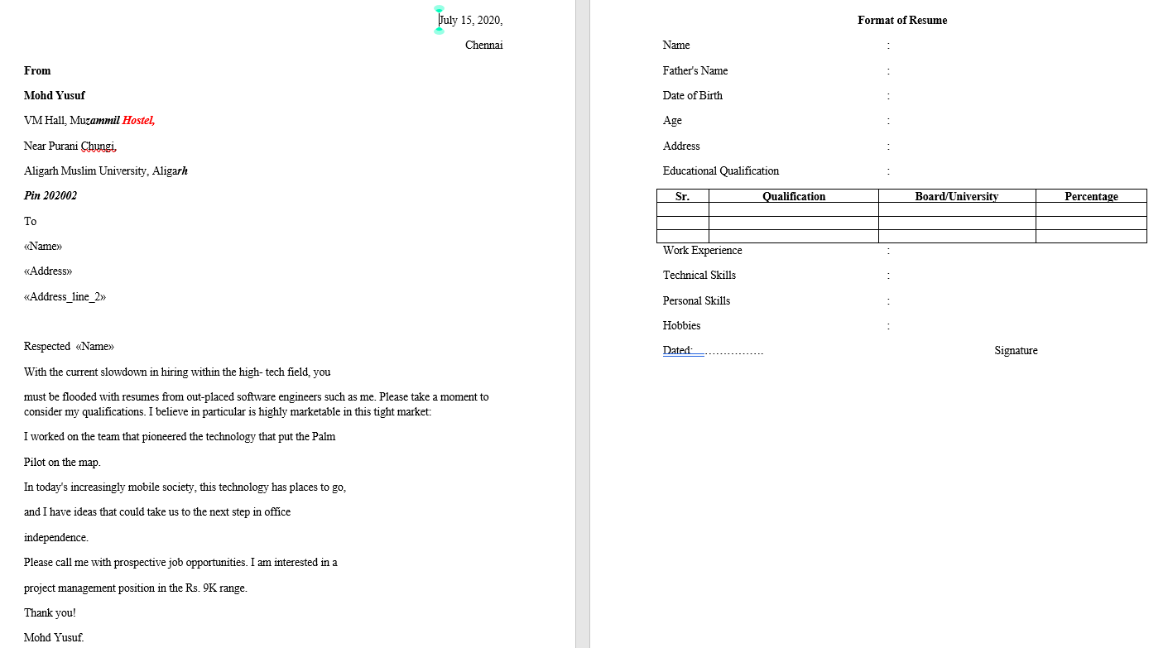

1. Send the document to 3 recipients using Mail merge. (Use 3 different addresses)

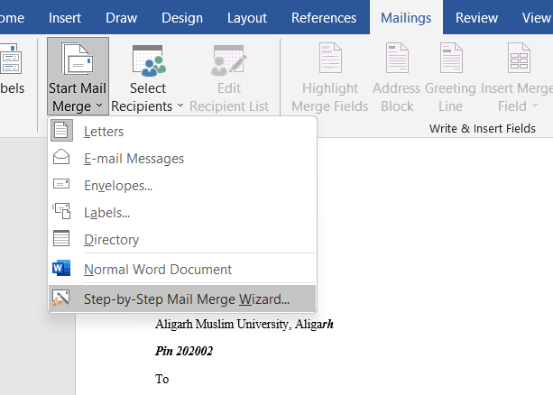**Steps :** Go the mailings tab and click on the **Start Mail Merge** drop down button. From there, select **Step by Step Mail Merge Wizard.**

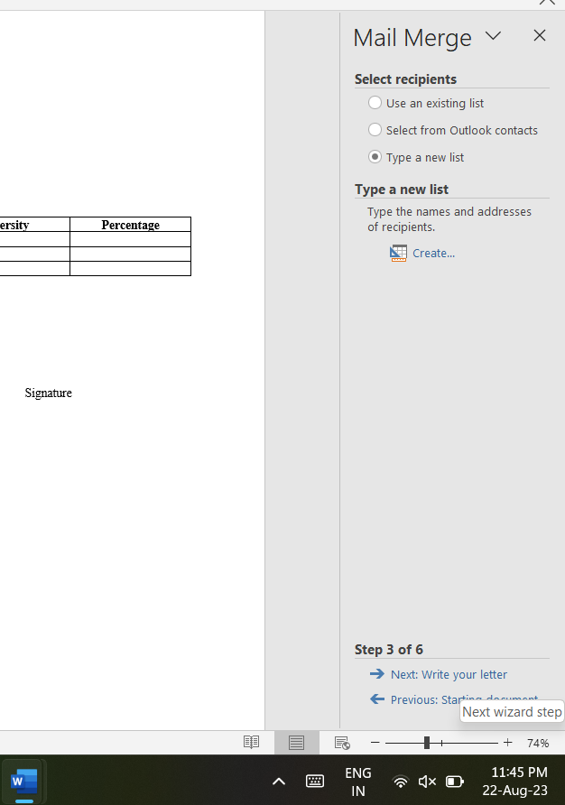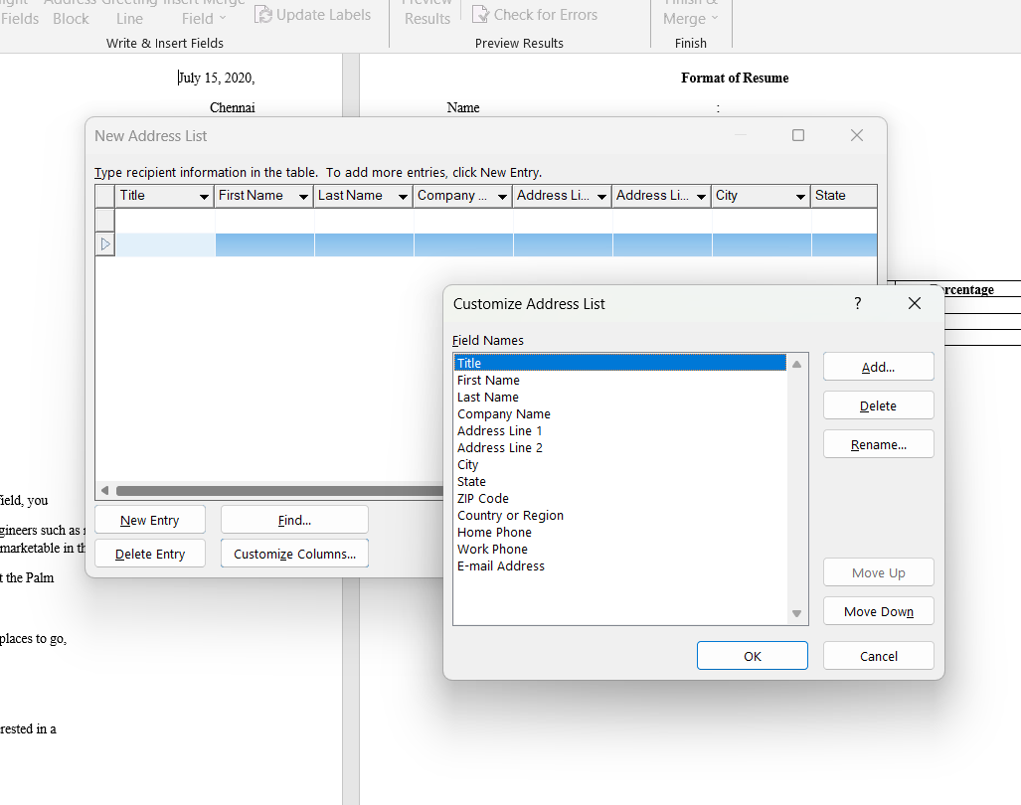The mail merge wizard appears on the right side of the screen. Since we’re working on letters, chose **letters** and click on **Next** :**Starting Document** at the bottom .

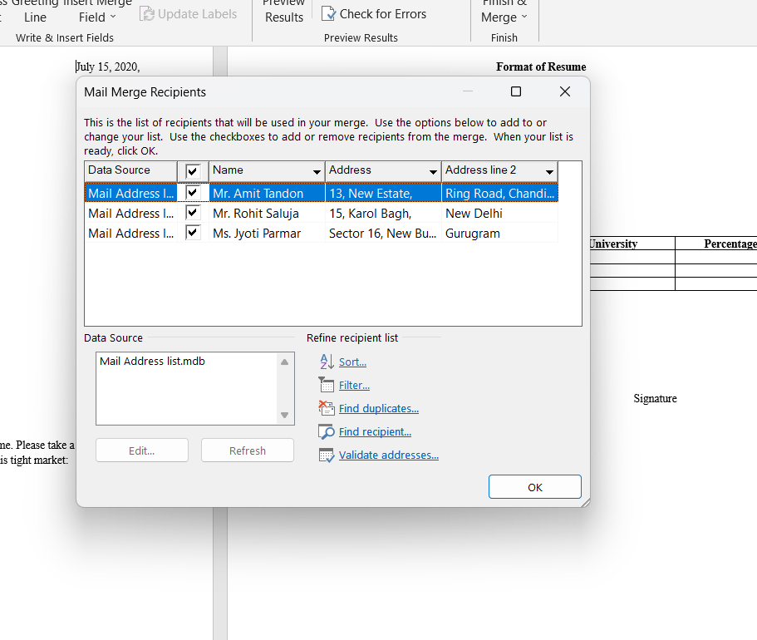Type the fields that u want to insert in your letter. After clicking on **OK** type the names and other information of the recipients which are provided in the question. Then click on **Next:Write your letter** at the bottom.

Now on the letter which has been written already, select the fields that you want to insert by placing the cursor at the required place. You can see that the fields you inserted would appear like **«Name»,«Address»,«Address_line_2».** Now click on **Next:Preview your letters** at the bottom.

Here , all the letters can be individually previewed. This is how mail merge is done.

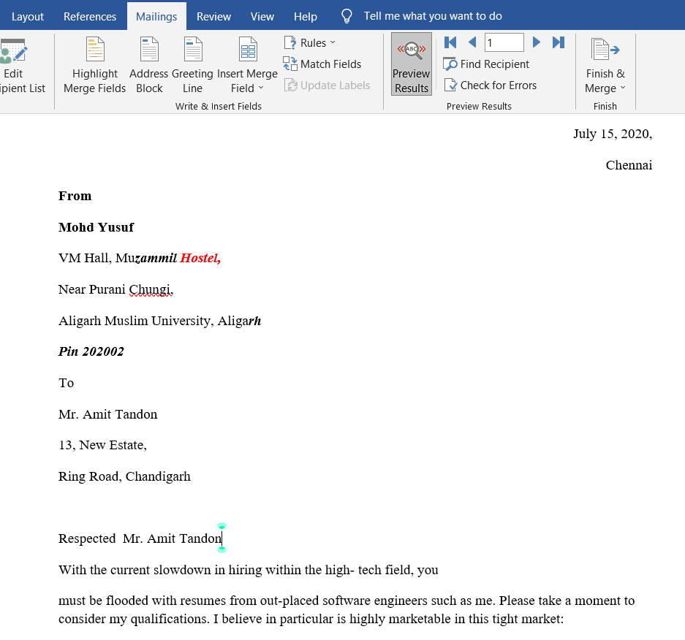**Final Result** : The letters can be printed from here.

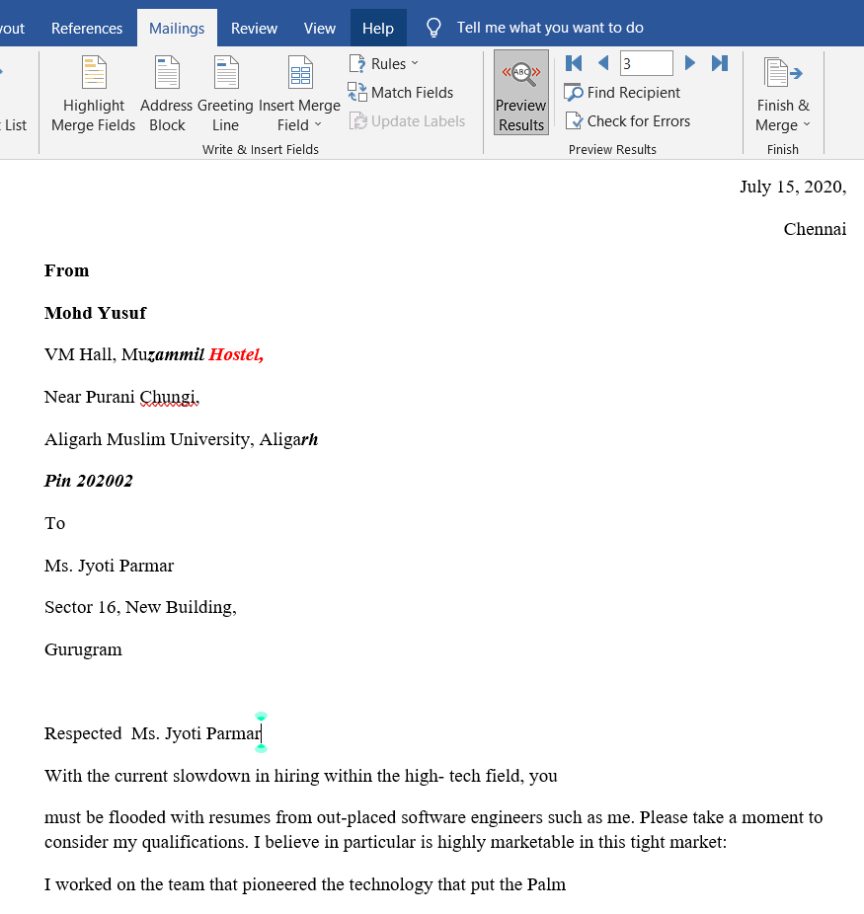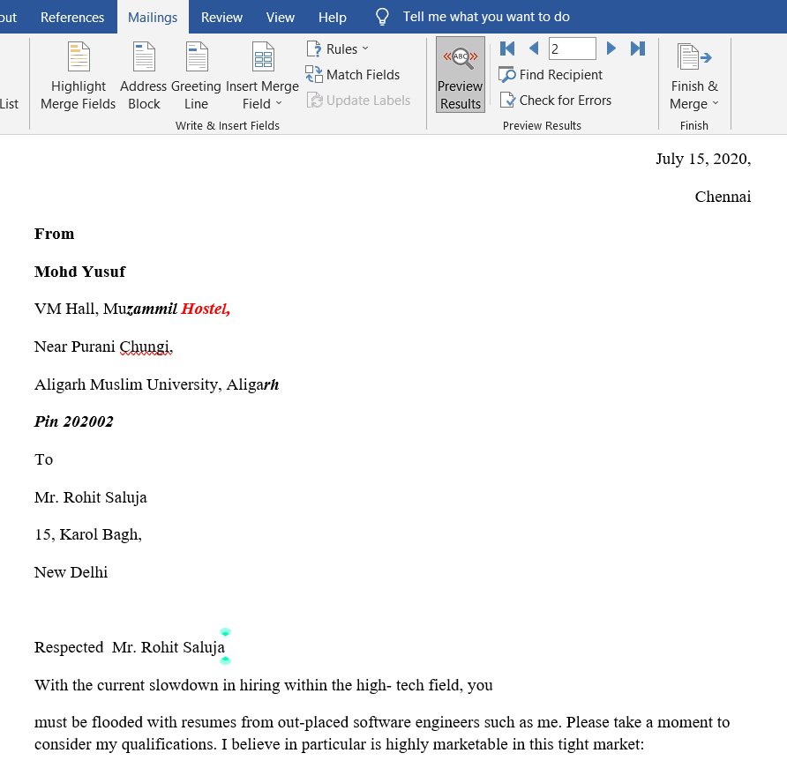

(iii) Define a Macro ‘Decorate’ which makes the text bold, Red in color and italic, font size Assign a shortcut key Alt + Z to this macro.

**Steps :** Open a word document and go to the **View** tab. Click on the **Macros**

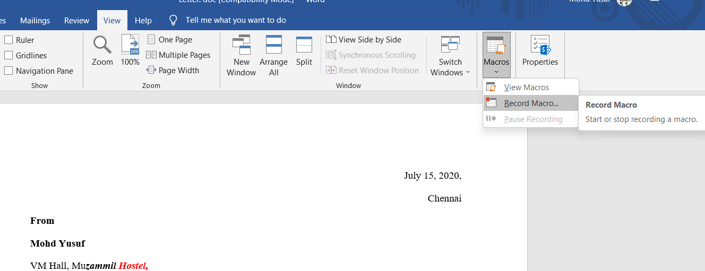dropdown button and select **Record macro.**

A new window appears for recording a macro. Here, set the macro name as

**Decorate.** After this select the **keyboard** icon.

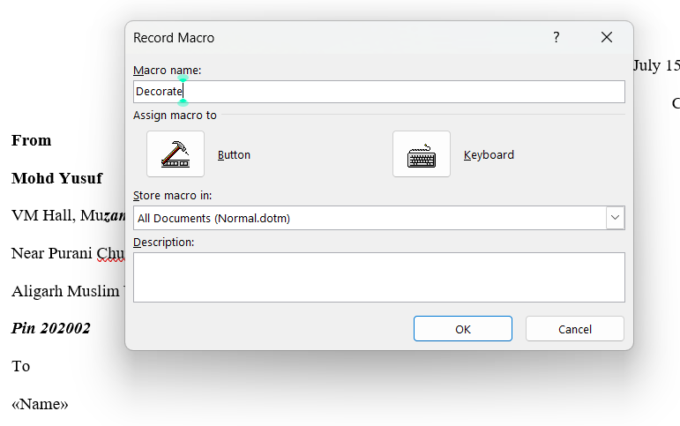

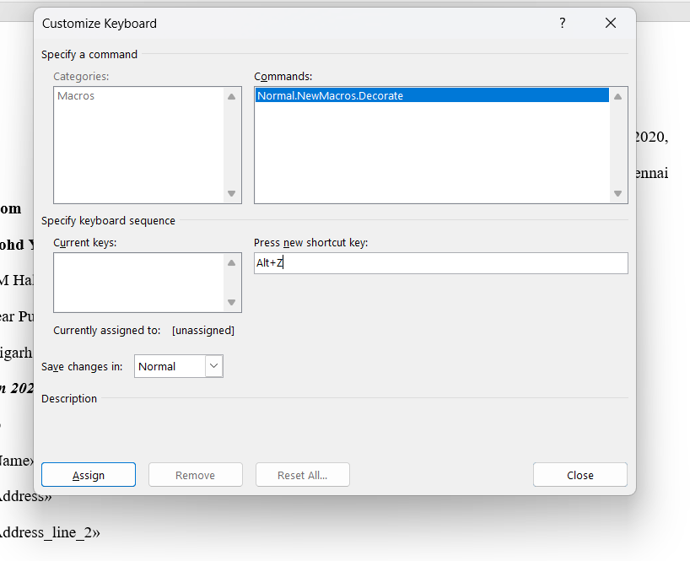Assign the shortcut key as **Alt+Z.** Close the dialog box.

Press Cltrl+D to open the dialogue box for editing and applying the macro and select **BOLD , ITALIC** and **RED** font color.

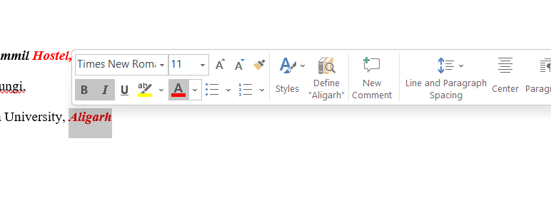

Once again go to the **View** tab. Click on **Macros** and then click on **Stop Recording**.

1. 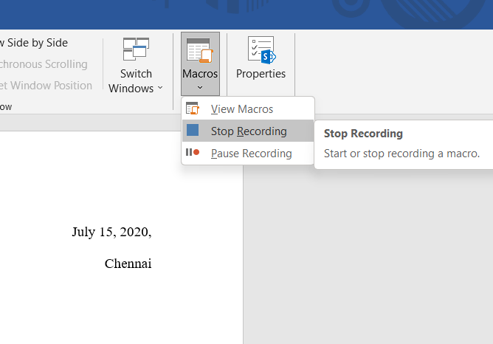Close the document.
2. The Sample Addresses are:
3. Mr. Amit Tandon 13, New Estate,

Ring Road, Chandigarh

1. Mr. Rohit Saluja

15, Karol Bagh, New Delhi

1. Ms. Jyoti Parmar

Sector 16, New Building, Gurugram

## Format of Resume

Name :

Father’s Name :

Date of Birth :

Age :

Address :

Educational Qualification :

|  |  |  |  |
| --- | --- | --- | --- |
| **Sr.** | **Qualification** | **Board/University** | **Percentage** |
|  |  |  |  |
|  |  |  |  |

Work Experience : Technical Skills :

Personal Skills :

Hobbies:

2# Create a table in word as shown below:

|  |  |  |  |  |
| --- | --- | --- | --- | --- |
| Roll No | Name | Marks in Physics | Marks in Chemistry | Total Marks |
| 1 | Sakshi | 80 | 70 |  |
| 2 | Rohit | 70 | 80 |  |
| 3 | Amit | 60 | 50 |  |
| 4 | Rakesh | 40 | 60 |  |
| 5 | Komal | 30 | 70 |  |
| 6 | Garima | 80 | 80 |  |

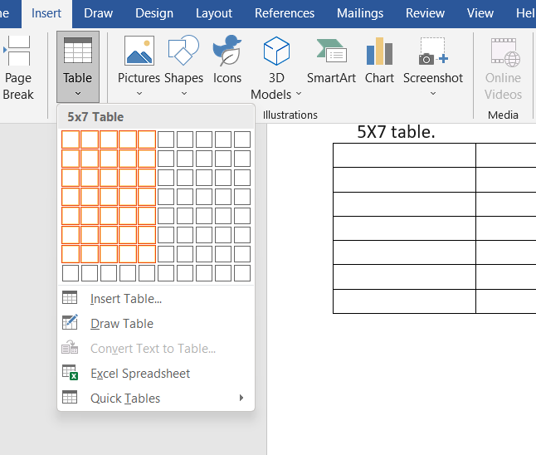Open a word document , go to **INSERT** tab and click on **TABLE** drop down box. Draw a 5X7 table.

Enter the headings of every column. From the LAYOUT tab, keep the headings centre aligned. From the HOME tab select bold and underlined to keep the headings that way as per the requirement of the question. Type down the rest of the entries.

Do the following:

1. In the total marks column, entries should be calculated using formulas and it is the sum of marks in physics and marks in chemistry.

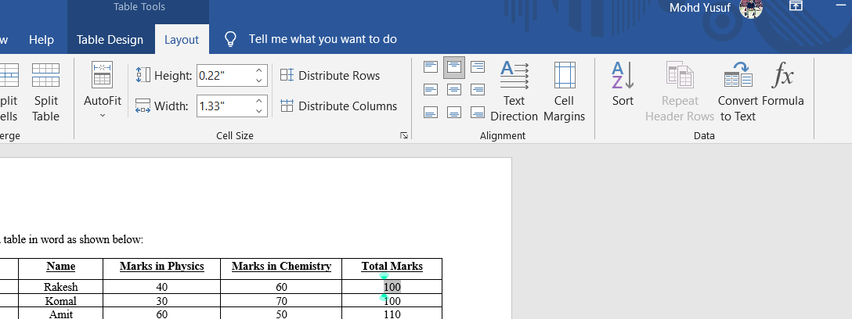Steps : To calculate the values for the 5th column select the given cell and then click on *formula* from the LAYOUT tab. We are using sum formula since marks of physics and chemistry are to be added as per the question.

(b) Insert a new row at the end of the table and also find grand total using formula.

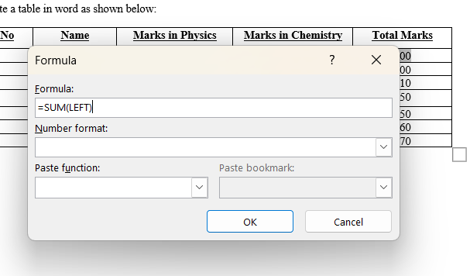Steps : After calculating the sum for each cell of the 5th column, insert a new row at the end of the table by using the Insert Below option from LAYOUT tab. Now calculate the grand total by clicking on the last cell and then using formula from LAYOUT tab. Type “ABOVE” in the formula to calculate the grand total of the marks.

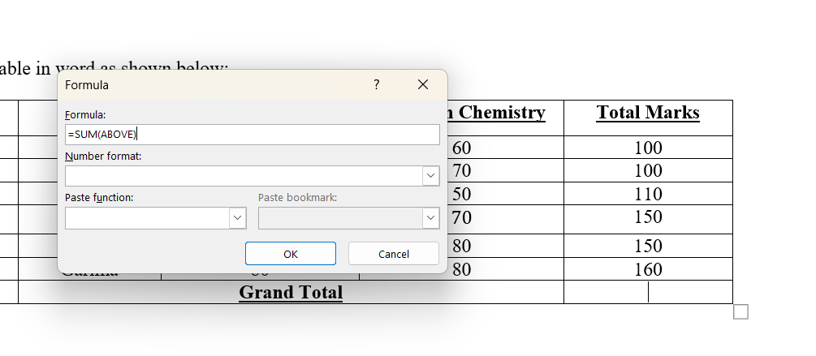(c) Sort the table based on total marks.

Steps : For sorting the table based on total marks, select the 5th column and click on the SORT option, and in the dialog box choose “descending order”.

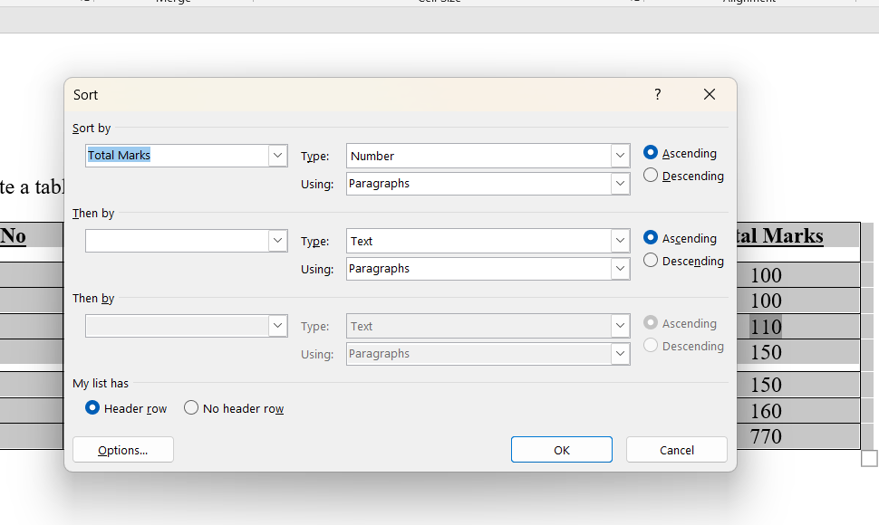

## Final table after Sorting:

1. The date and heading should be centre aligned.
2. Heading should be in bold and underlined.

3# Using a spreadsheet package you have studied, construct T Morongo’s pay slip for December 2016 following the instructions below. Insert a custom footer with your *name, subject, course, exam/Test &question number.* Save it as Salary advice.

## Instructions:

1. Housing Subsidy 6000.00 per year.
2. Car Allowance 100.00 per month.
3. Pension 8% on Basic Salary. iv) P.A.Y.E. 636.83
4. Medical Aid 70.00
5. U.I.F. 1% on Basic Salary + Housing Subsidy
6. Bond Repayment 630.00

**Steps** : Open a new workbook and fill in the entries that are given in the table (provided in the question). Also, apply borders to the table with the help of the border icon on **Home** tab.

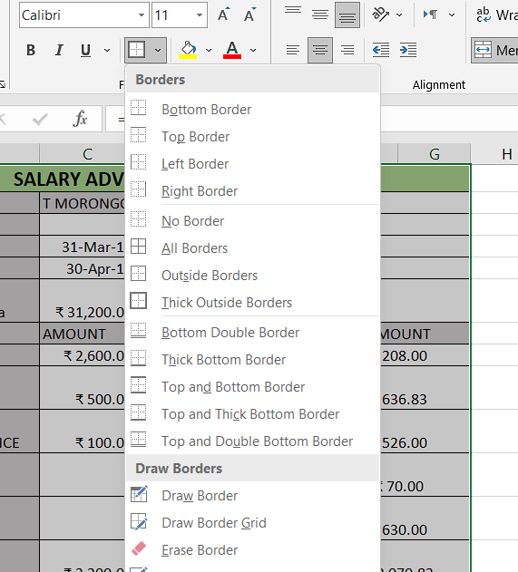

Using the division formula, calculate **basic salary** per month by dividing **basic salary p.a.** by 12.

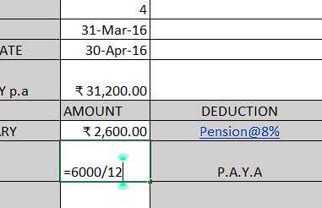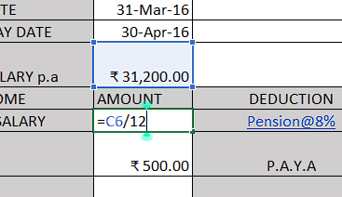Next calculate the housing subsidy by dividing Rs.6000 by 12. Type“=6000/12’’ in the formula box.

Fill the entries for P.A.Y.E , Medical Aid, and Bond Repayment as per

provided in the question. Next repeating the same process as before calculate :

Calculate the pension, using formula for “8% of base salary”, i.e, =C8*(8/100). Calculate U.I.F., using formula “1% of basic salary + Housing subsidy”, i.e., = C8*(1/100) + C9.

Calculate Gross income, using addition of above columns according to “sum” formula, i.e., =C8+C9+C10.

Calculate Total Deductions, using addition of above columns according to “sum” formula, i.e., =G8+G9+G10+G11+G12.

1. Calculate Net Salary.

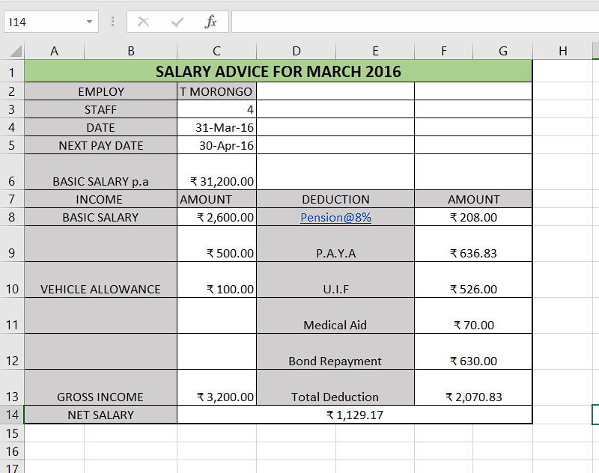Steps: Calculate Net salary by using formula “Net salary = Gross salary – Total deduction”, i.e., =C13-G13.

To show all the formulas used in the sheet go to the FORMULA tab and click on Show formulas.

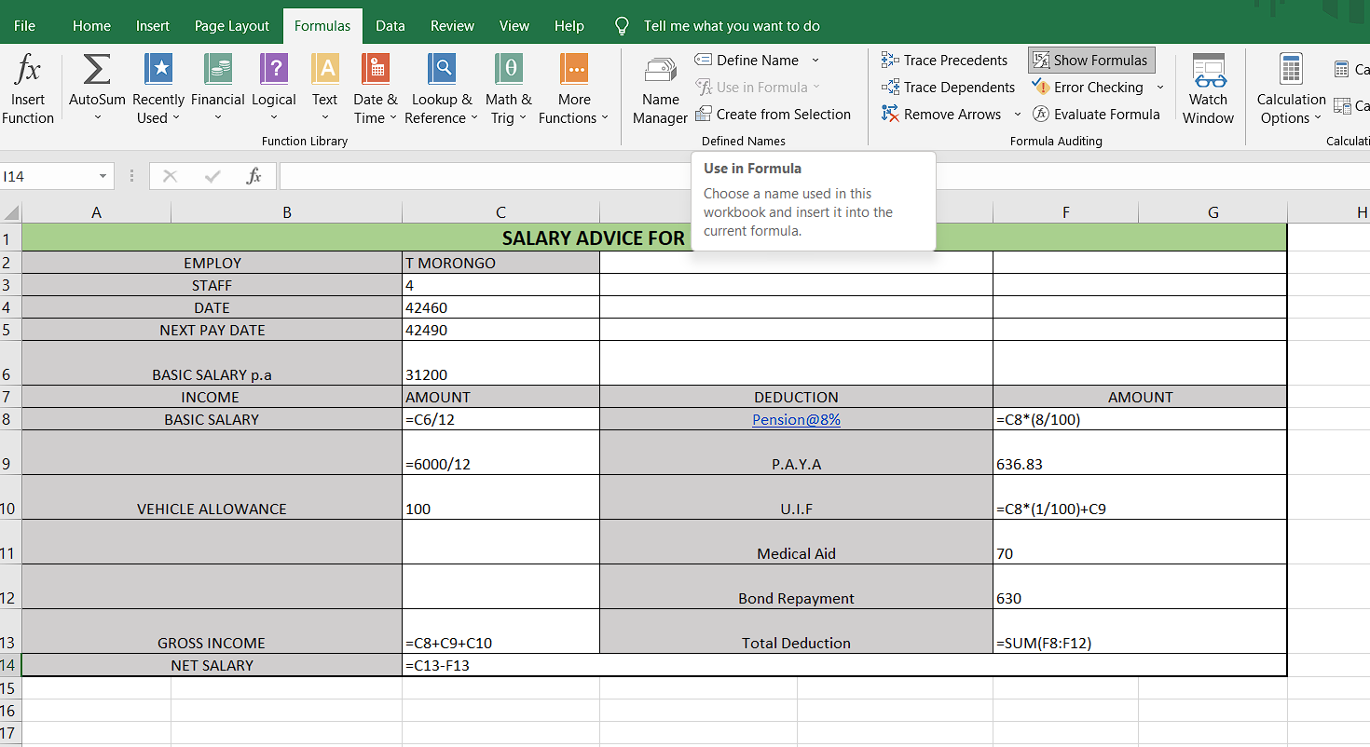

1. Format all figures to two decimal places and insert ₹ currency symbol.

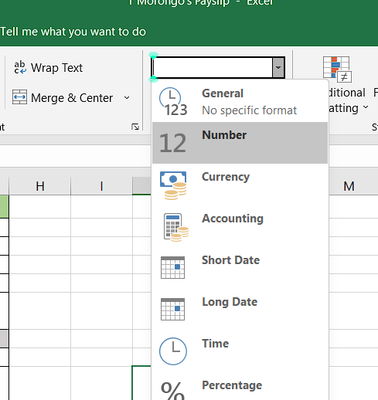**Steps :** For formatting all the figures to two decimal places , select the column then click on the **General** drop down menu in the **HOME** tab and choose **Number** option.

For applying currency symbol, select the column of cells where the currency sign needs to symbol needs to be applied , then click on the **Format** drop- down menu on the left (from the **HOME** tab).In the drop-down menu , select **Format Cells.**

A pop-up window will appear. Select the **Currency** option and choose the **INR**

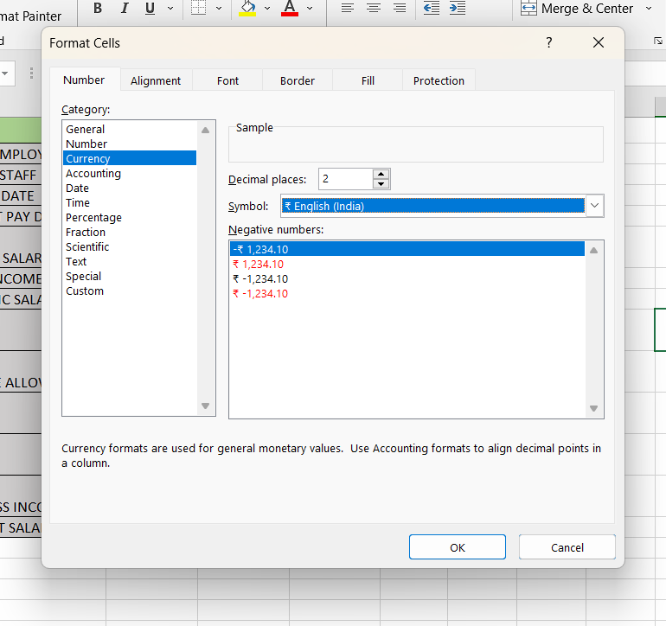symbol. Press **OK.**

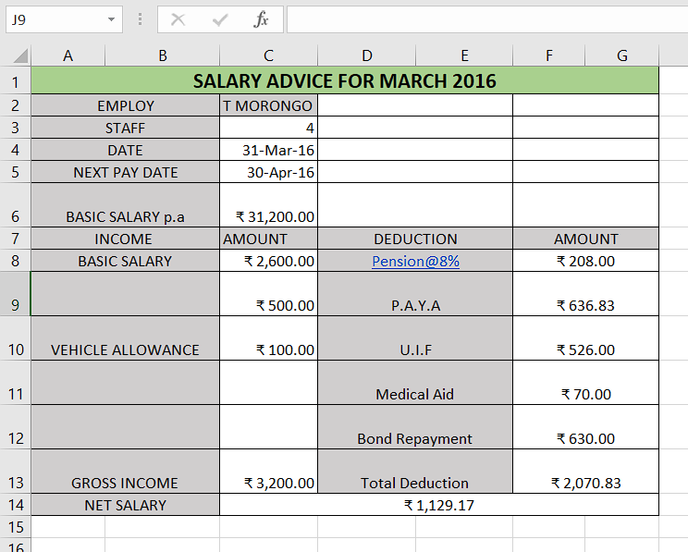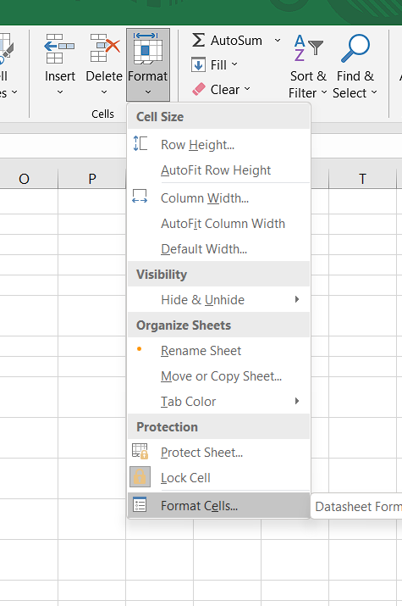

1. Insert a custom footer with your name, subject, and question number. Save it as salary advice2.

**Steps :** For adding custom footer, go to the **PAGE LAYOUT** tab and click on **page setup** at the bottom of the ribbon. A new window appears. Select **Header/Footer** and next click on custom footer.

A new window **Footer** opens. As per the question, write down your name , subject and question number and then click on **OK.**

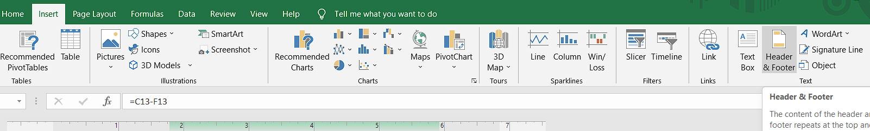

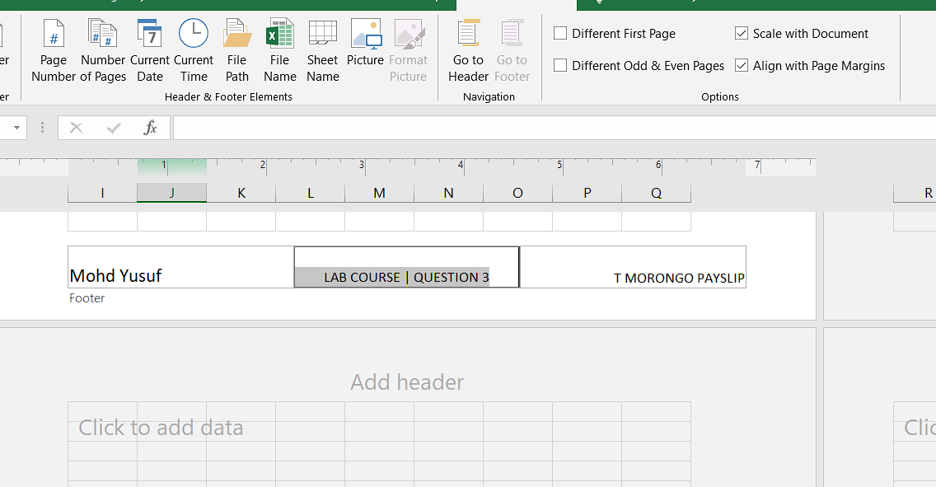

4# Use a new workbook & construct a worksheet with the data given & save it as LYONS.

## LYONS INC

**Orange JUICE Sales**

## Instructions

* **Markup** = Cost price/Litre x 35%
* **Selling price**= Cost price/Litre + Mark up
* **Total income**= Litres sold x Selling Price
* **Profit** = Total income – (Cost price/Litre x Litres sold)

1. The MARKUP % (35%) must be inserted in a separate cell under the heading. USE IT as an absolute cell reference in the formula to calculate the mark up per item.
2. Calculate the mark up for each item.
3. Calculate the selling price for each item.
4. Calculate the Total Income for each item.
5. Calculate the profit for each item.

Steps : Open a new workbook and construct a table of required size, fill in all the entries from the question.

Calculate the **markup ,selling price ,total income** and **profit** for each item.

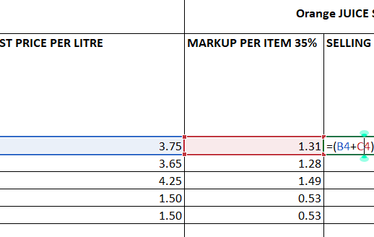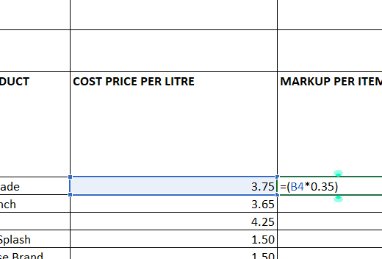

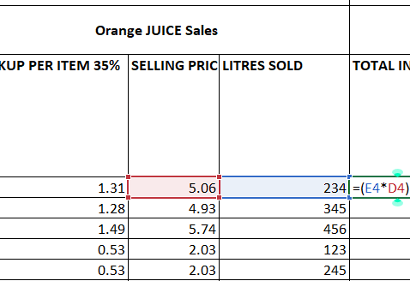

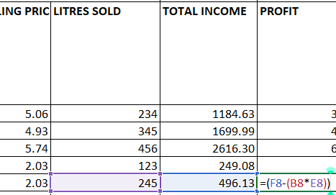

1. Format the column LITRES SOLD to display the number of litres as integers. The rest of the worksheet must be formatted to display two decimals.

Select the required column and click on the **General** drop-down option in the

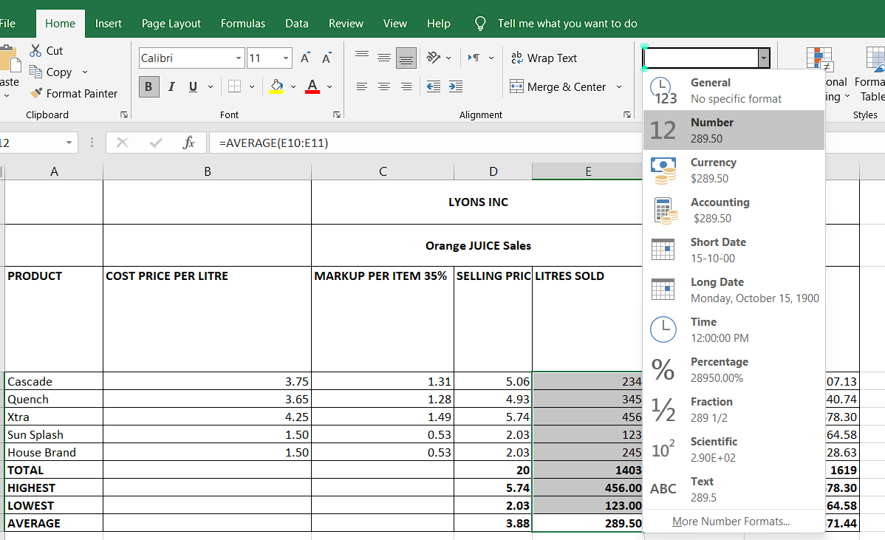**HOME** tab.

1. Use statistical functions to calculate the:

* AVERAGE
* HIGHEST (MAX)
* LOWEST (MIN) for Selling Price column up to Profit Column.

Now calculate the **total** value , the **highest** ,the **lowest** and **average** values for each column.

1. Show all formulas you have used in a new sheet. Adjust the column width so that the formulae are displayed in full and the sheets fits into one side of A4 landscape format and save it as formulas.

For showing all the formulas used in this excel sheet ,click on the **FORMULAS**

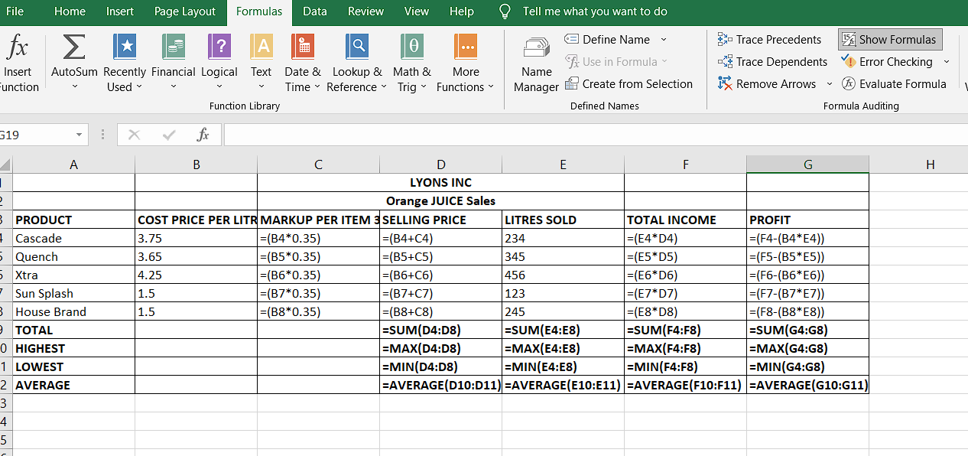ribbon and then click on **Show Formulas** on the left.

1. Under the worksheet Create a pie chart titled PRODUCT COST PER UNIT for Product & Cost price per Litre columns. Data labels indicating percentages should be displayed.

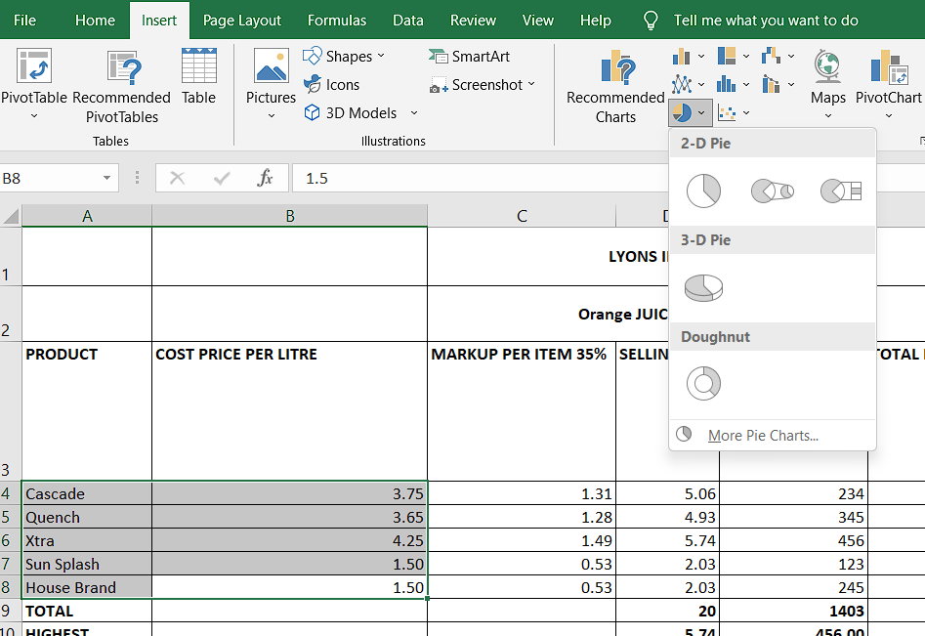For creating a pie chart, go to the **INSERT** tab and select **PIE**. After selecting the design for pie chart, click on **Select Data** on the top-left. Select the column of **Product** and **Cost per litre** and press **OK.**

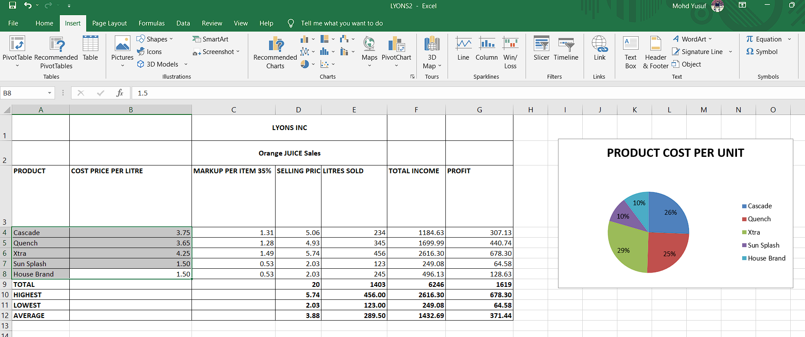

1. Put borders neatly on the on the work sheet & save it as LYONS2.

Apply borders to the table using the border icon from **HOME** tab.

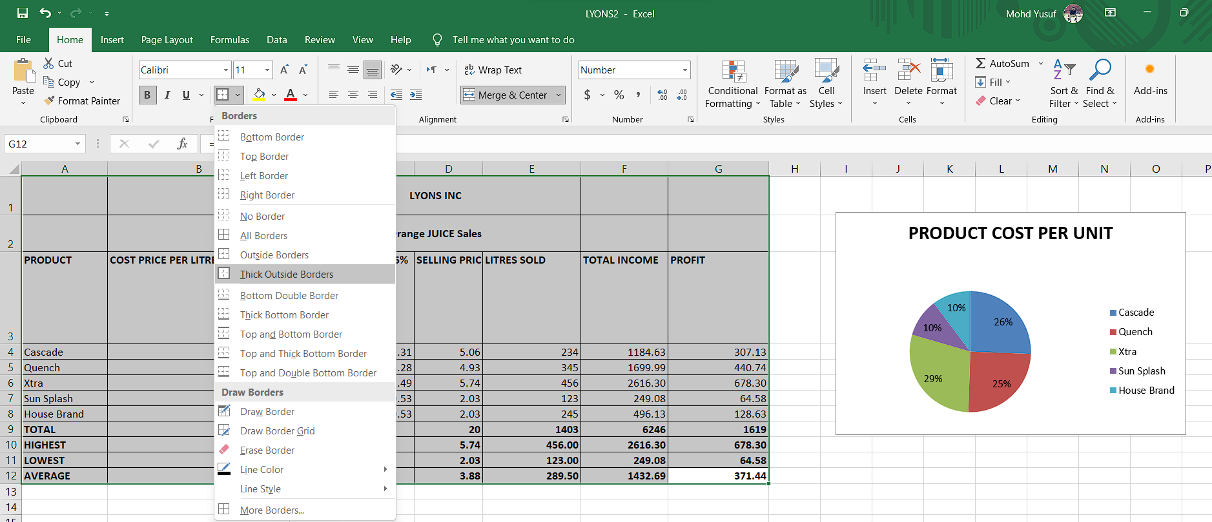

**WEEK 2**

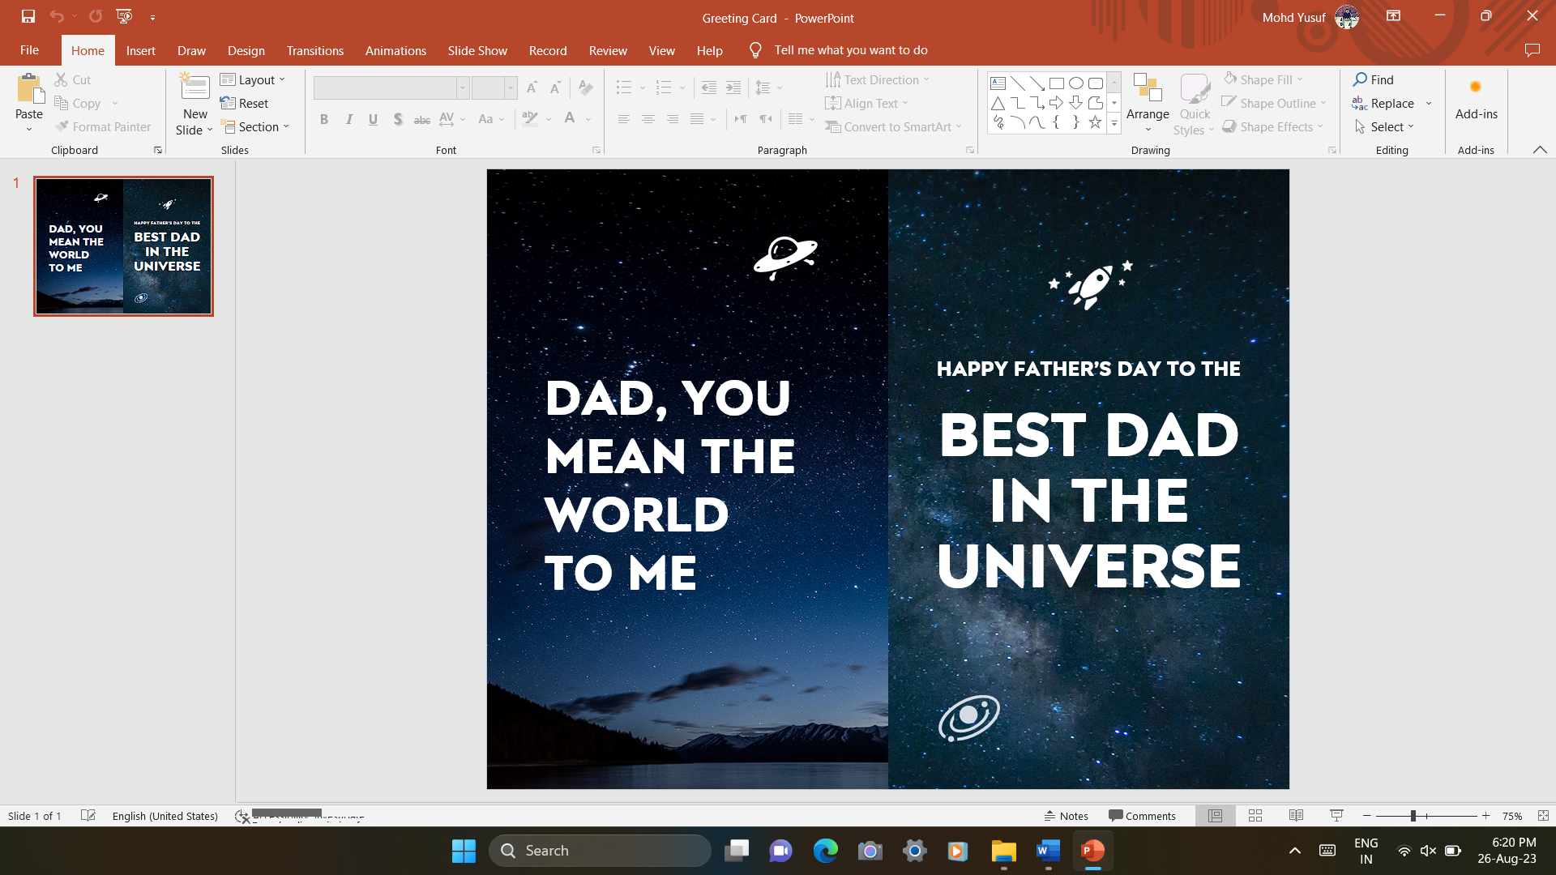1# Design Seasonal Greeting cards using MS-Power Point.

2# Design a AMU Magazine cover in MS-Power Point. Use the following:

1. Select a theme for the page.
2. Insert either a picture or clipart, and
3. 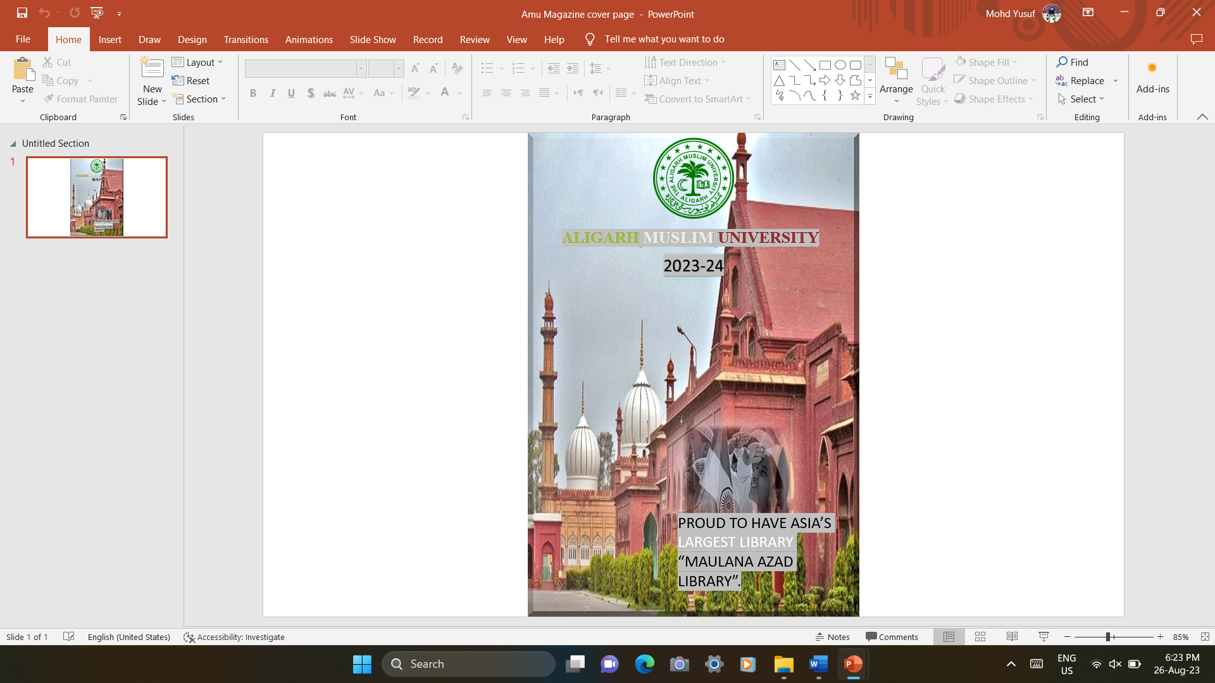Use WordArt.

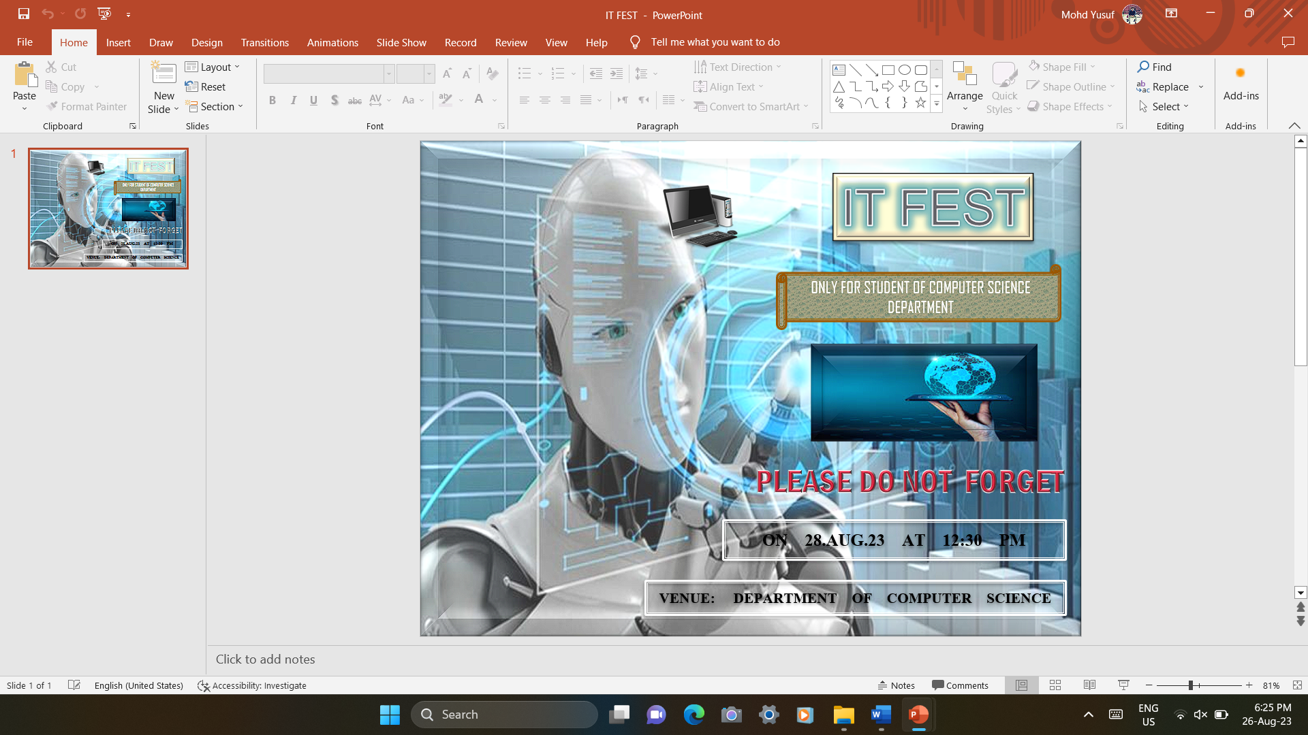3# Design a poster inviting all students of your department to the IT Fest (using MS-Power Point).

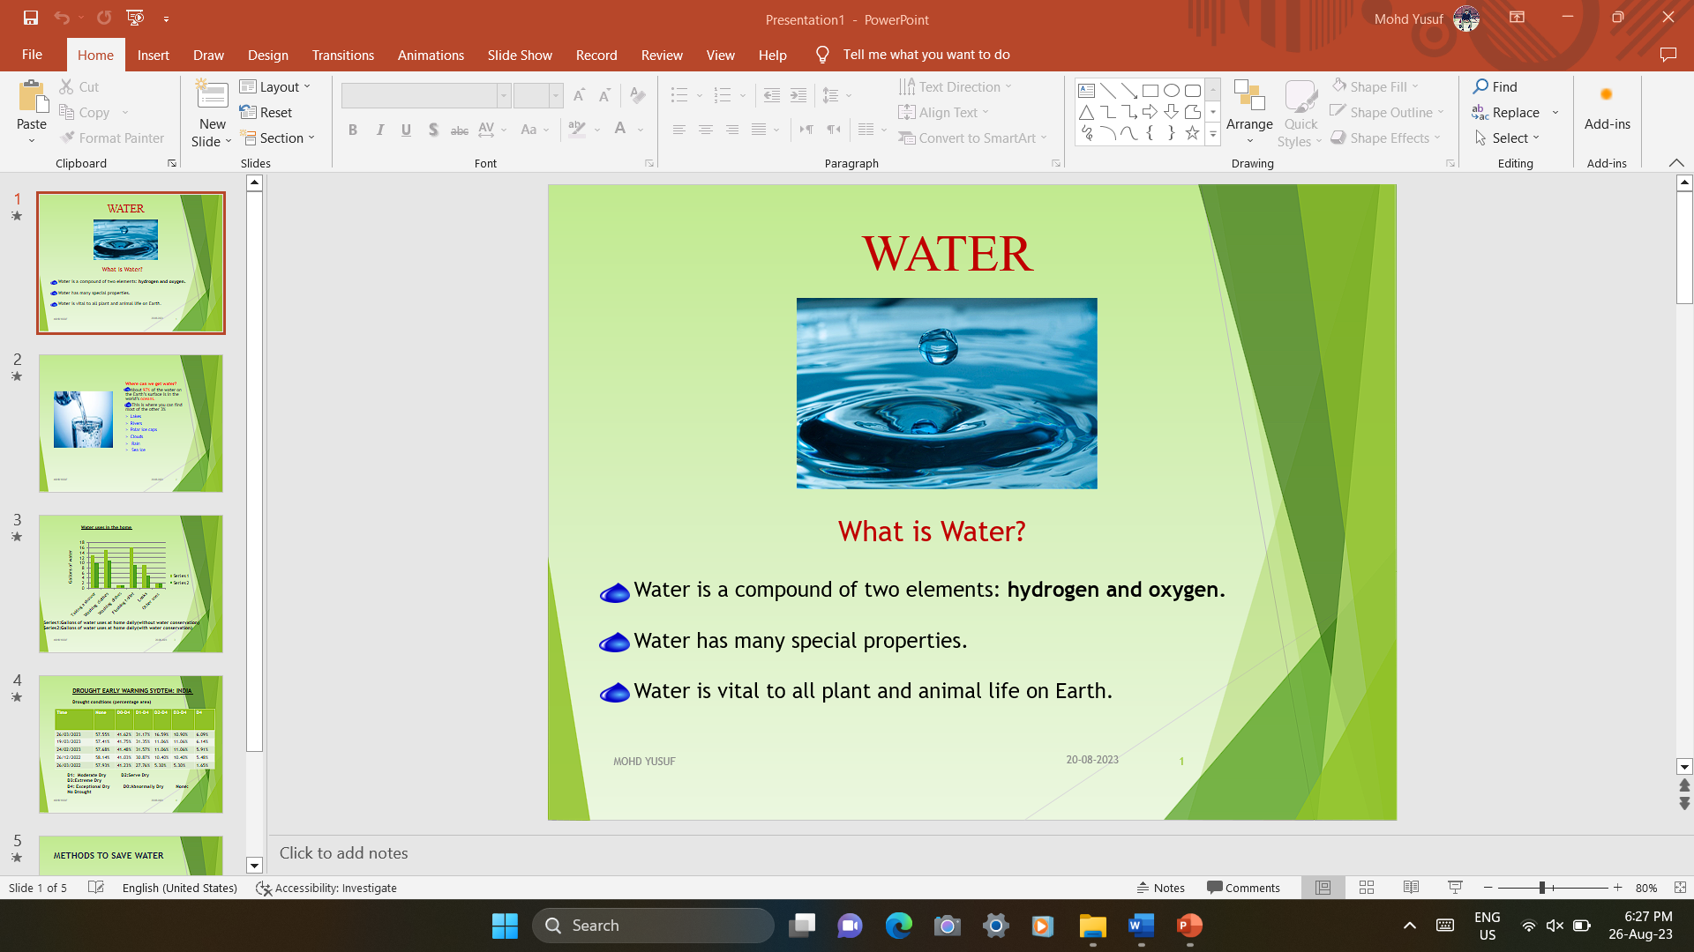4# Create a 5-slide presentation on any topic. Use Images, Graphs, Chart, Tables, Animation, Time, Bullets, Transition, Sound, Hyperlink, Background template, Header and Footer (using MS-Power Point).

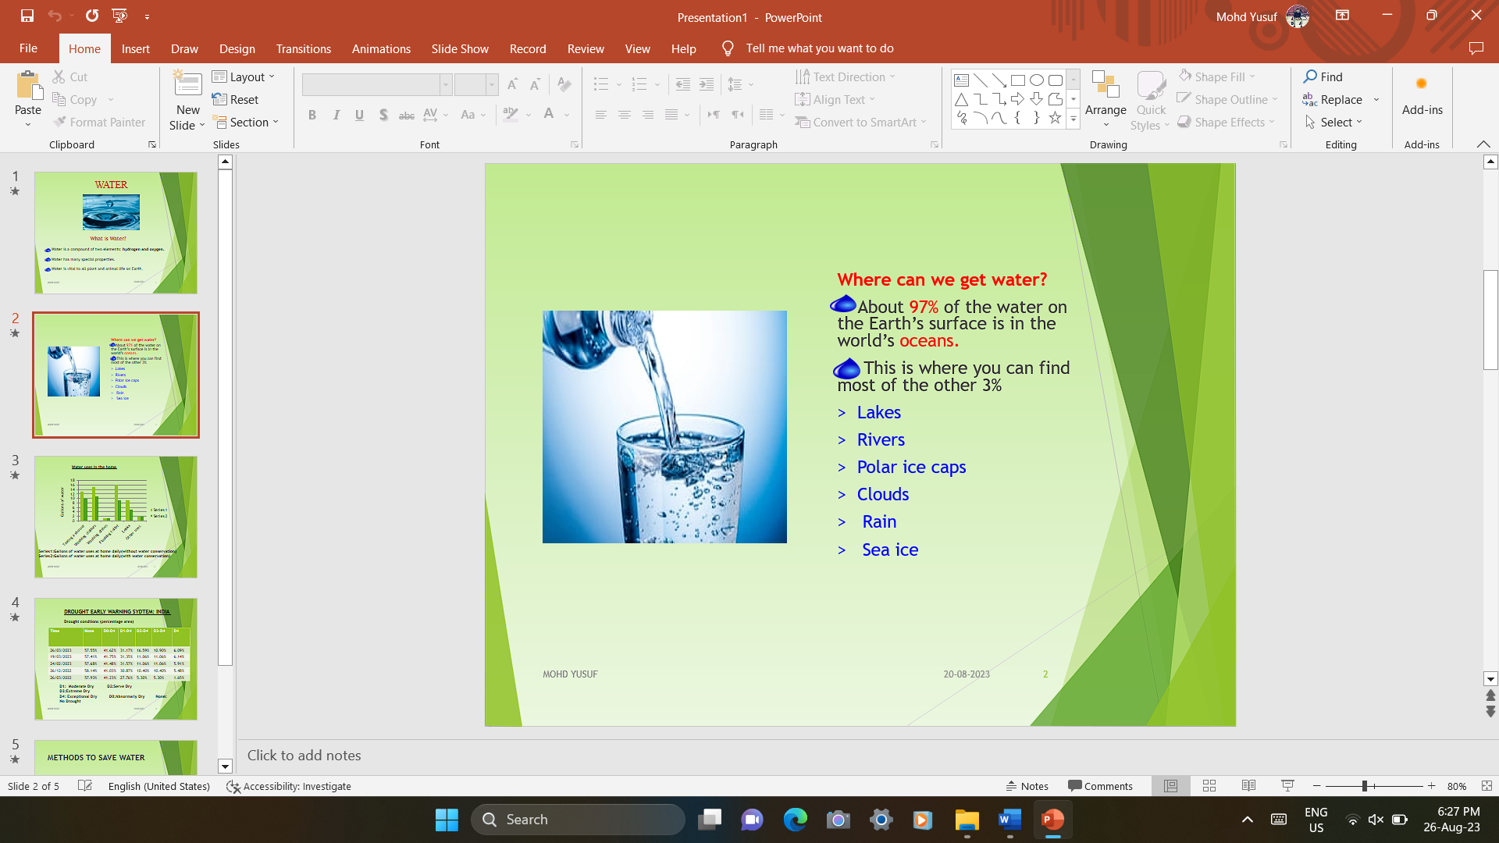

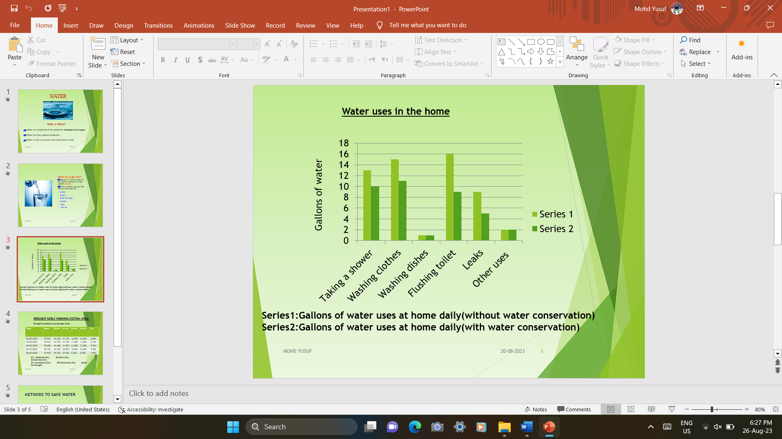

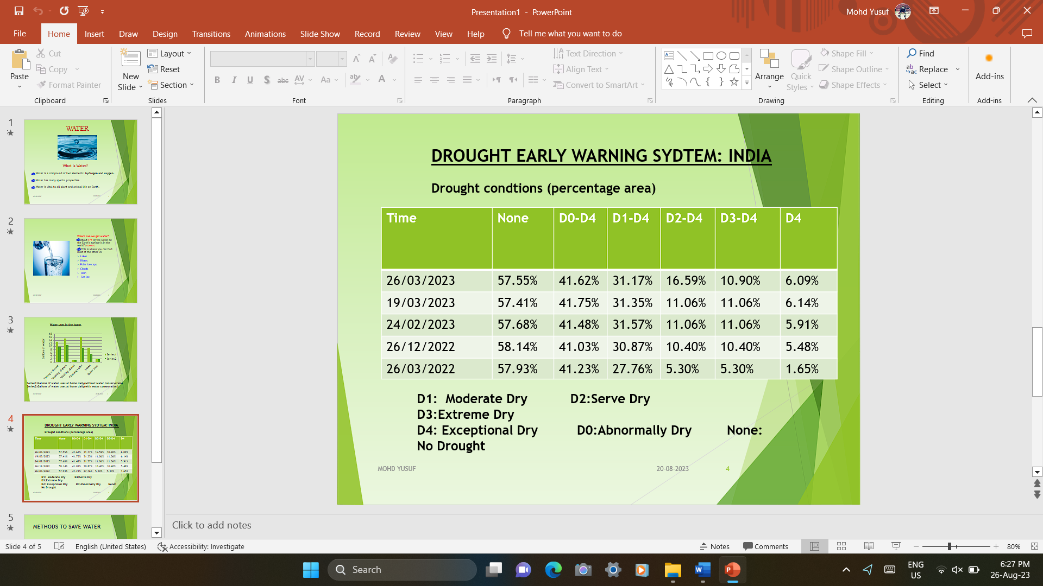

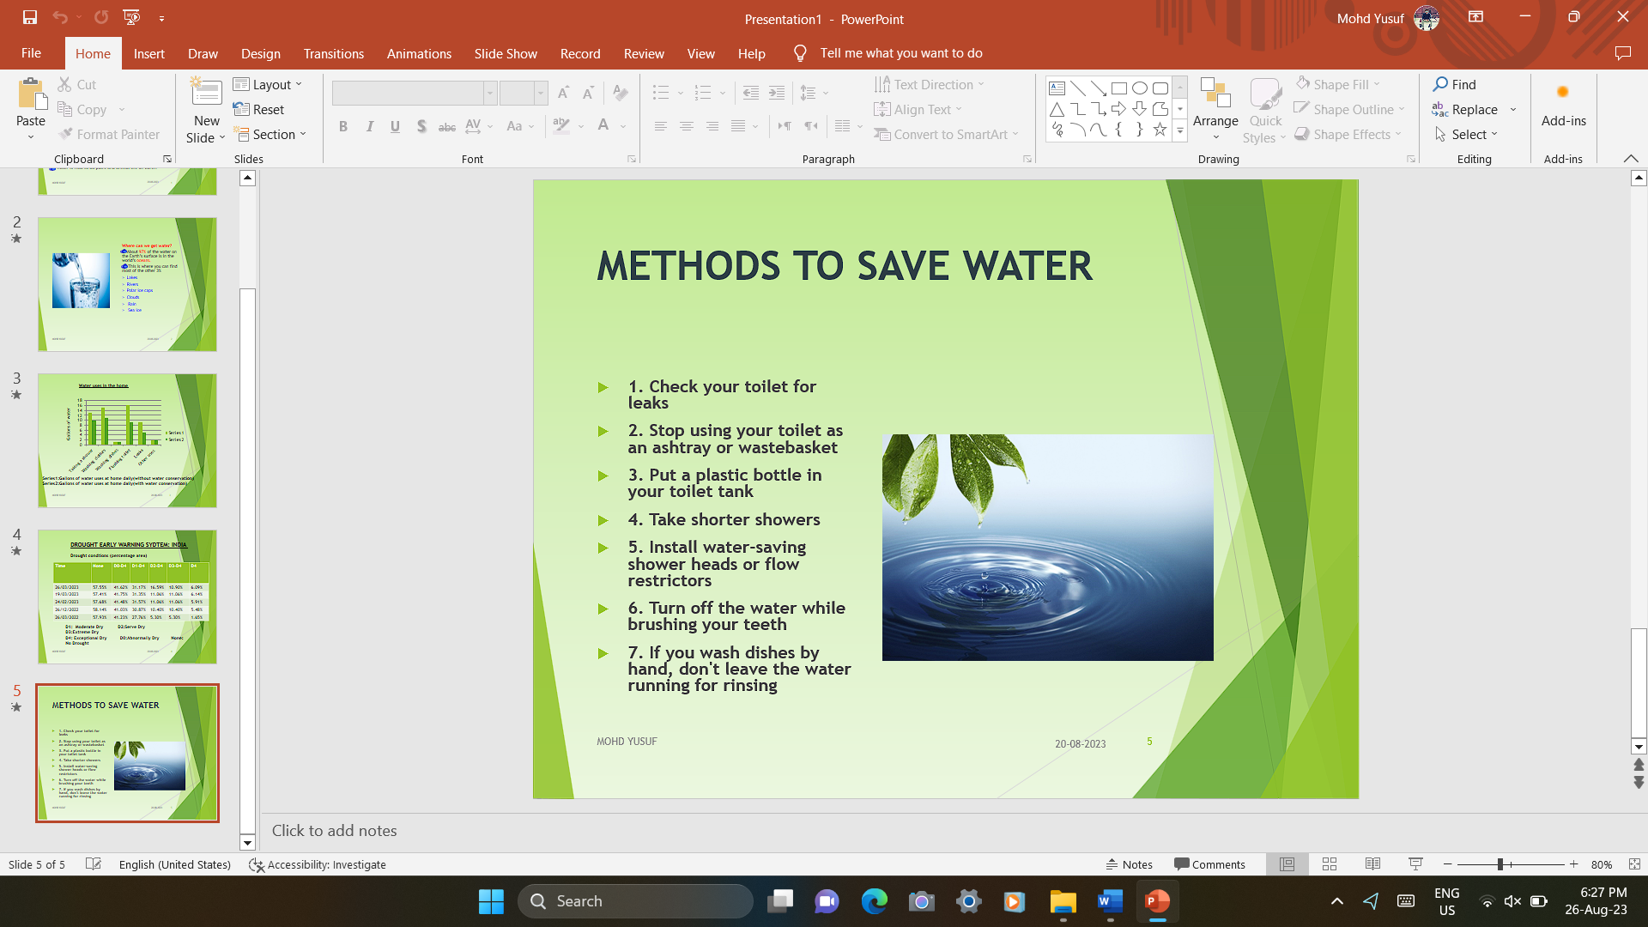

**WEEK 3**

**Dev C++ IDE: Installation, Features and C++ Development**

Dev-C++ is a fully featured graphical IDE (Integrated Development Environment) that uses the MinGW compiler system to create Windows as well as Console based C/C++ applications. It can also be used with any other GCC-based compiler like Cygwin.

Dev-C++ is free software and is distributed under the GNU General Public License. Thus we can distribute or modify the IDE freely. It was originally developed by “Bloodshed Software”. It has been formed by Orwell after it was abandoned by Bloodshed in 2006.

**Features of Dev-C++ IDE**

Enlisted below are some of the features of this IDE that help us developing efficient and user-friendly C/C++ applications.

* Dev-C++ supports GCC-based compilers including Cygwin, MinGW, etc.

We can either install a Dev-C++ IDE along with the compiler integrated or

just an IDE if we already have a compiler on our system.

* We can use integrated debugging (using GDB) with this IDE. The debugger allows us to perform all the general debugging operations on source code.
* It has a localization feature that provides support for multiple languages. We can select the language the first time when we open the IDE after installing it. We can also change the language anytime using settings.
* Like the other IDEs, this IDE also provides the “Auto-Completion” feature

for the code we write.

* It comes with customizable syntax highlighting editor that can make the

source code more readable.

* Allows editing and compiling the Resource files.
* Has a Tool Manager that contains various tools that can be used in the project.
* This IDE also has inbuilt Find and replace facilities.
* Using Dev-C++ IDE, we can create various types of applications be it

Windows, Console, Static libraries or DLLs.

* We can also create our own project templates to create our own project types.
* Make files that are used for managing the build process for the application can also be created using dev-C++ IDE.
* It provides support for Class Browser as well as Debug variable Browser.
* It has a Project Manager that helps us to manage various projects.
* Also provides print support through its interface.
* We can easily install the add-on libraries using the package manager provided by the IDE.
* This C++ IDE also provides CVS support for source code management.

# Installing and Configuring C++ IDE

First you must download the Dev C++ on your Windows machine. Visit to Download Dev C++: <http://www.bloodshed.net/>

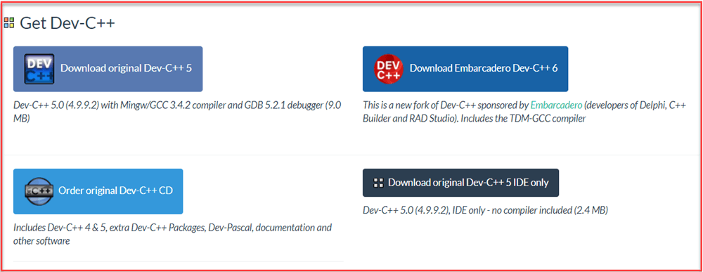There are packages for different Operating Systems.

Under package Dev-C++ 5.0 (4.9.9.2) with Mingw/GCC 3.4.2 compiler and GDB 5.2.1 debugger (9.0 MB) Click on the link “Download from SourceForge”.

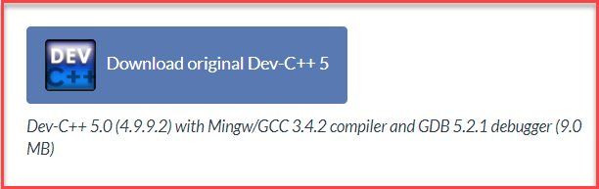

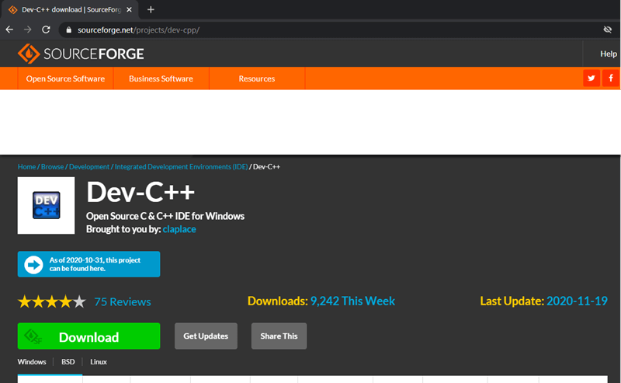This package will download C++ **.exe file** for Windows that can be used to install on Windows 7/8/XP/Vista/10.

You will direct to SourceForge website, and your C++ download will start automatically.

* Click on save button to save. By default, it is saved in “Downloads” folder.
* After the download completes, go to the saved .exe file and click on it to Run.

The installer will ask you a language to select. Select “English” and click on “OK”.

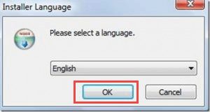

Then screen for license agreement will appear. Click on “I agree” to proceed further.

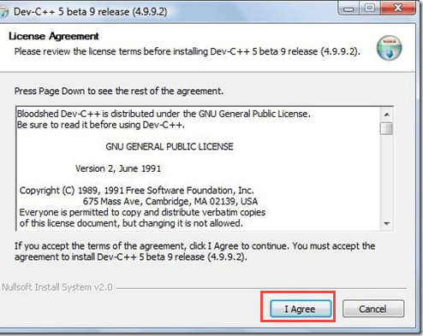

In this step,

1. You can see different components of Dev C++ that will be installed with this package.
2. 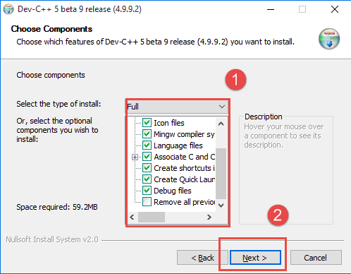Just click on “next” button.

**Step 7)** In this step,

1. By default, the destination folder is in C drive. You are free to change this destination folder but make sure you have enough memory.

Click on “Install” button.

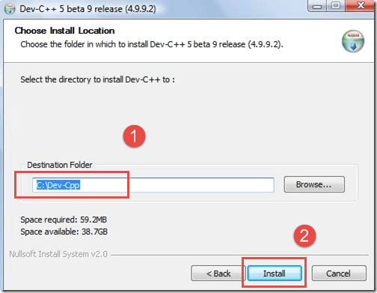

In the next screen, installation begins.

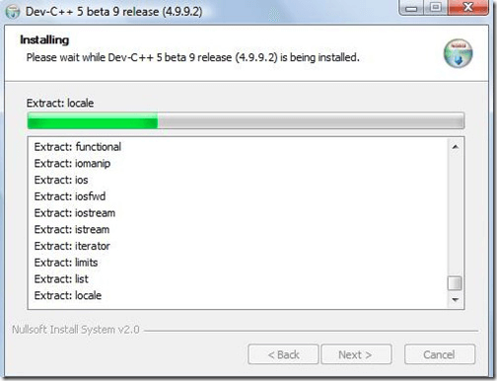

Now, Dev C++ is installed successfully on your Windows. Select ” Run Dev C++” to run it and click on ” Finish” button.

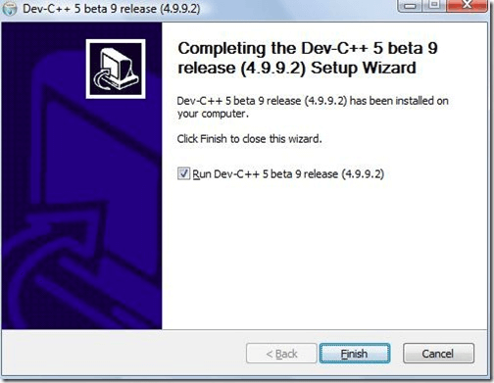

That’s it! Now you are ready to compile your C or C++ programs with Dev C++ compiler.

**WEEK 4**

1# Write a C++ program to check whether a number is even or odd using ternary operator.

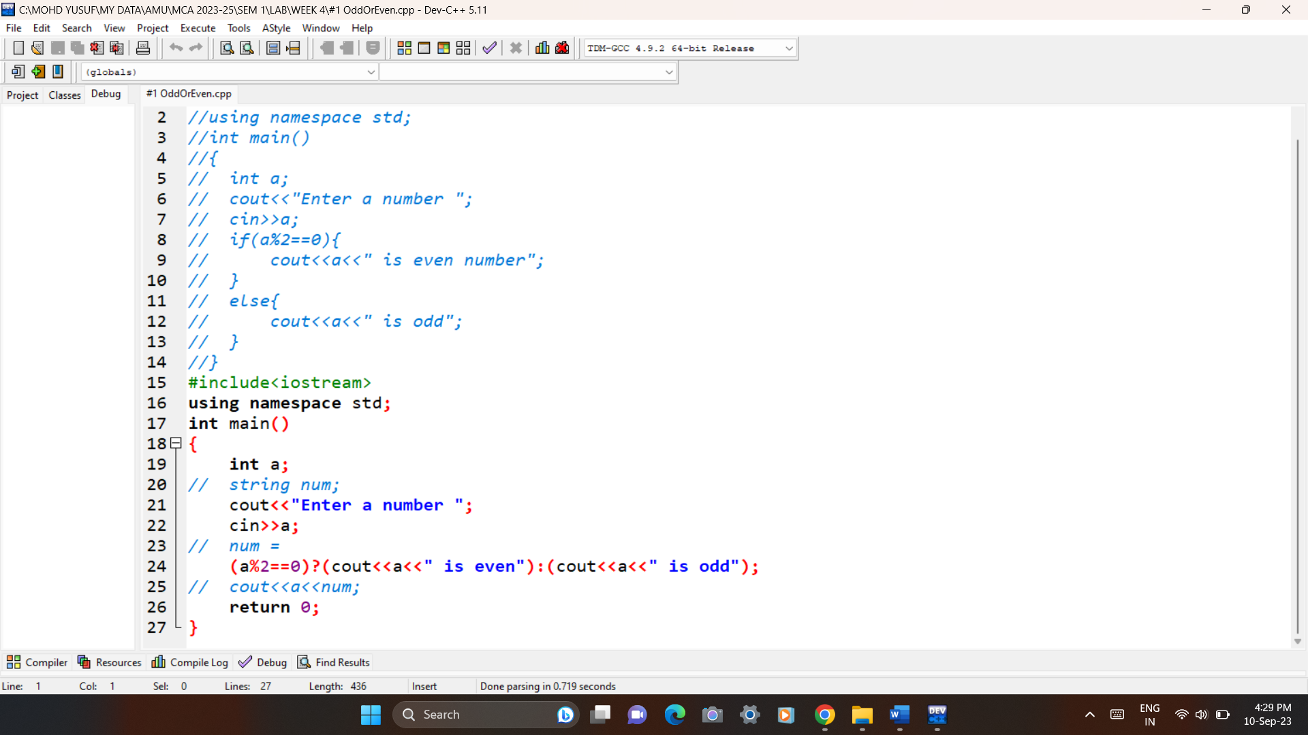Code:

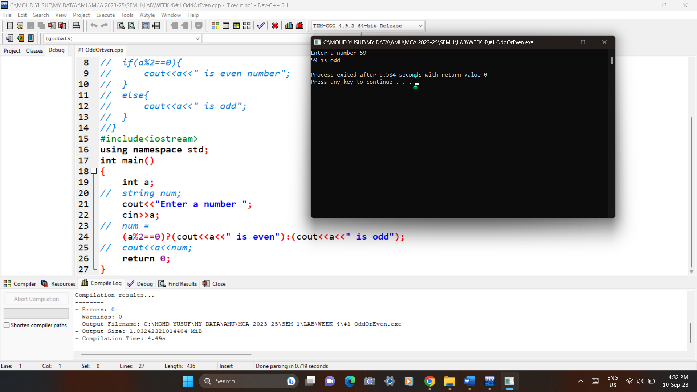Output:

2# Write a C++ program to perform the addition of two numbers without using + operator.

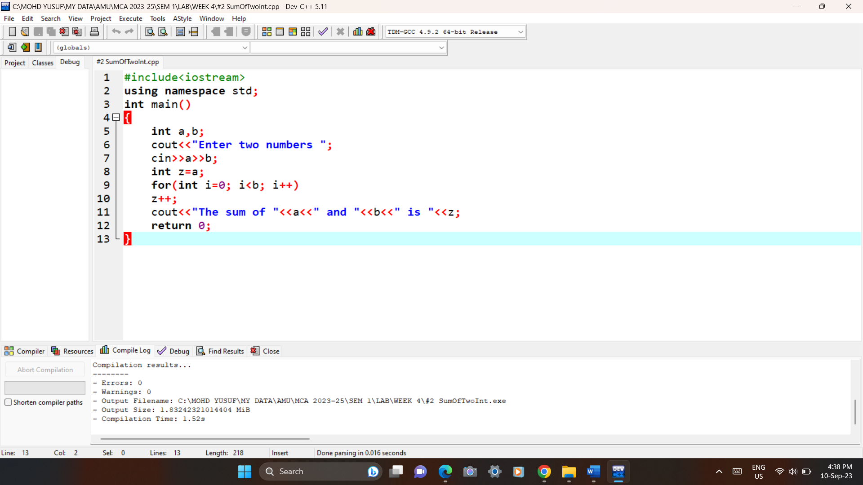Code:

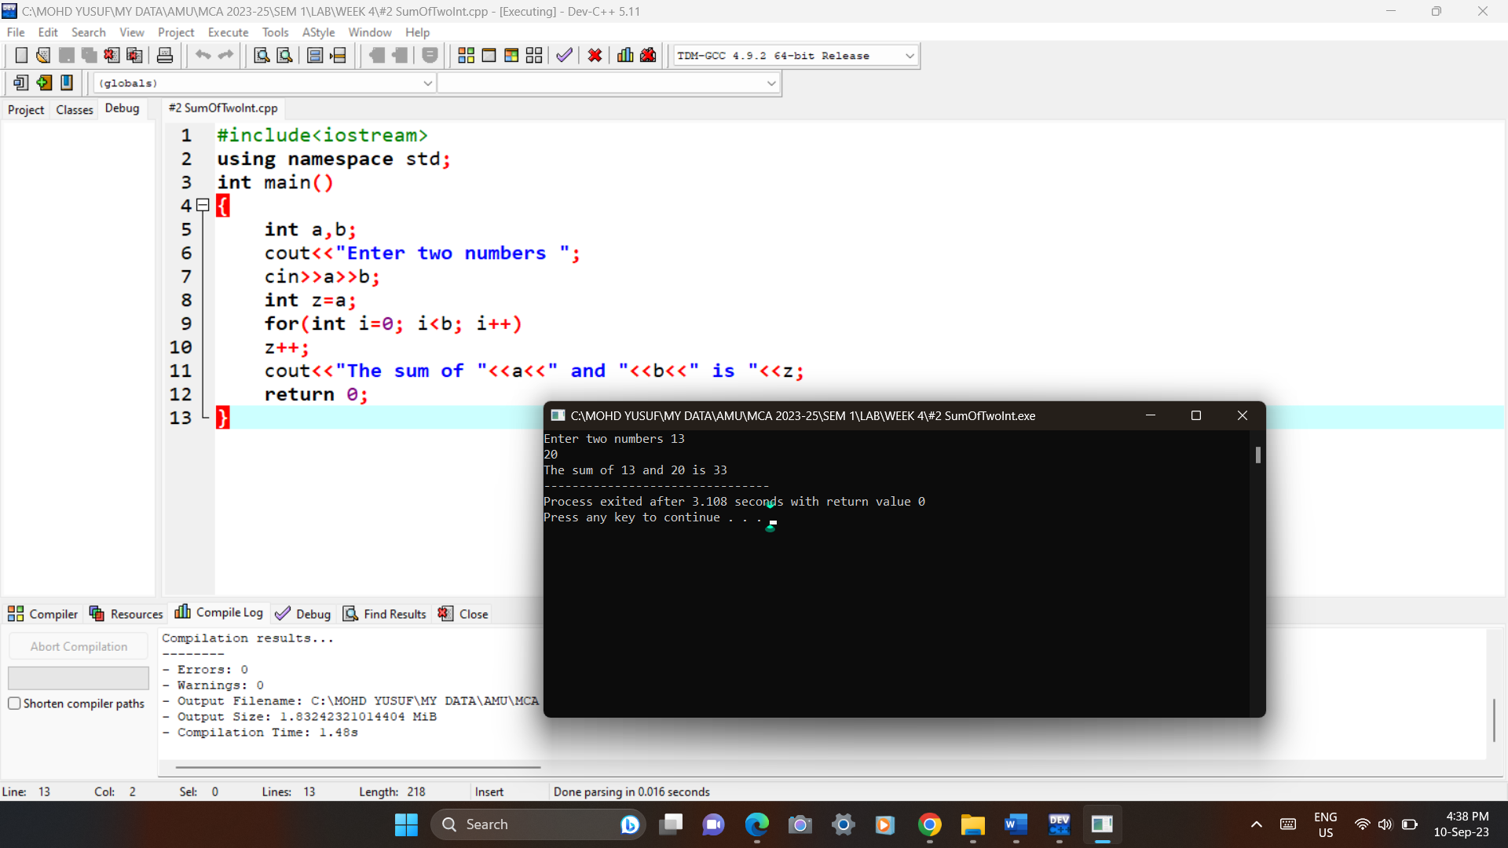Output:

3# Write a C++ program to evaluate the arithmetic expression ((a + b / c * d - e) * (f - g)). Read the values a, b, c, d, e, f, g from the standard input device.

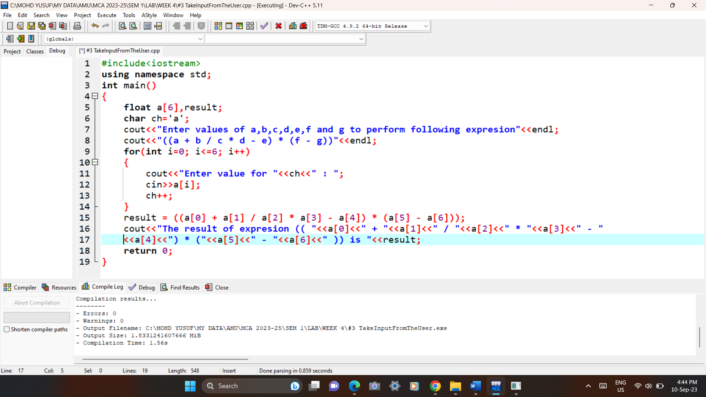Code:

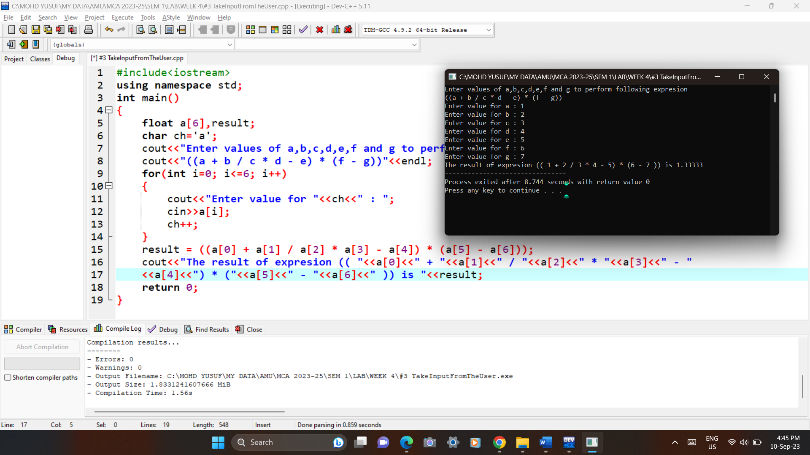Output:

4# A Fibonacci sequence is defined as follows: The first and second terms in the sequence are 0 and 1. Subsequent terms are found by adding the preceding two terms in the sequence. Write a C++ program to generate the first n terms of the sequence.

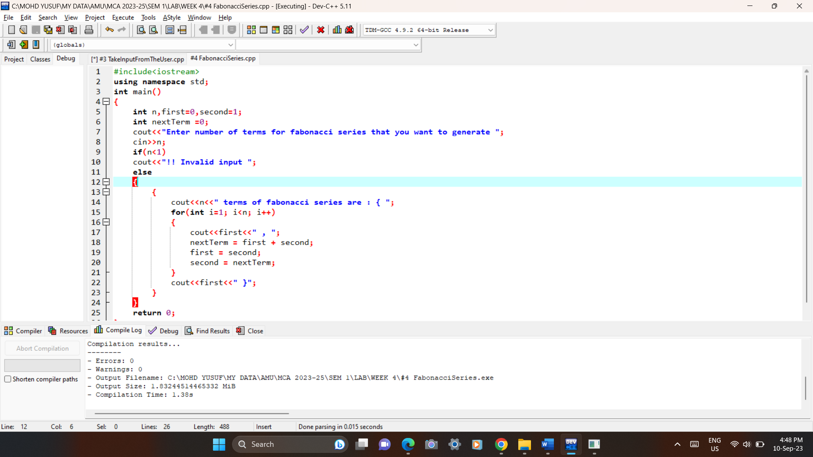Code:

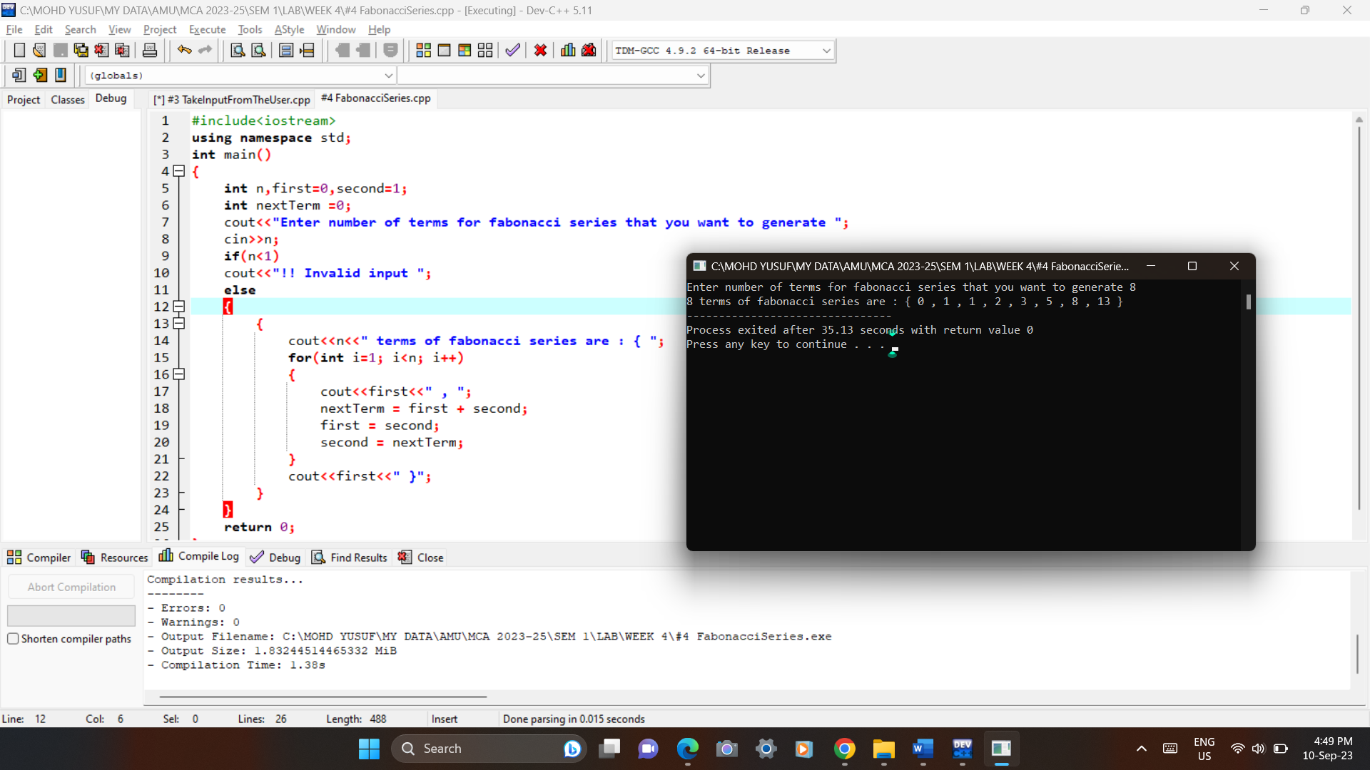Output:

5# Write a C++ program to generate all the prime numbers between 1 and n, where n is a value supplied by the user.

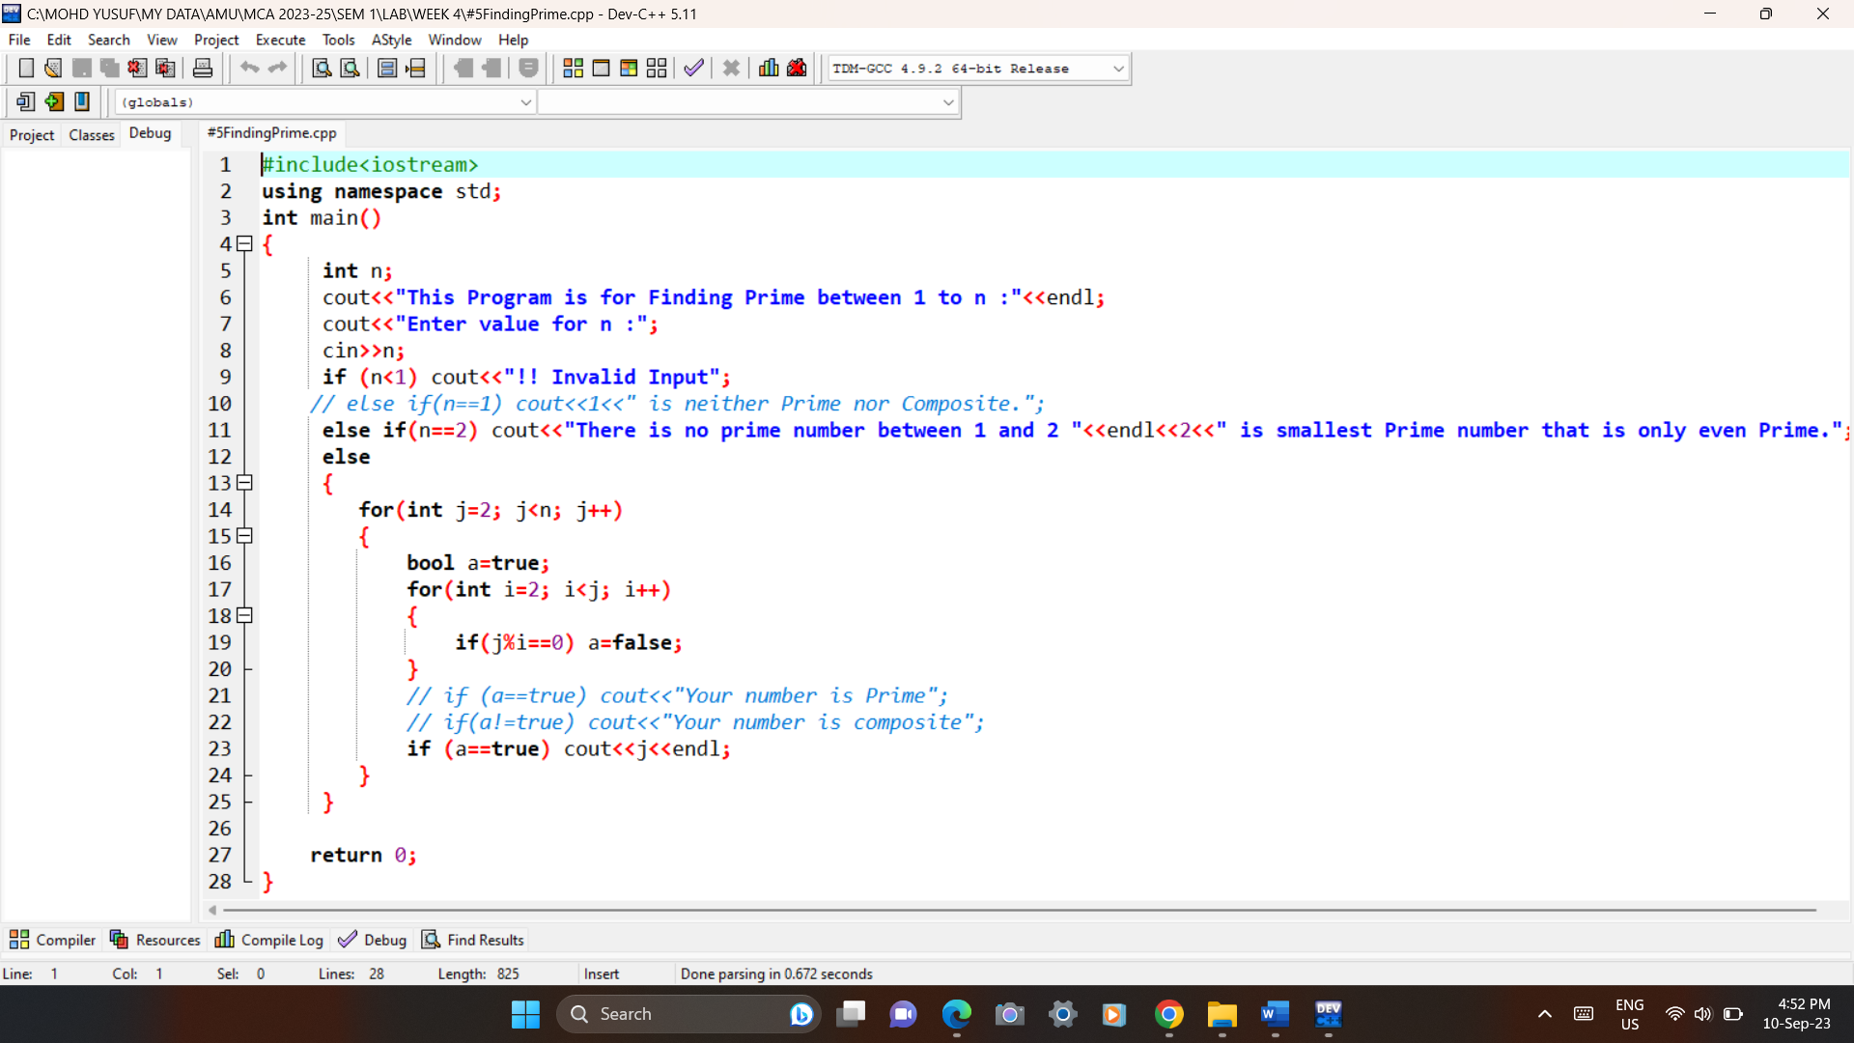Code:

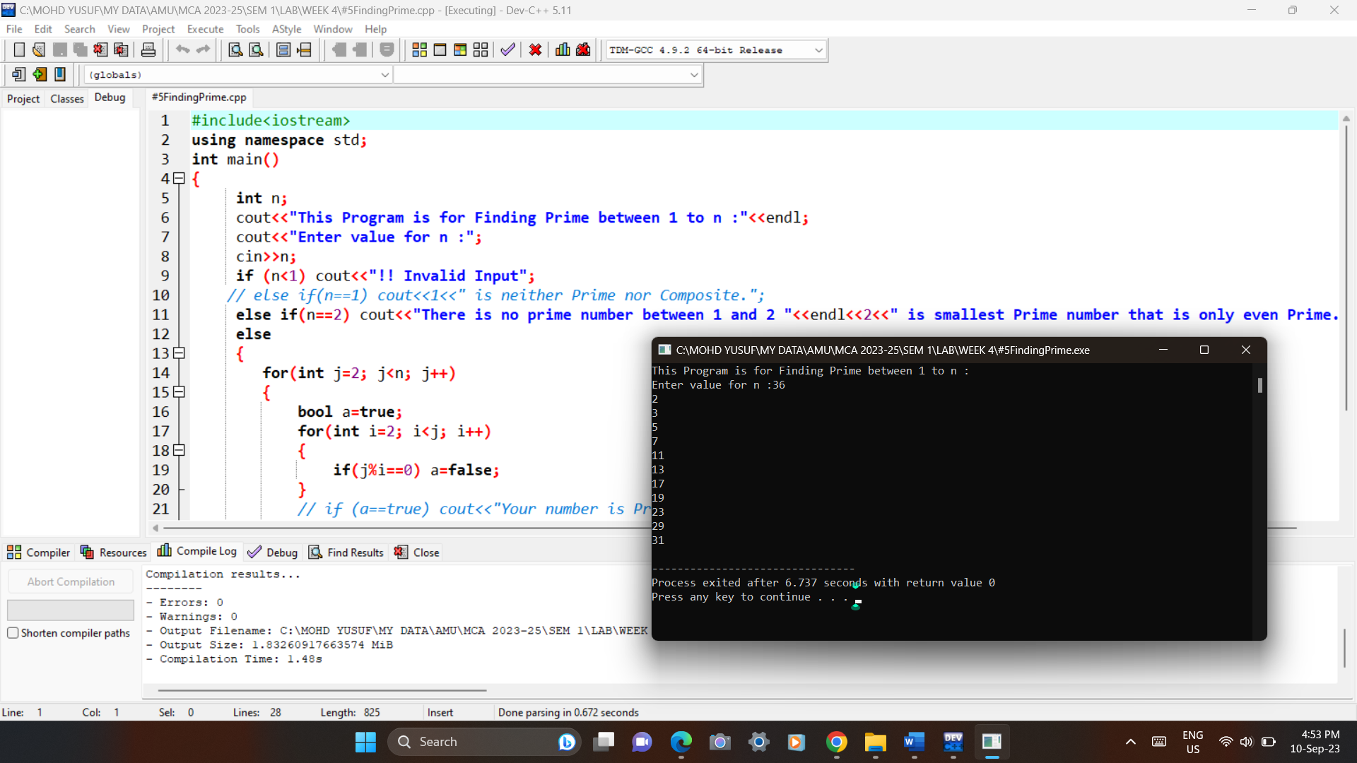Output:

6# A character is entered through keyboard. Write a C++ program to determine whether the character entered is a capital letter, a small case letter, a digit or a special symbol using if-else and switch case. The following table shows the range of ASCII values for various characters. Characters ASCII values A – Z: 65 – 90, a – z: 97 – 122, 0 – 9: 48 – 57 Special symbols 0 – 47, 58 – 64, 91 – 96, 123 – 127.

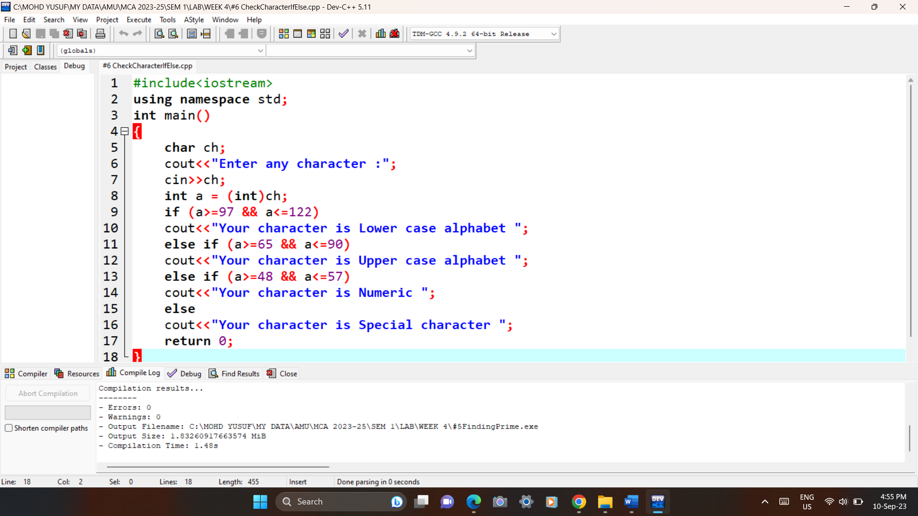Code: using if else

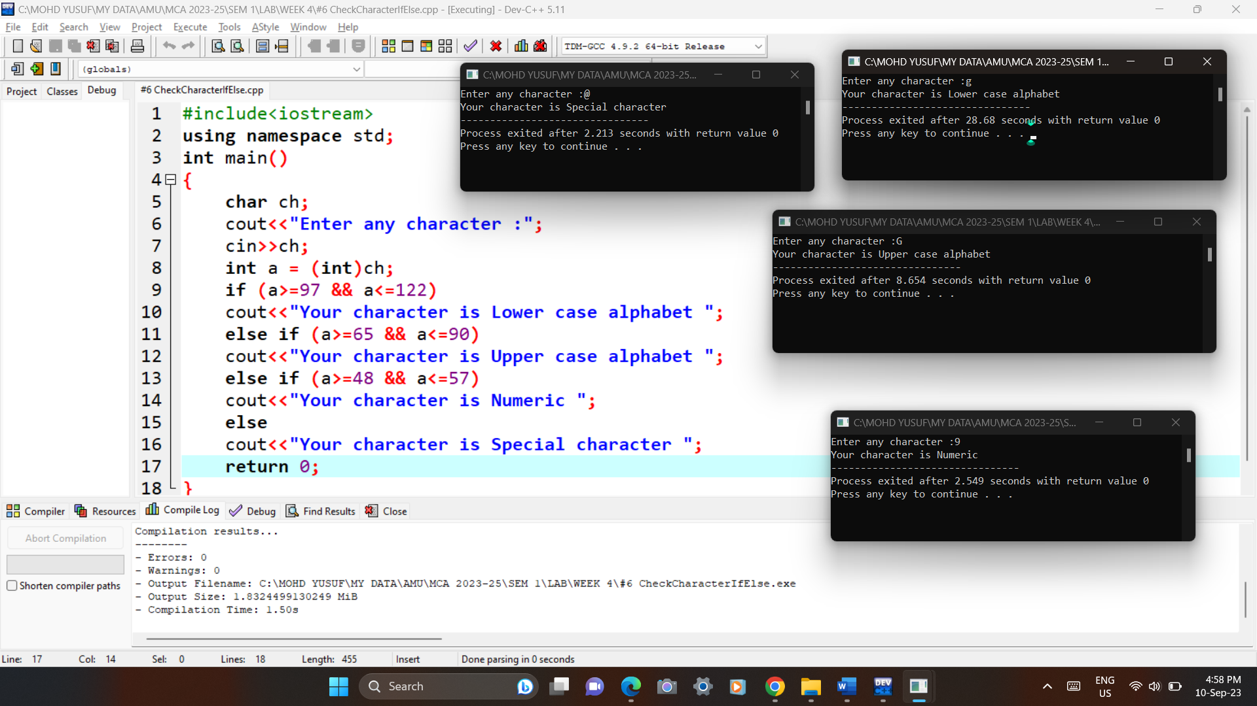Output:

6# A character is entered through keyboard. Write a C++ program to determine whether the character entered is a capital letter, a small case letter, a digit or a special symbol using if-else and switch case. The following table shows the range of ASCII values for various characters. Characters ASCII values A – Z: 65 – 90, a – z: 97 – 122, 0 – 9: 48 – 57 Special symbols 0 – 47, 58 – 64, 91 – 96, 123 – 127.

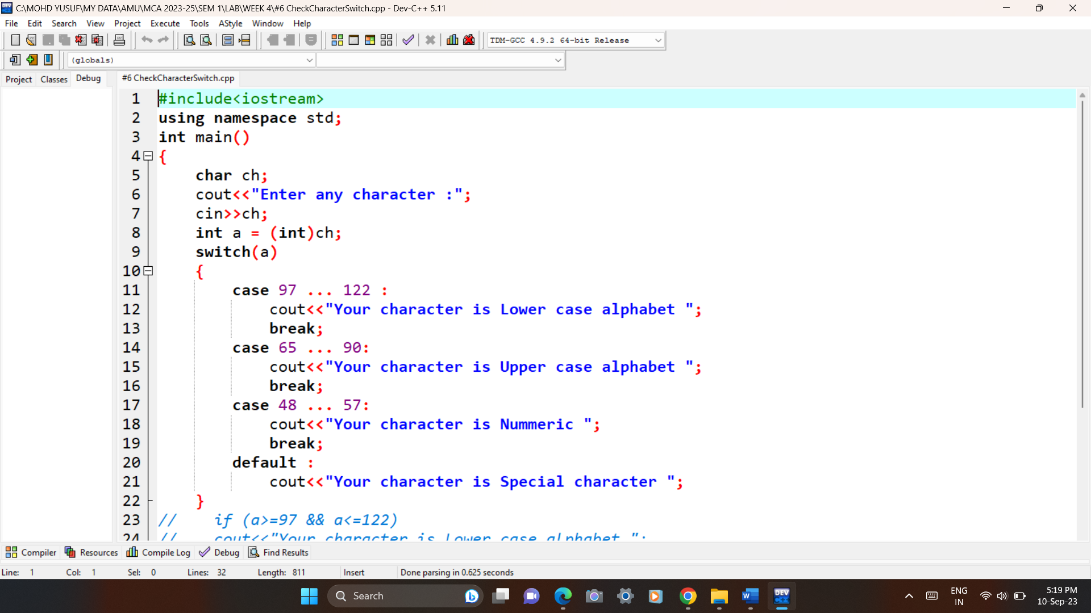Code: using switch

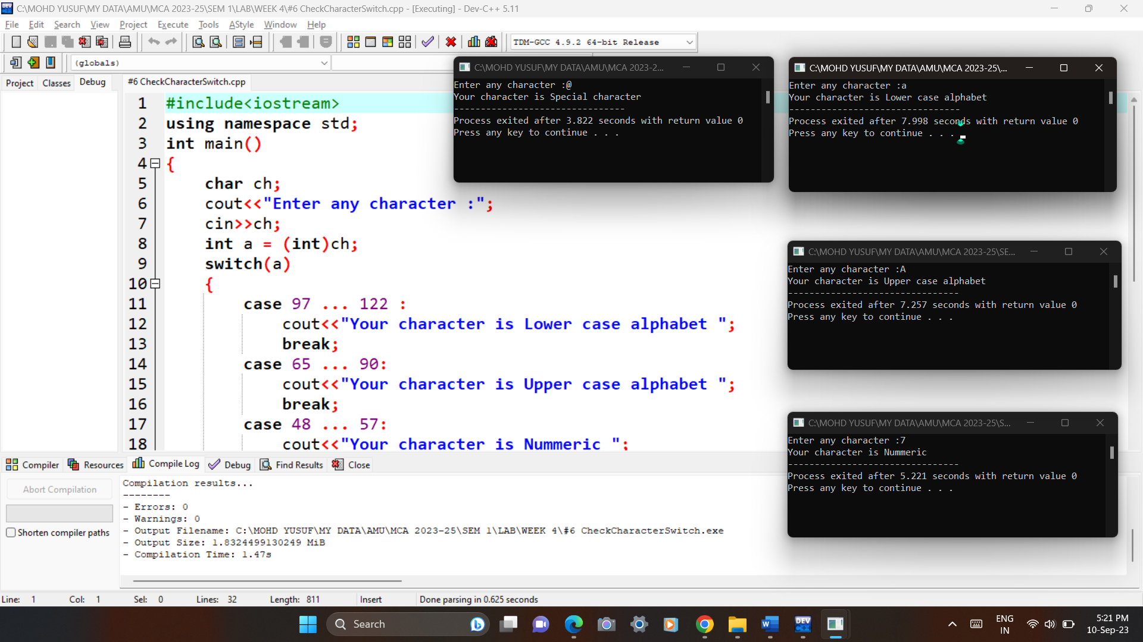Output:

7# Write a C++ program to find the roots of a quadratic equation.

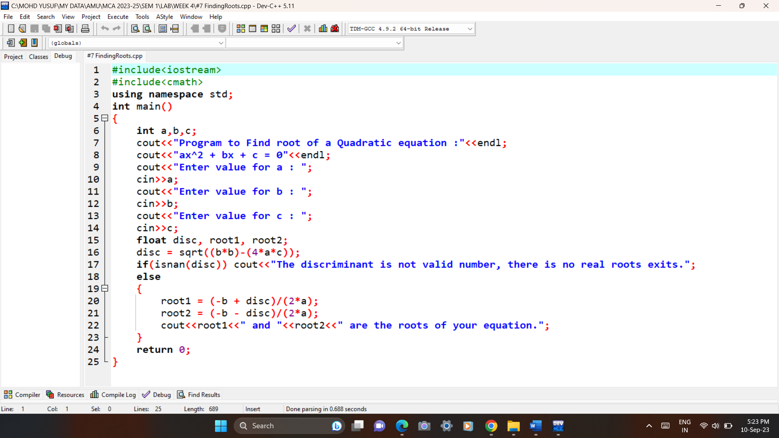Code:

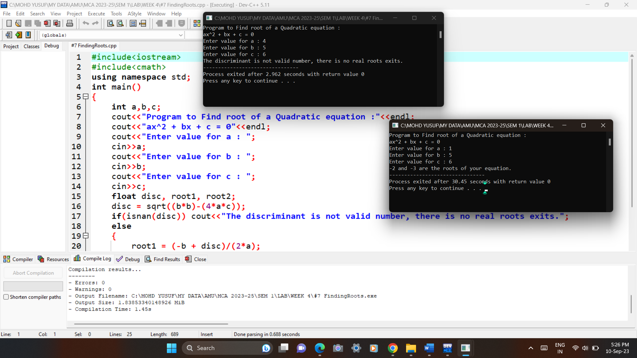Output:

8# Write a C++ program to check whether a given 3-digit number is Armstrongnumber or not.

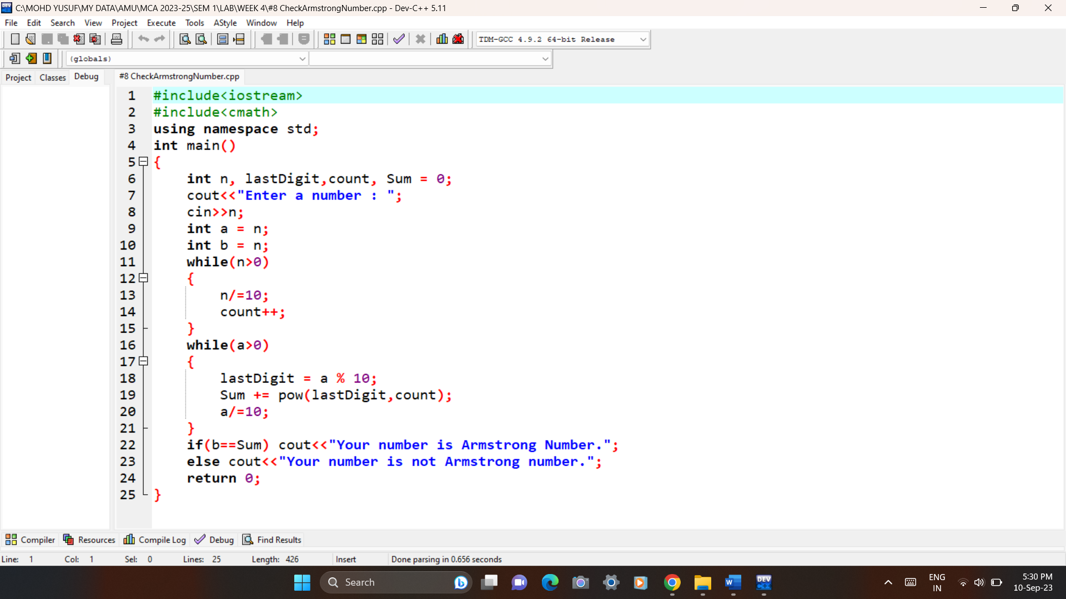Code:

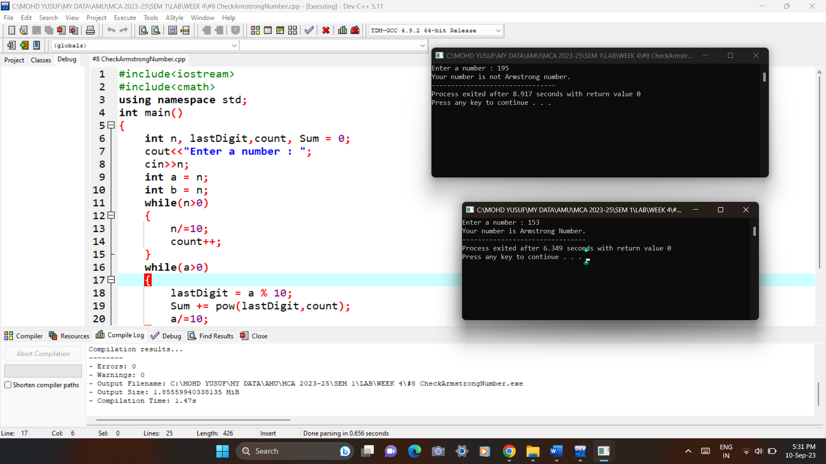Output:

**WEEK 5**

1# Write a C++ program to enter elements in the array and display the array elements.

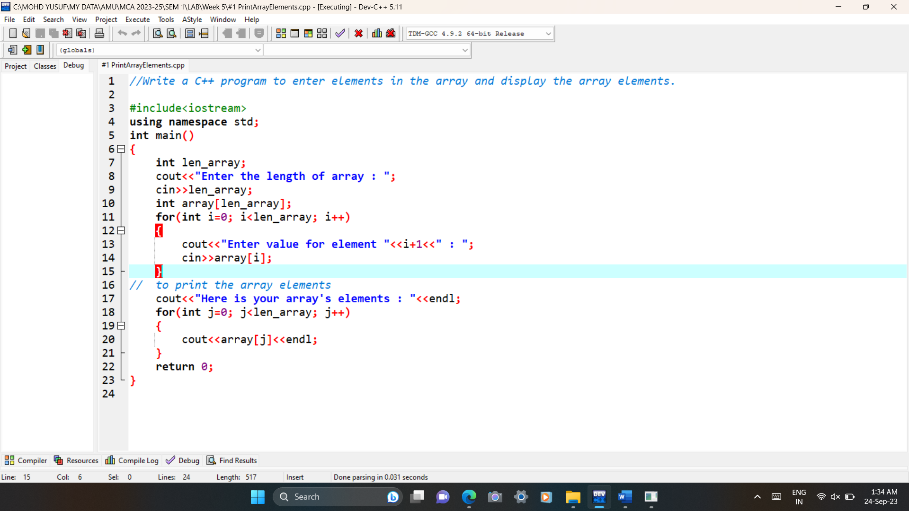Code:

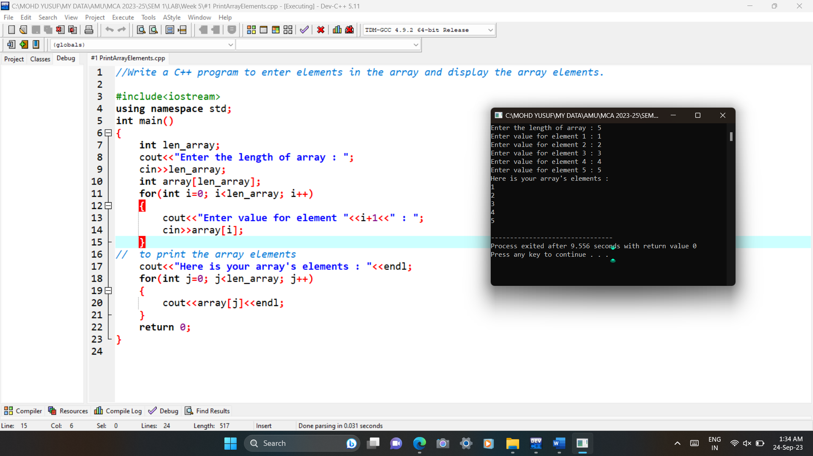Output:

2# Write a C++ program to find the sum of the all-array element.

Code: 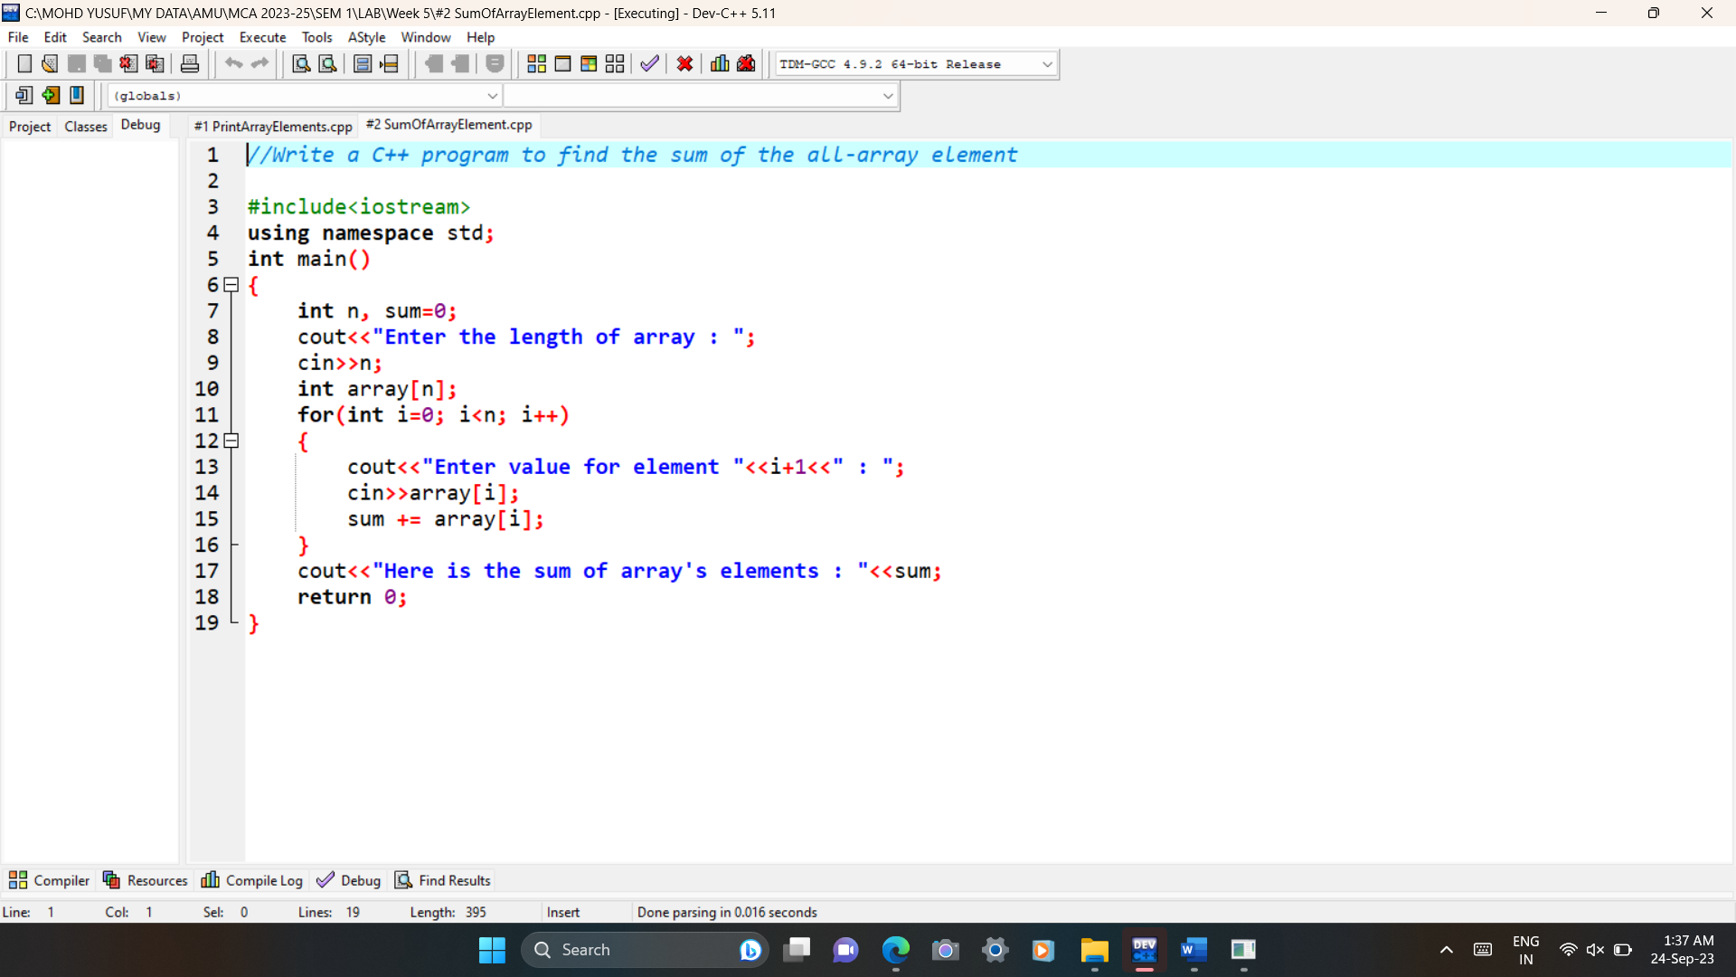

Output:

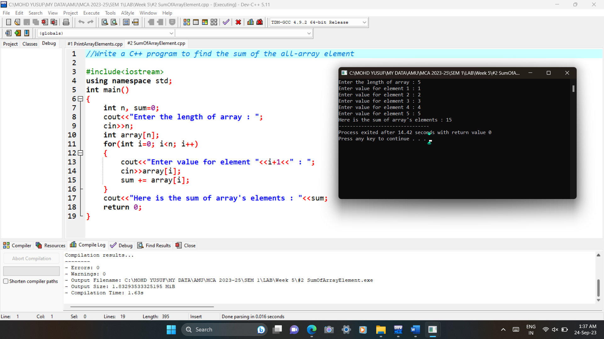

3# Write a C++ program to find the length of the array.

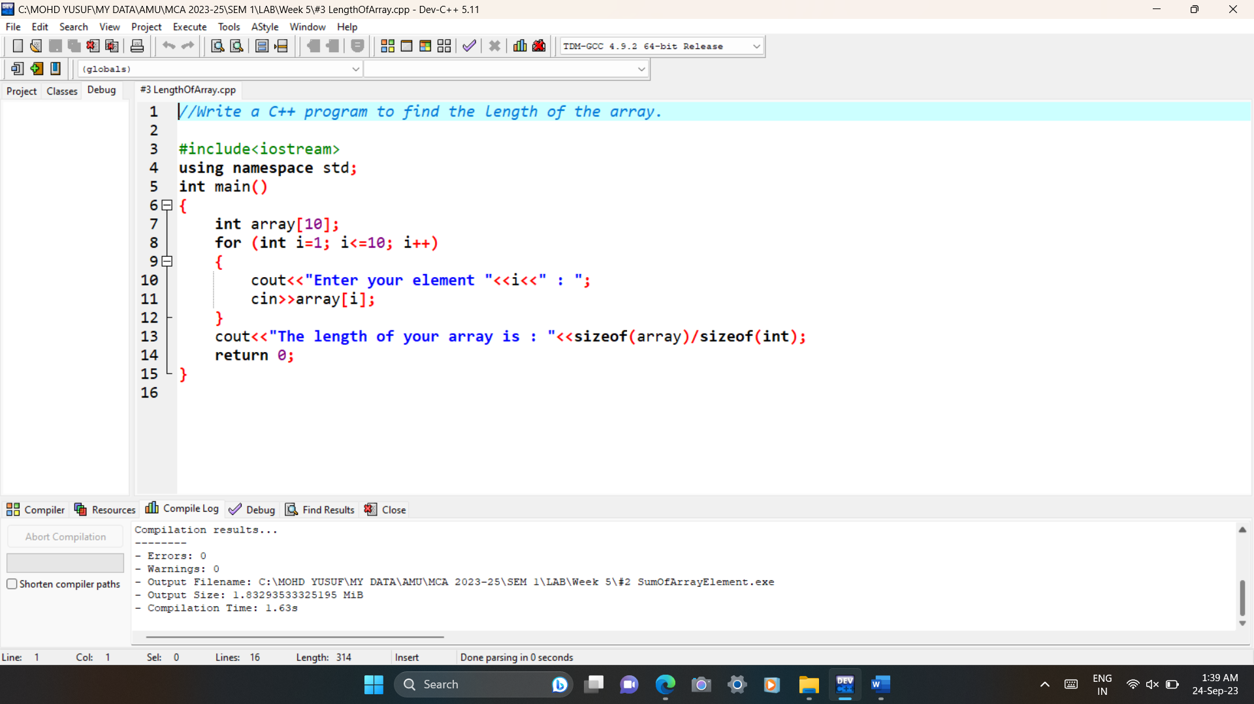Code:

Output:

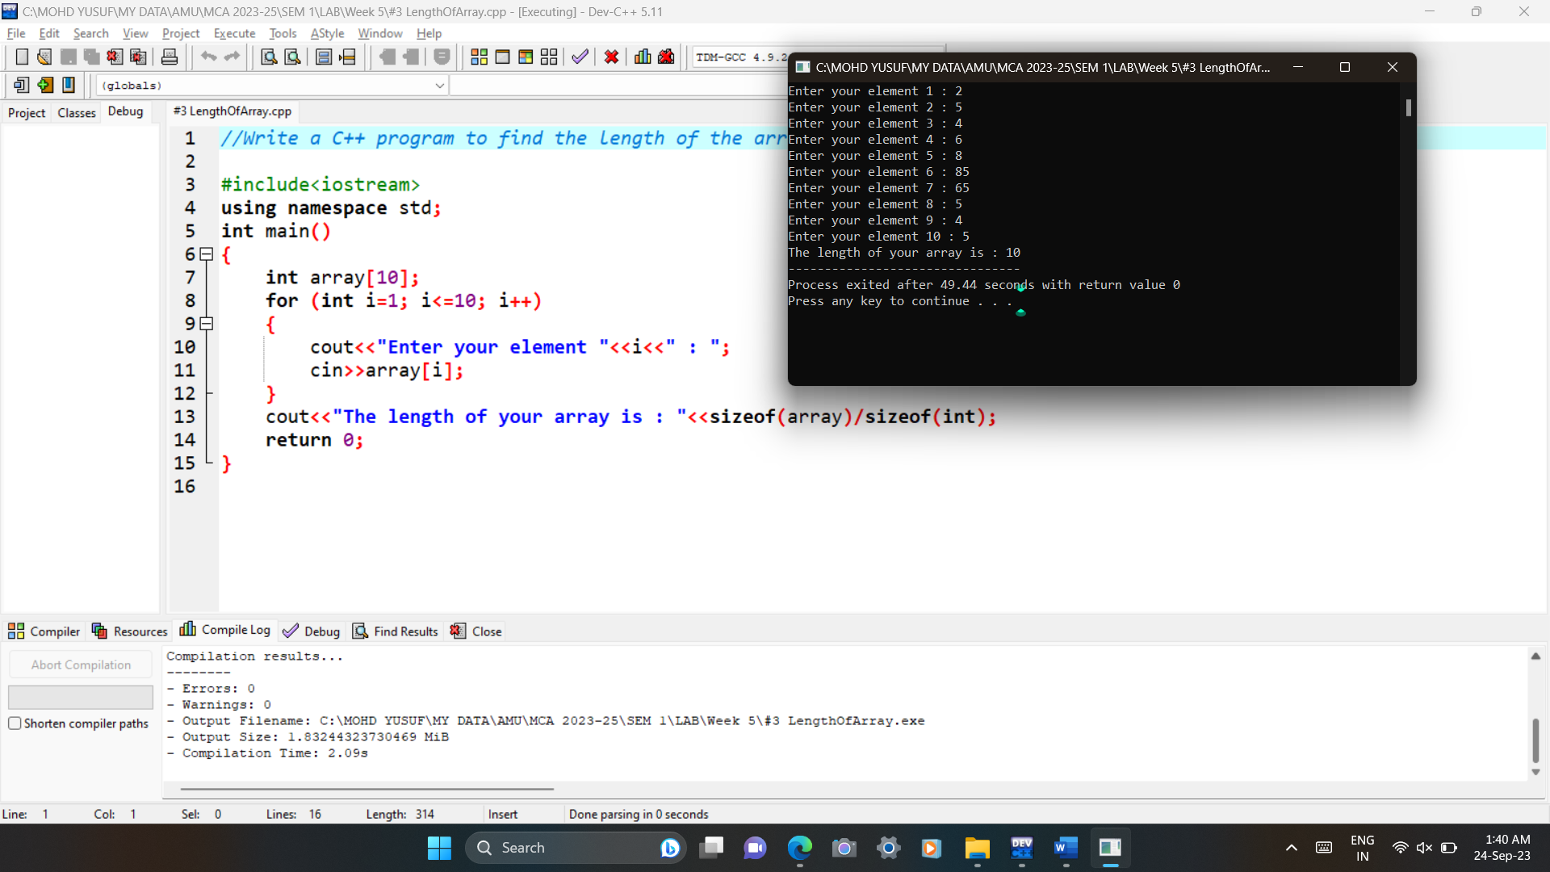

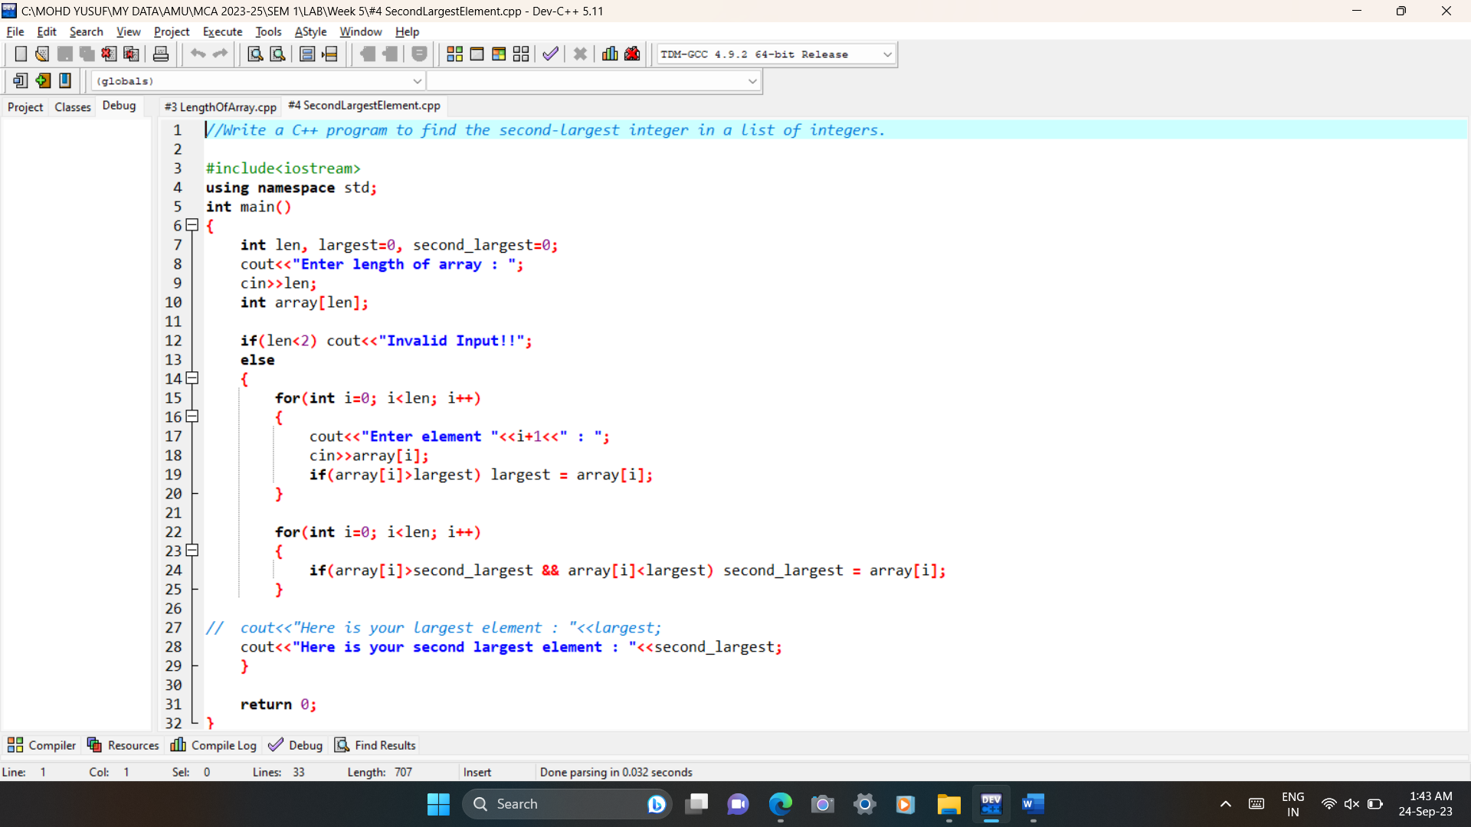4# Write a C++ program to find the second-largest integer in a list of integers.

Code:

Output:

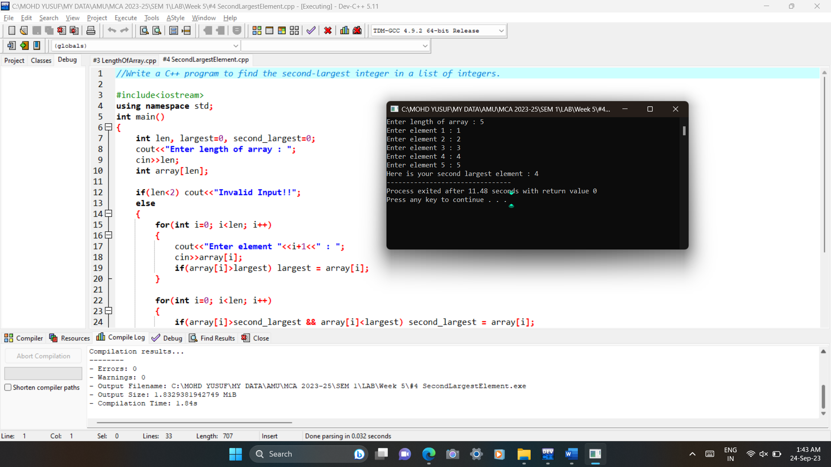

5# Write a C++ Program to reverse the position of the array element (Hint: First eminent to the last element.)

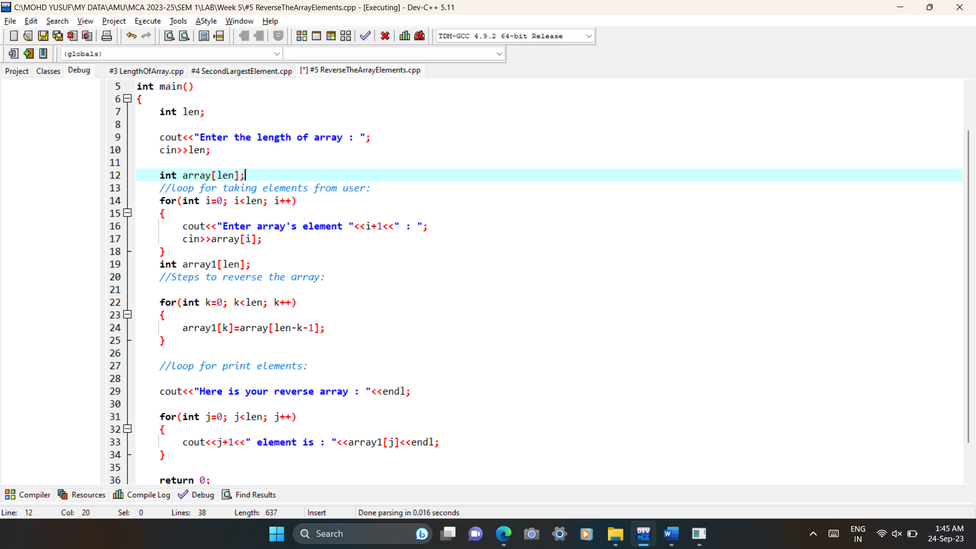Code:

Output:

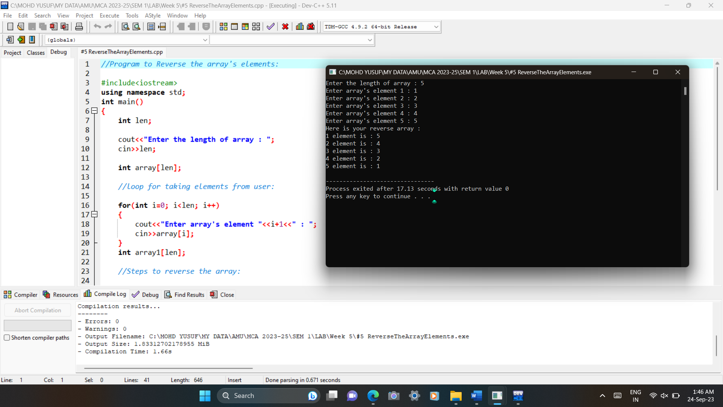

6.1# Write a C++ program to perform the following:

a. Addition of two matrices

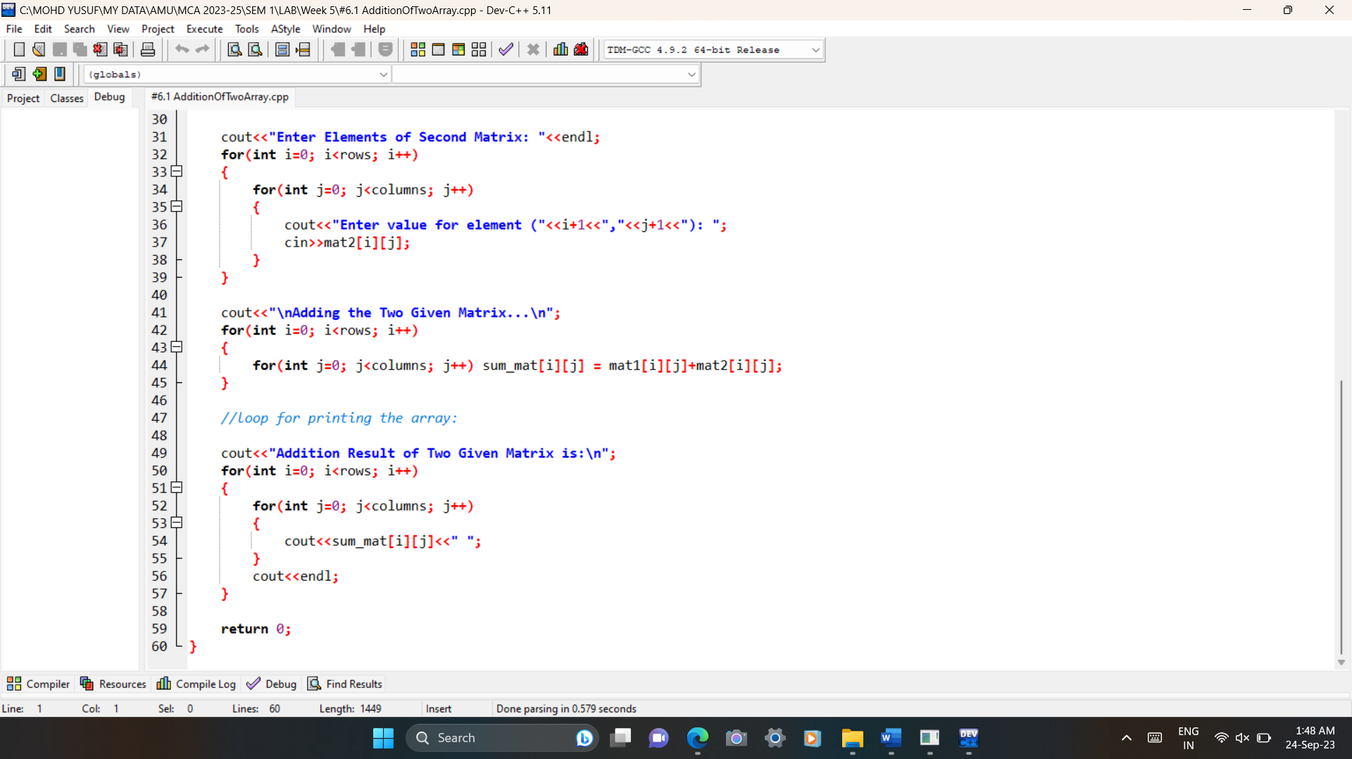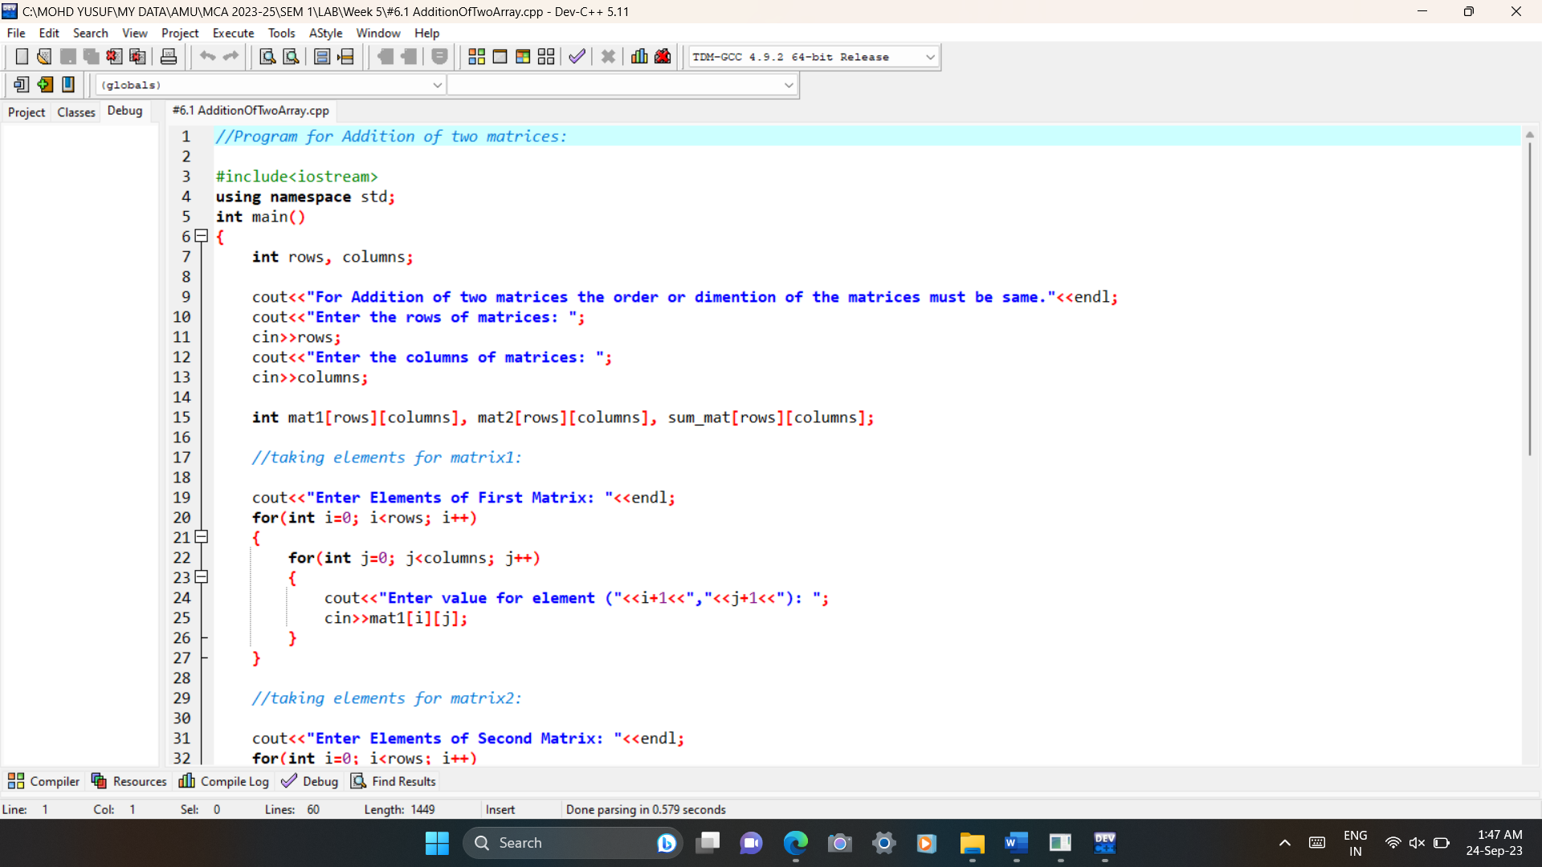code:

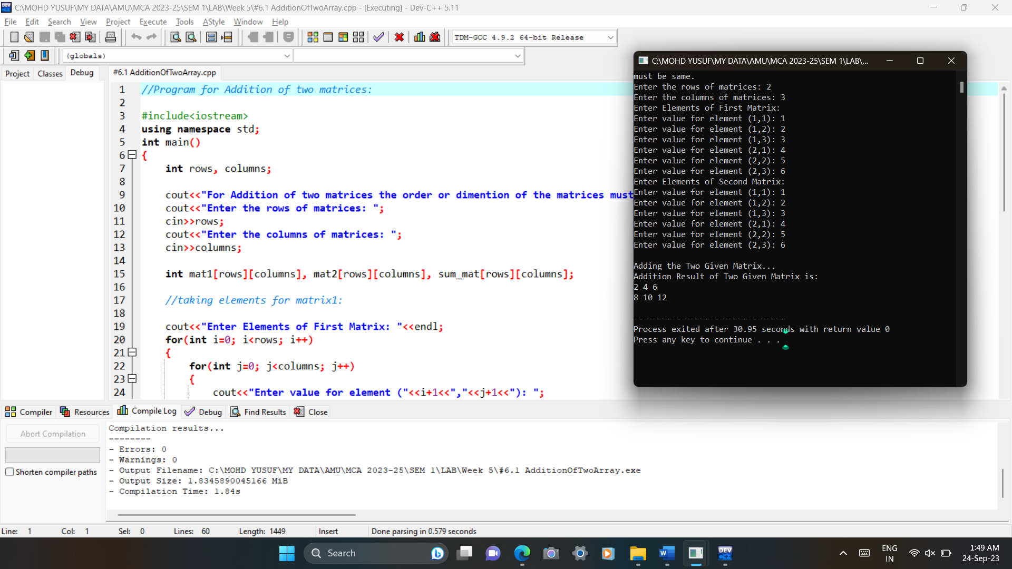Output:

6.2# Write a C++ program to perform the following:

b. Multiplication of two matrices

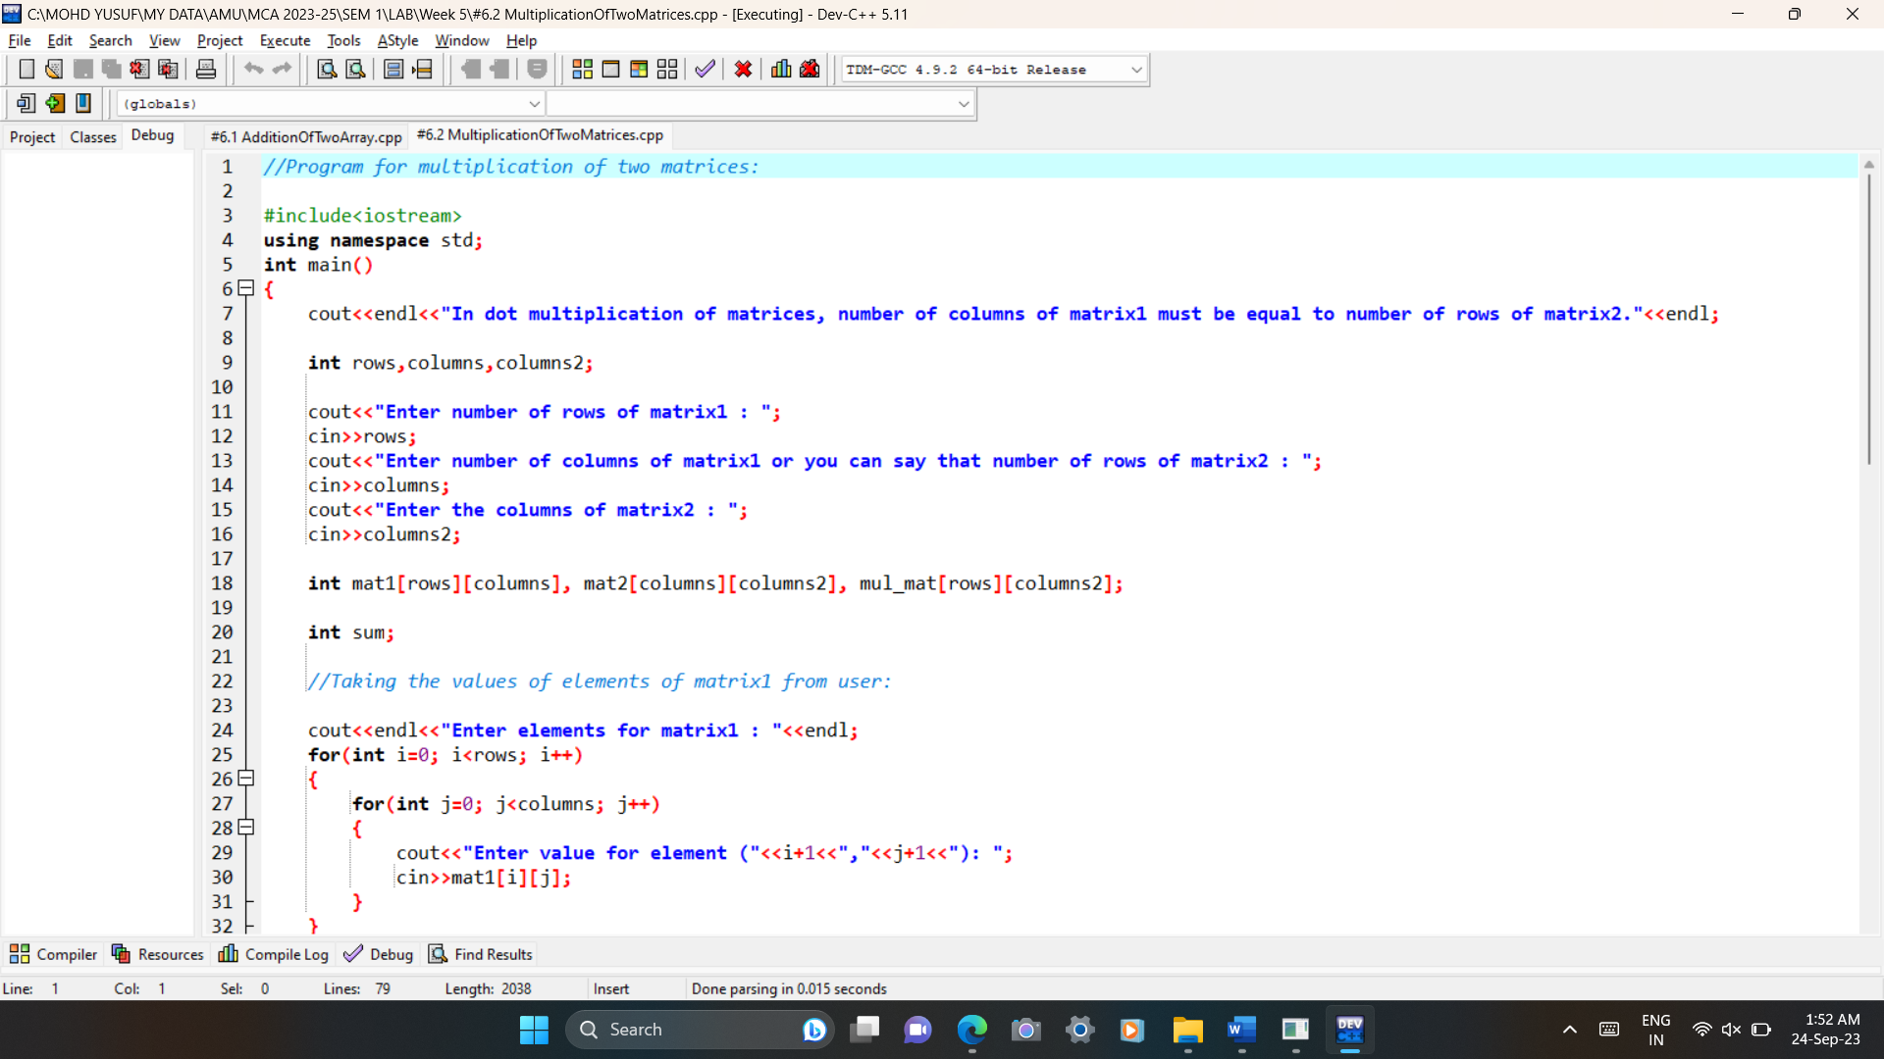code:

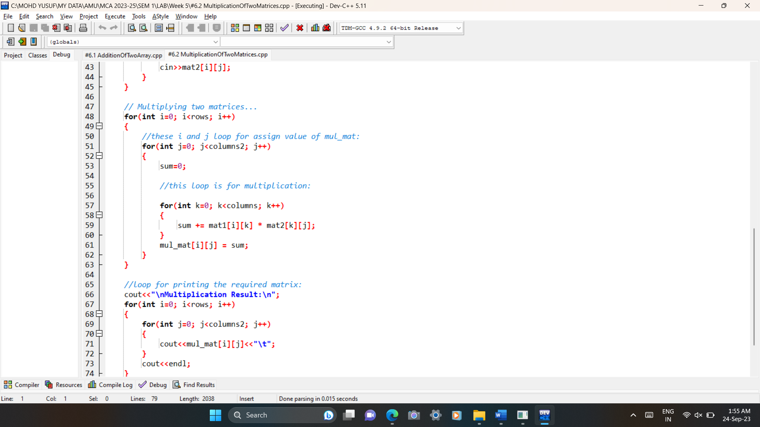

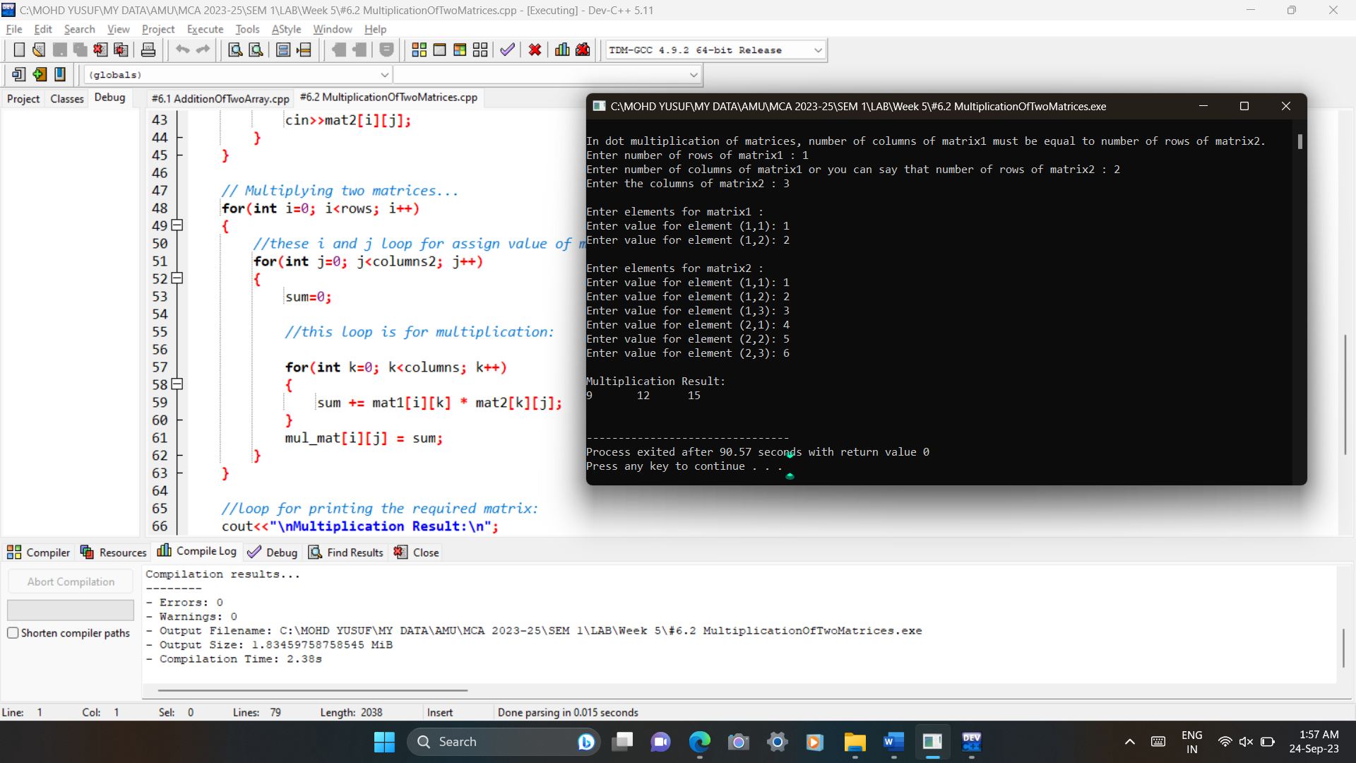Output:

7# Write a C++ program to count and display positive, negative, odd and even numbers in an array.

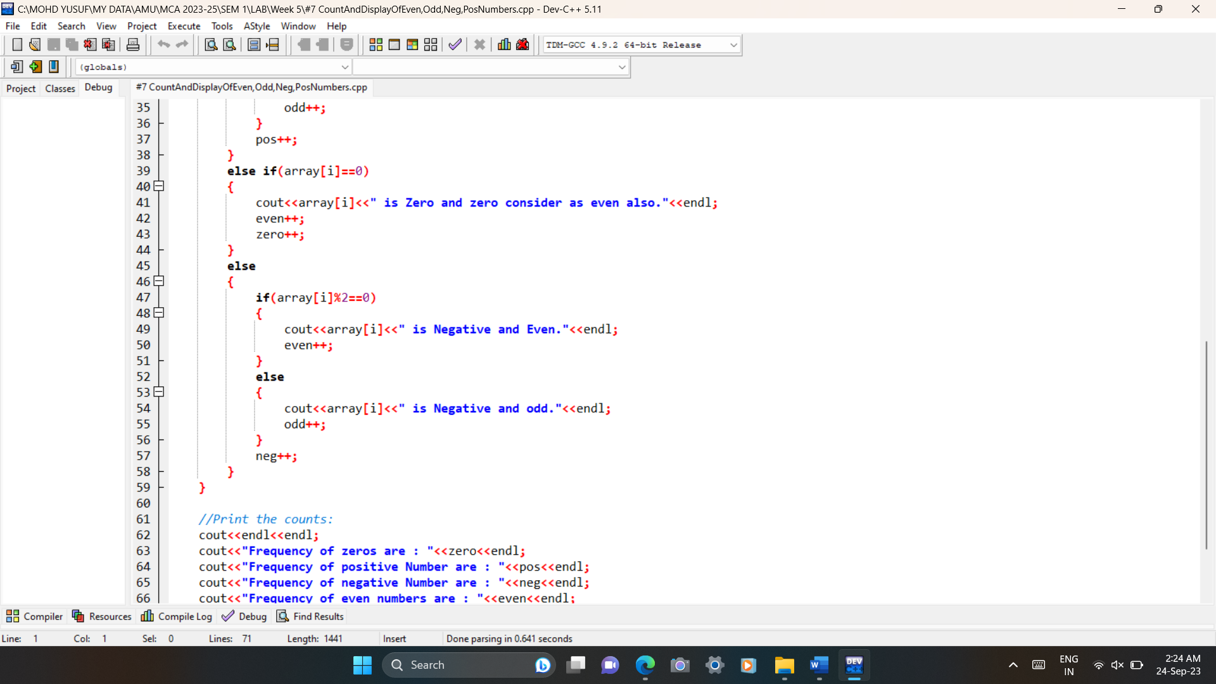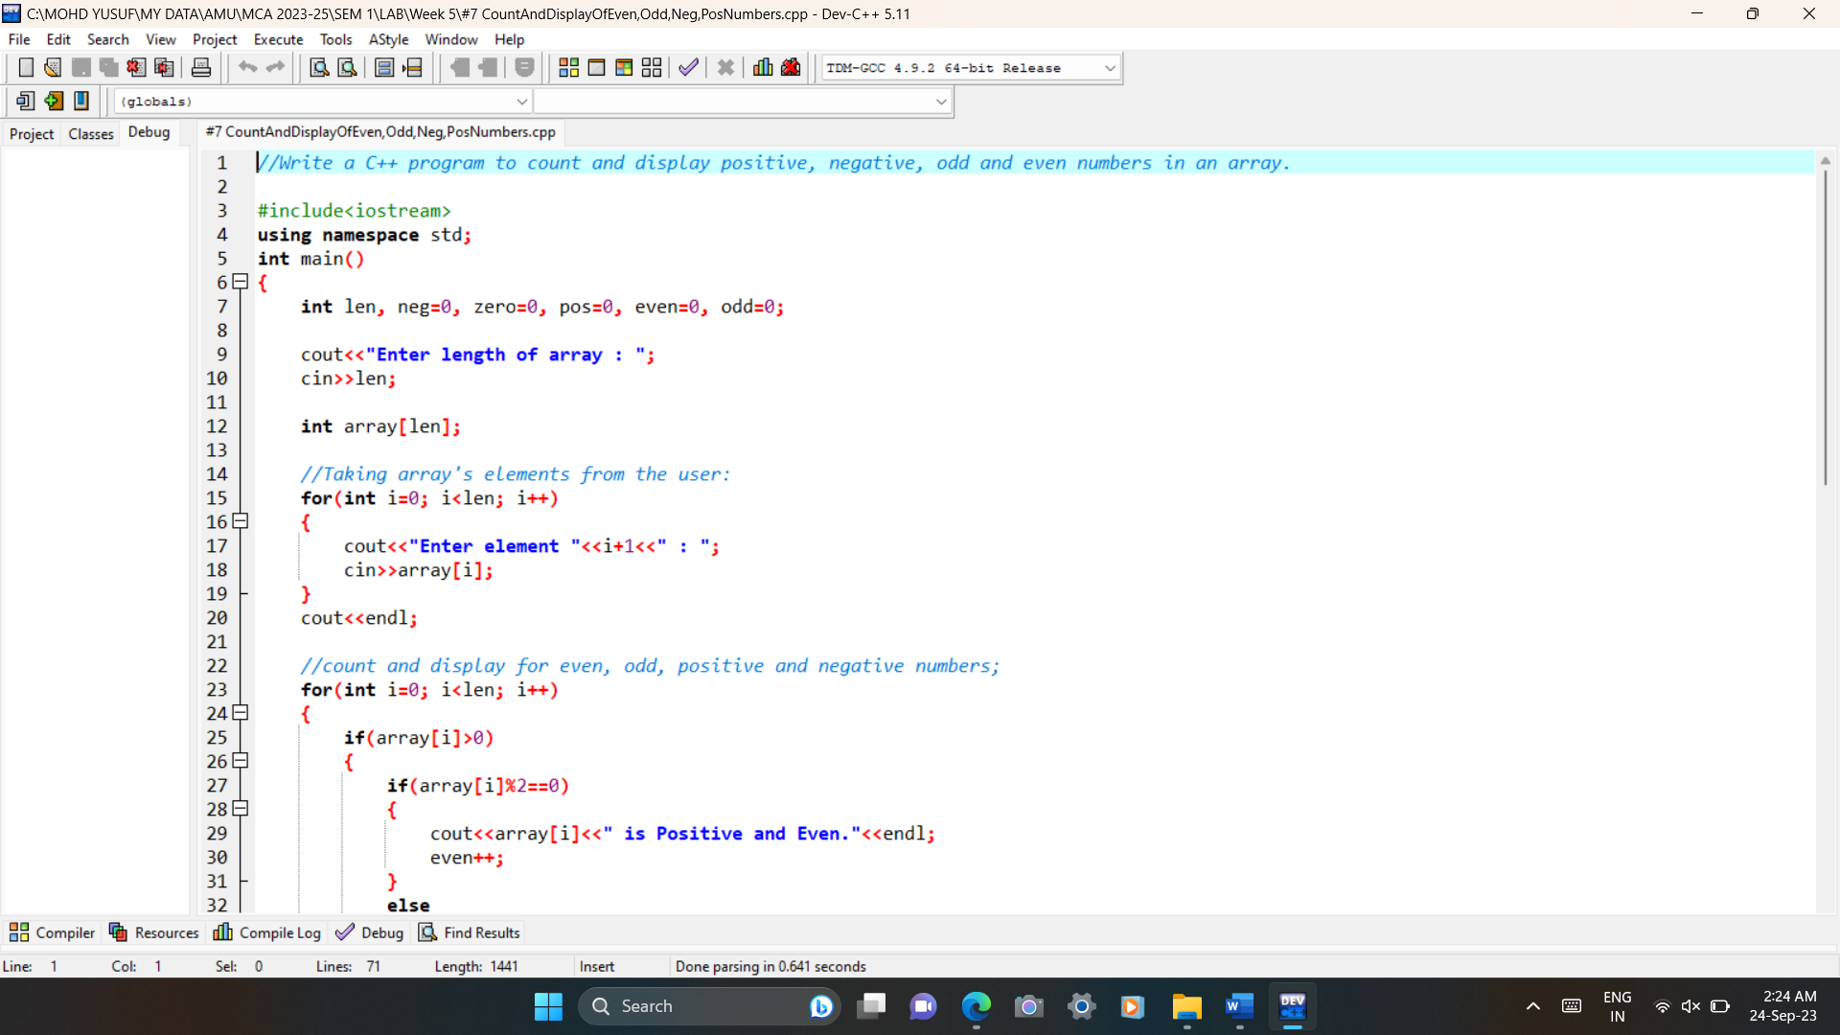Code:

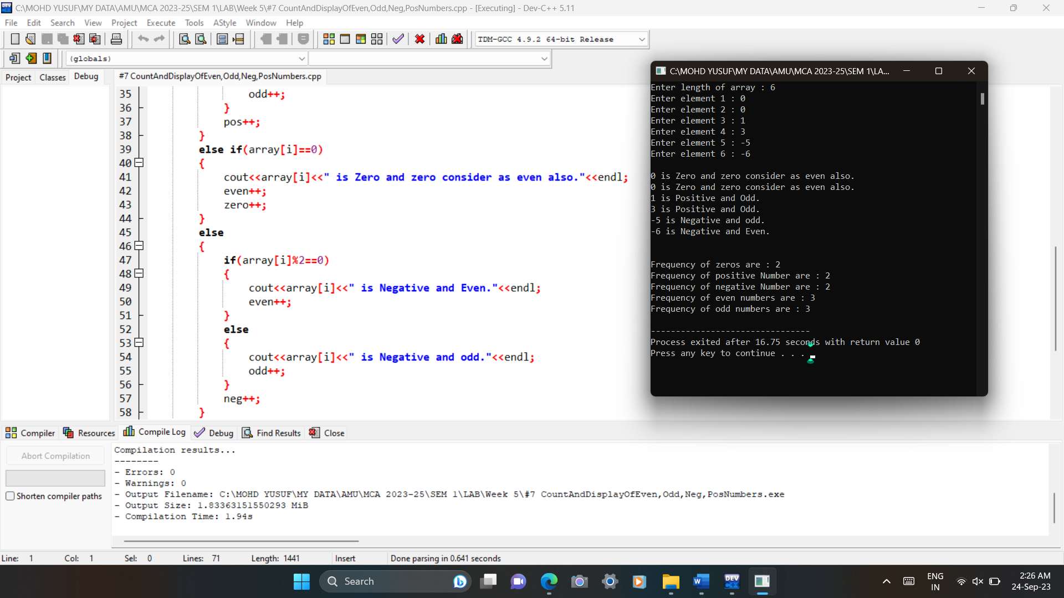Output:

8# Write a C++ program to merge two sorted arrays into another array in sorted order.

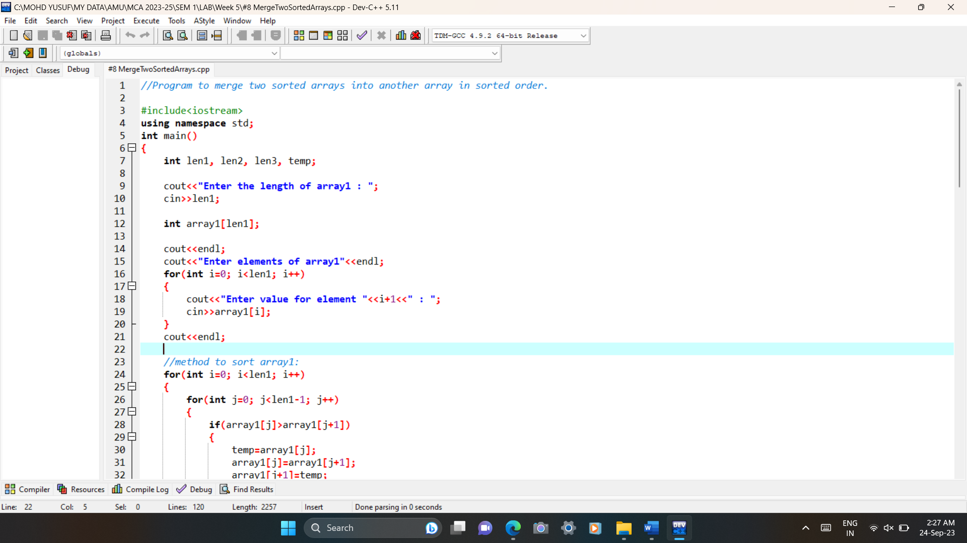Code:

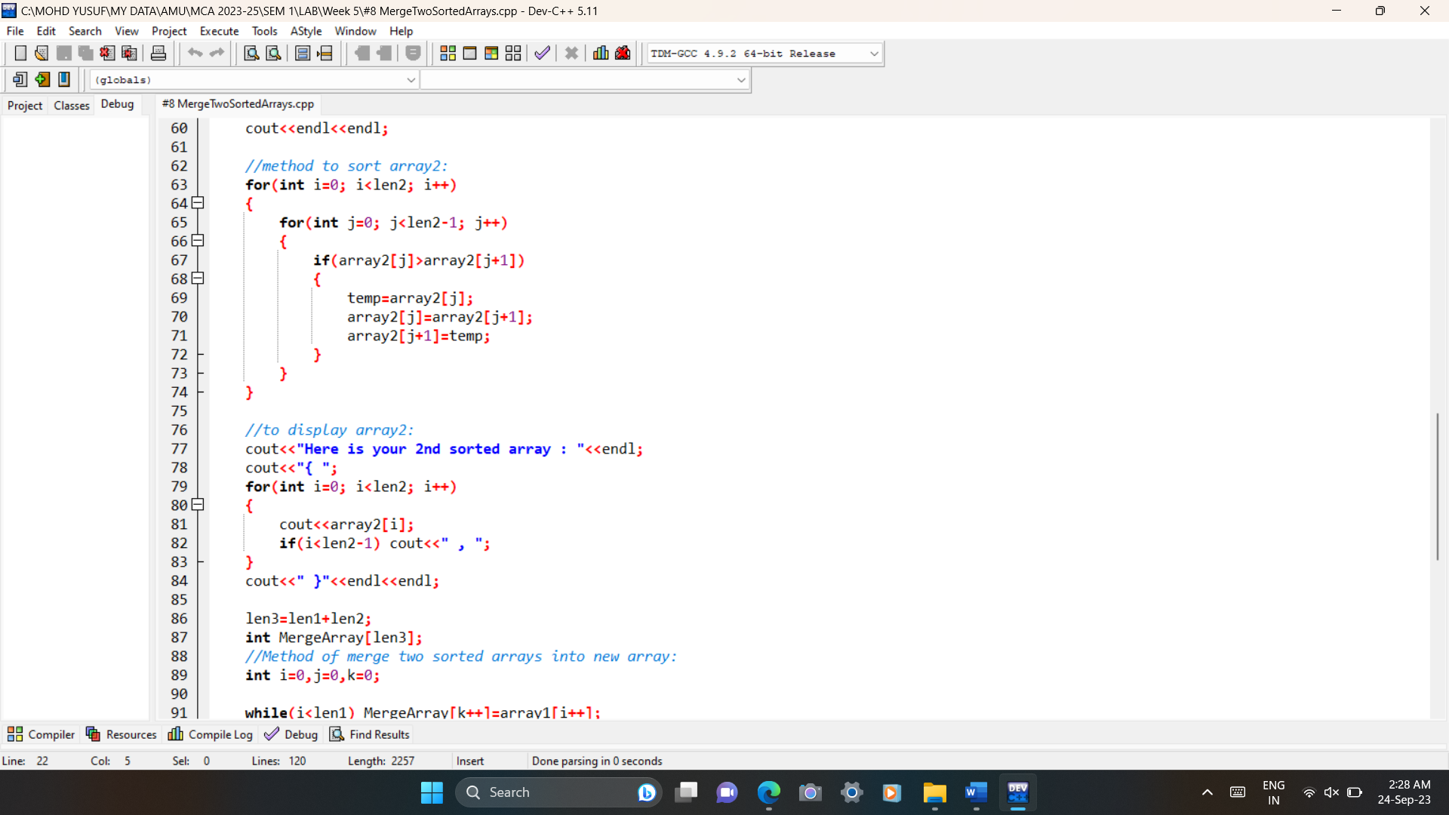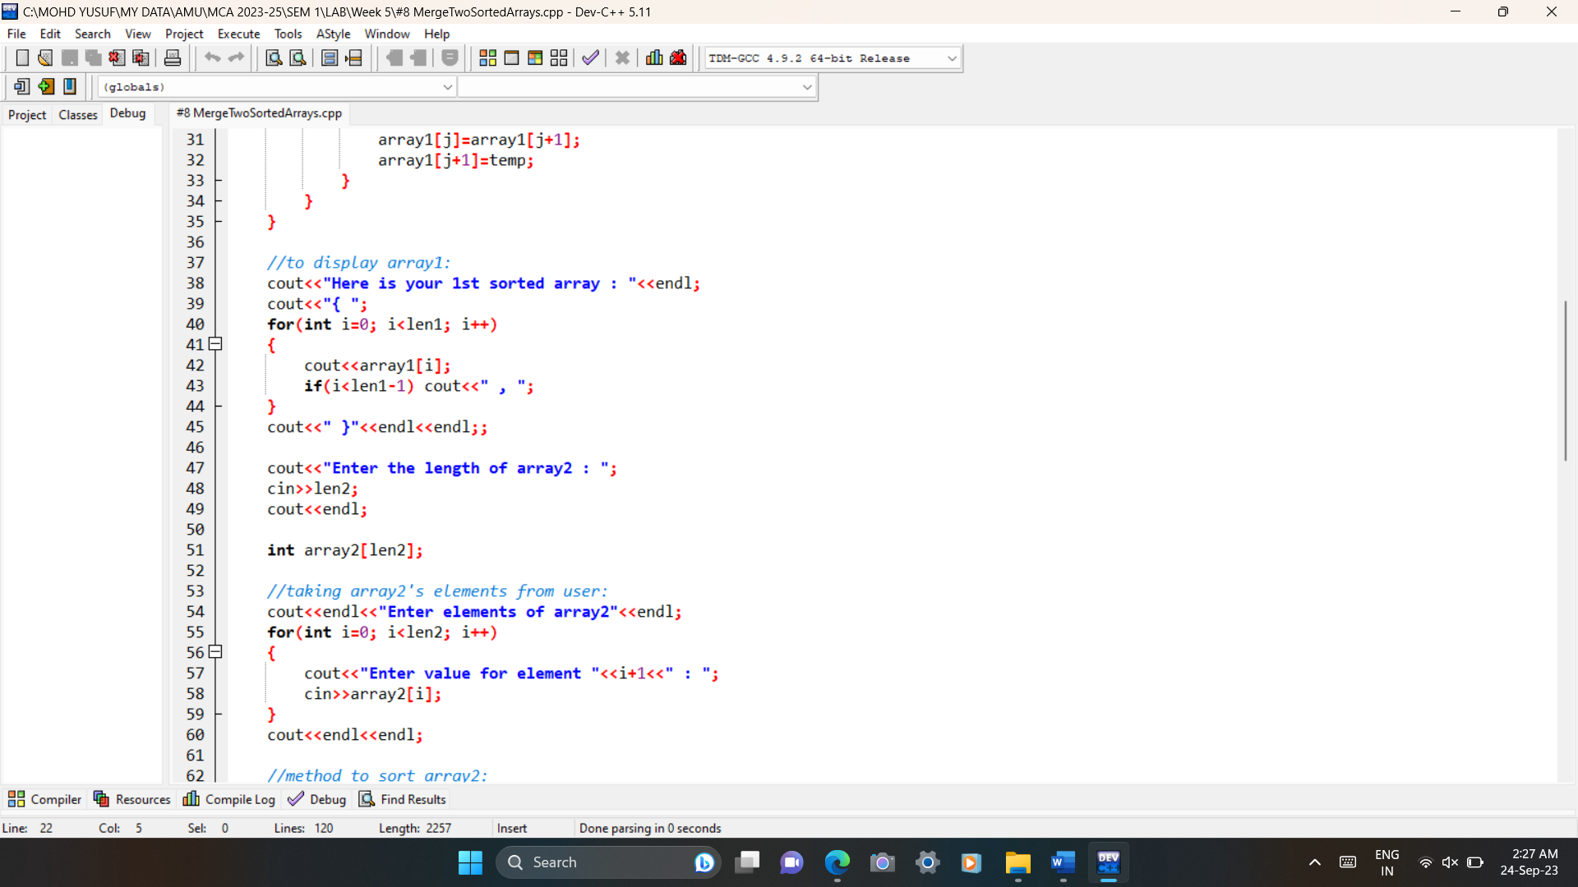

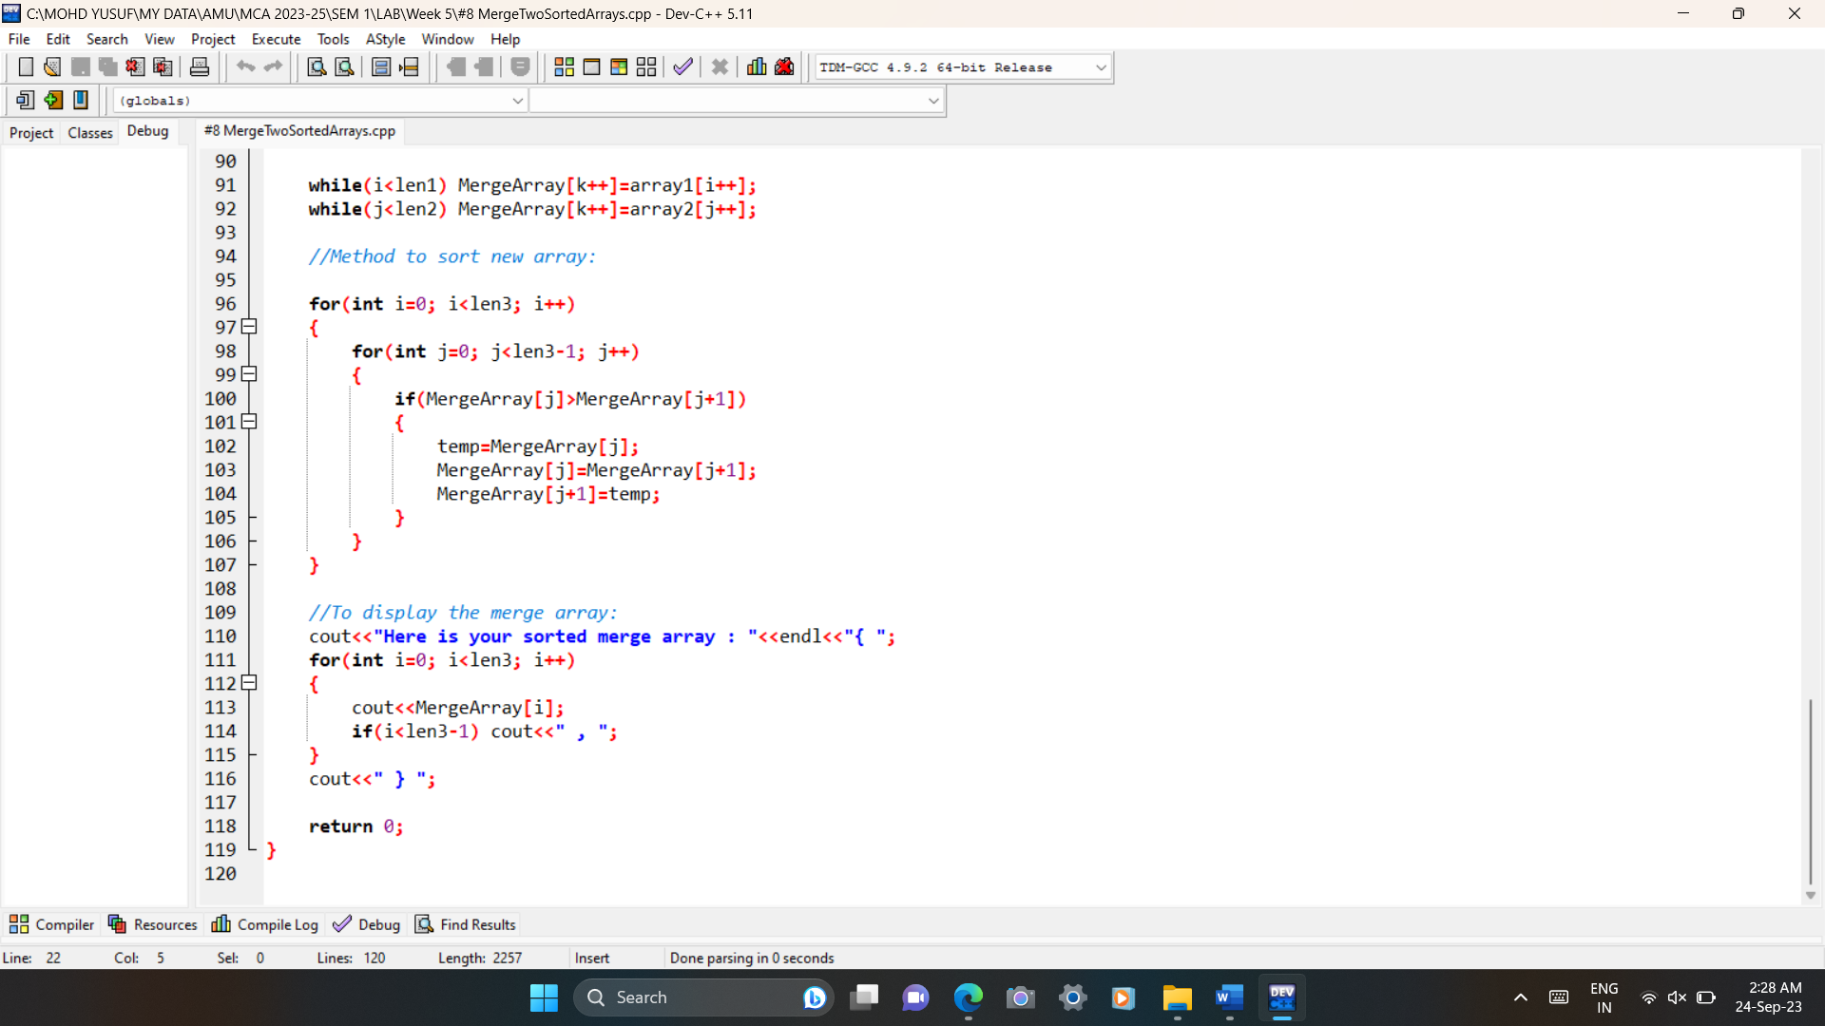

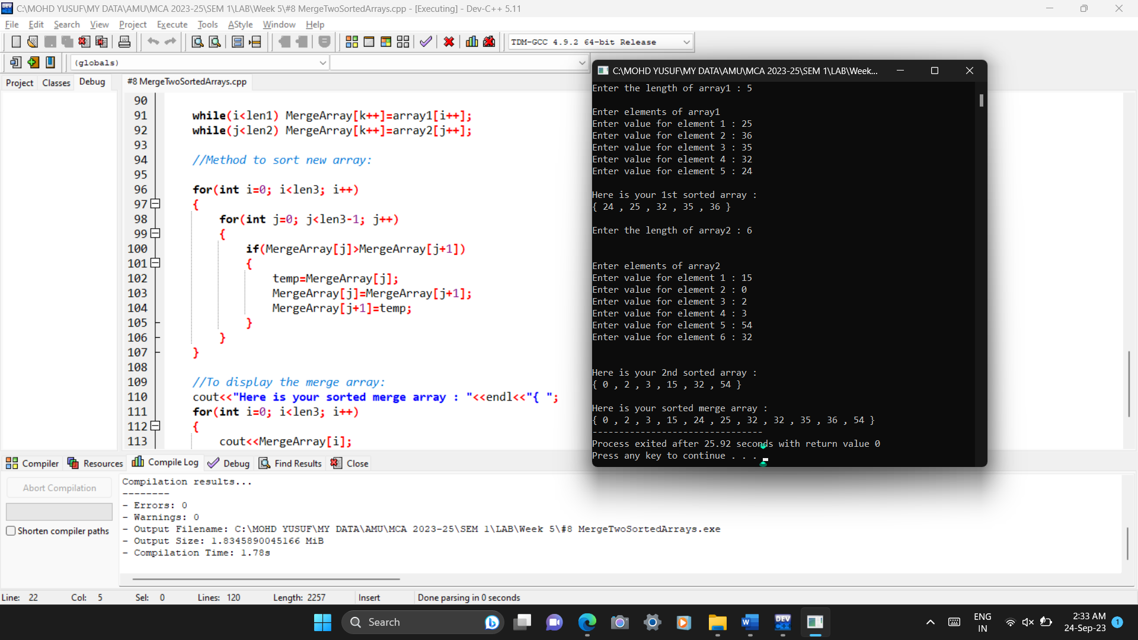Output:

9# Write a C++ program to find the frequency of a particular number in a list of integers.

|  |
| --- |
|  |
|  |  |

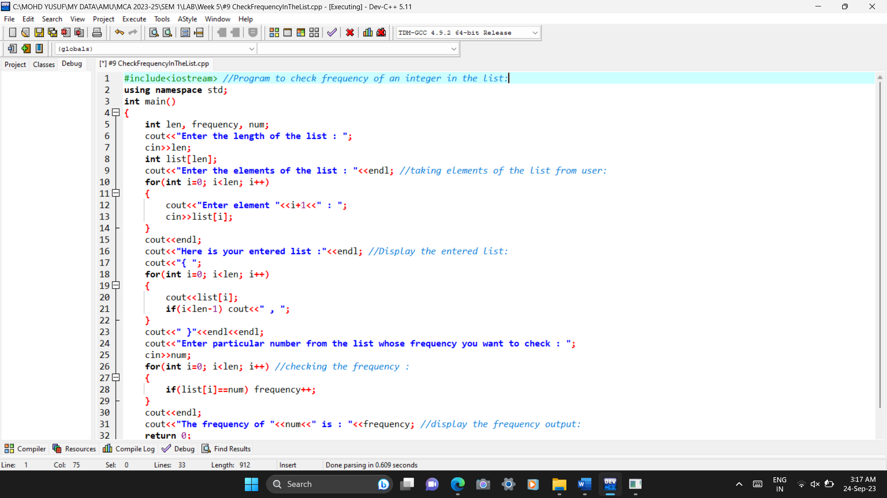  
Code:

|  |
| --- |
|  |
|  |  |

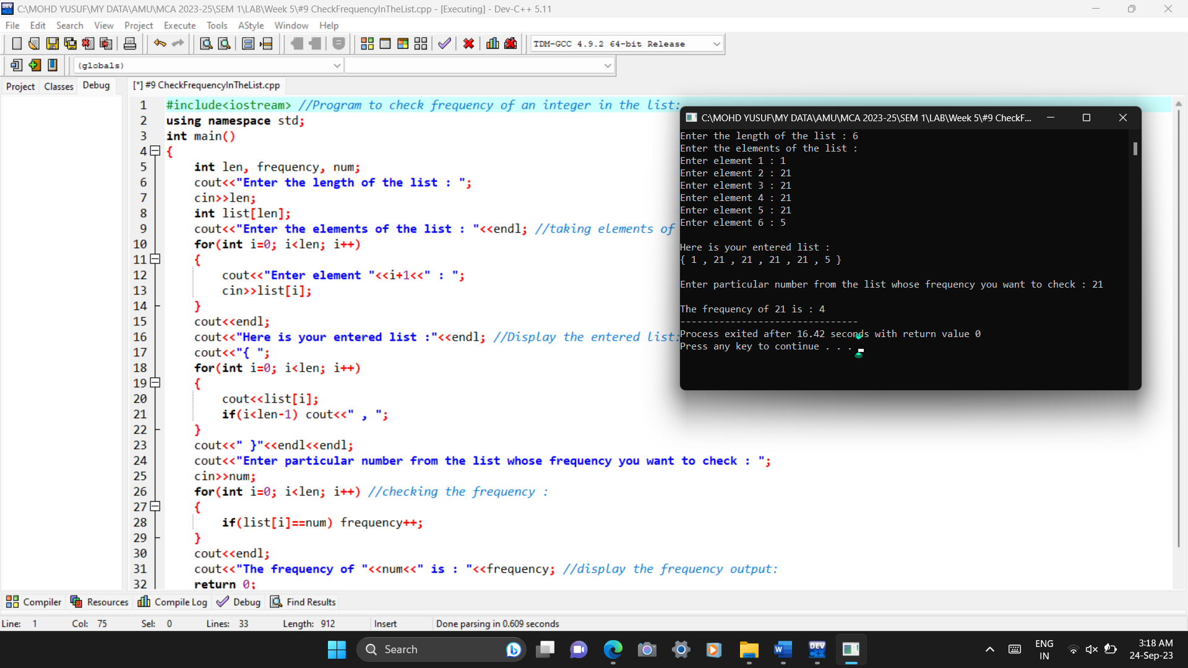  
Output:

**WEEK 6**

1# Write a C++ Program for Add Two Numbers Using Pointer.

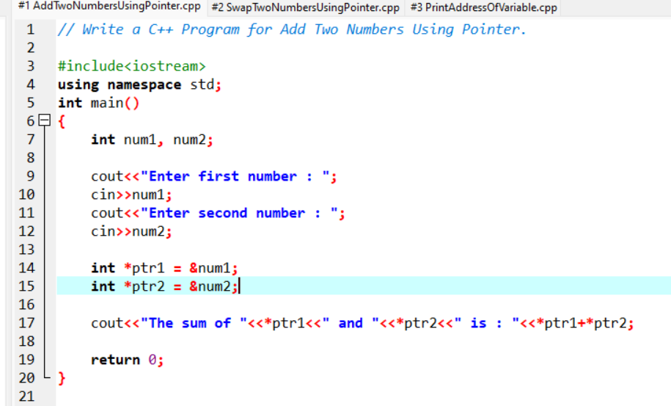Code:

Output:

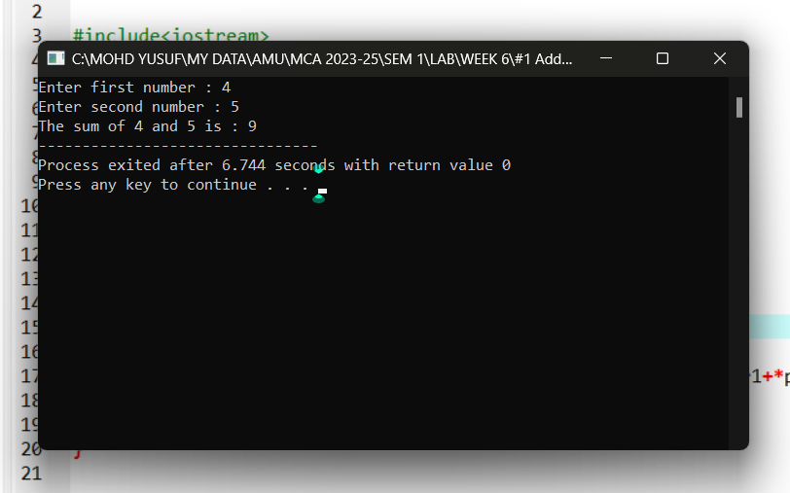2# Write a C++ Program for Swap Numbers Using Pointers:

|  |
| --- |
|  |
|  |  |

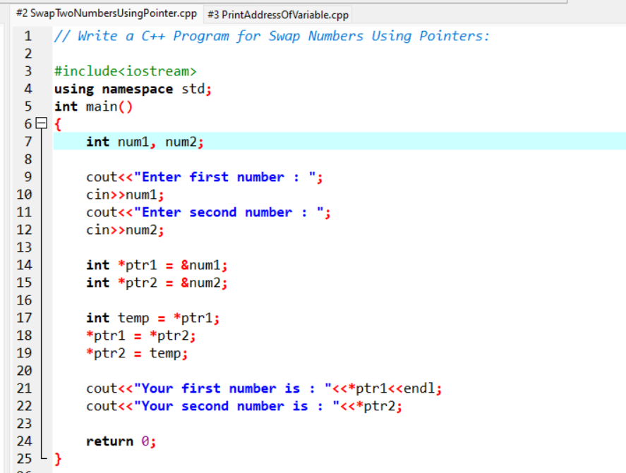  
Code:

|  |
| --- |
|  |
|  |  |

Output:

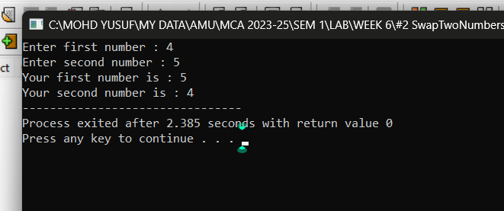

3# Write a C++ Program to Print the address of the Variable Using a Pointer.

|  |
| --- |
|  |
|  |  |

Code:

|  |
| --- |
|  |
|  |  |

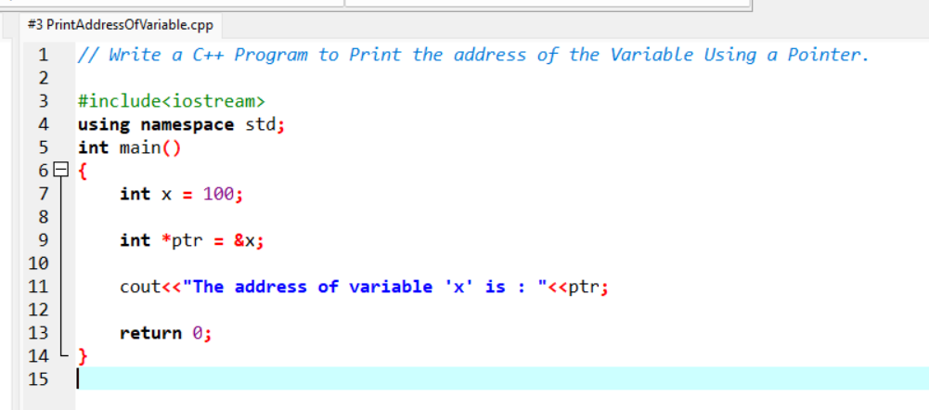

Output:

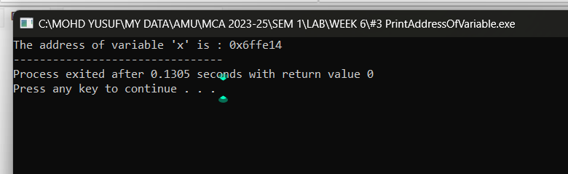4# Write a C++ Program for Increment and Decrement Integer Using Pointer.

|  |
| --- |
|  |
|  |  |

Code: 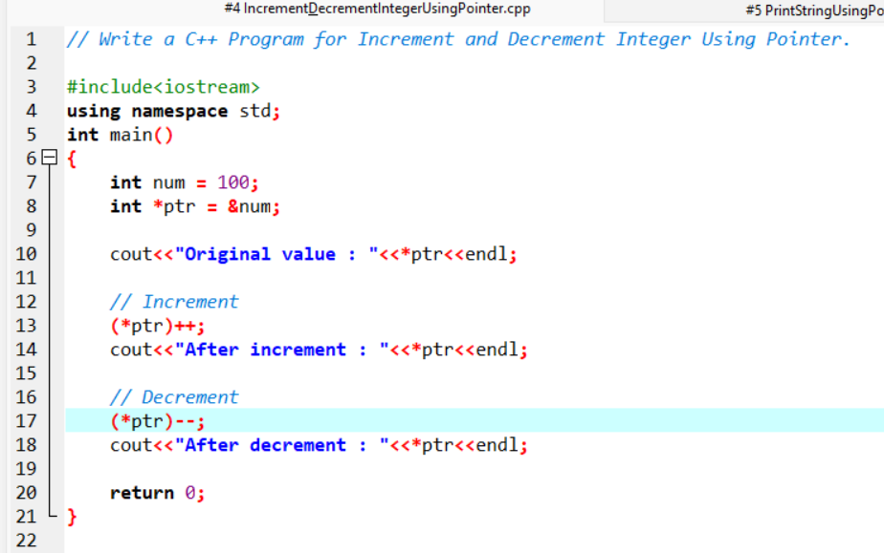

|  |
| --- |
|  |
|  |  |

Output:

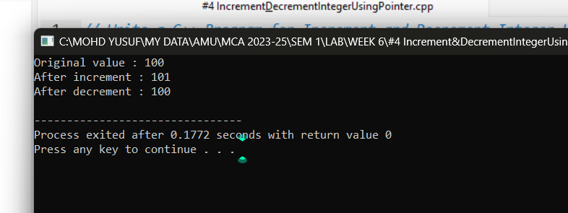

5# Write a C++ Program for Print String Using Pointer:

|  |
| --- |
|  |
|  |  |

Code:

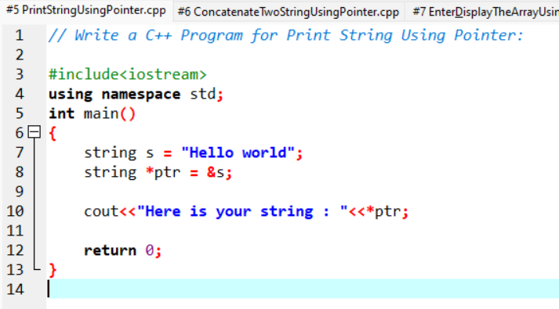

|  |
| --- |
|  |
|  |  |

Output:

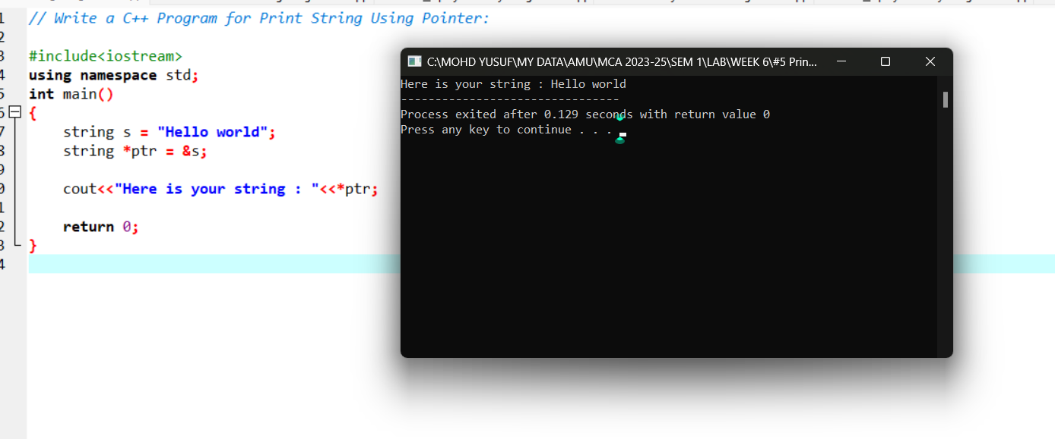6# Write a C++ program to concatenate two strings using pointers:

|  |
| --- |
|  |
|  |  |

Code:

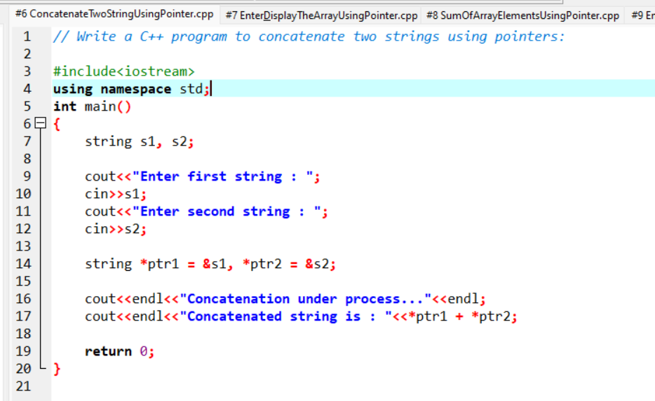

|  |
| --- |
|  |
|  |  |

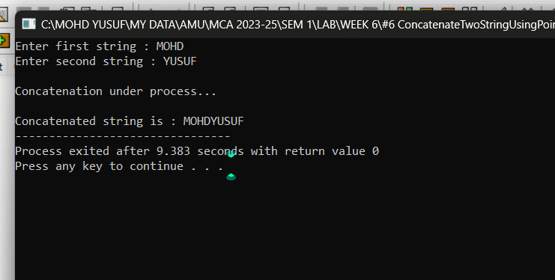  
Output:

7# Write a program for reading elements using a pointer into an array and display the values using an array.

i. Declare a set of elements.

ii. Declare the pointer and initialize it to the first element address of a set of elements(array).

iii. Repeat the loop until the pointer reaches to the last element and displays each element.

|  |
| --- |
|  |
|  |  |

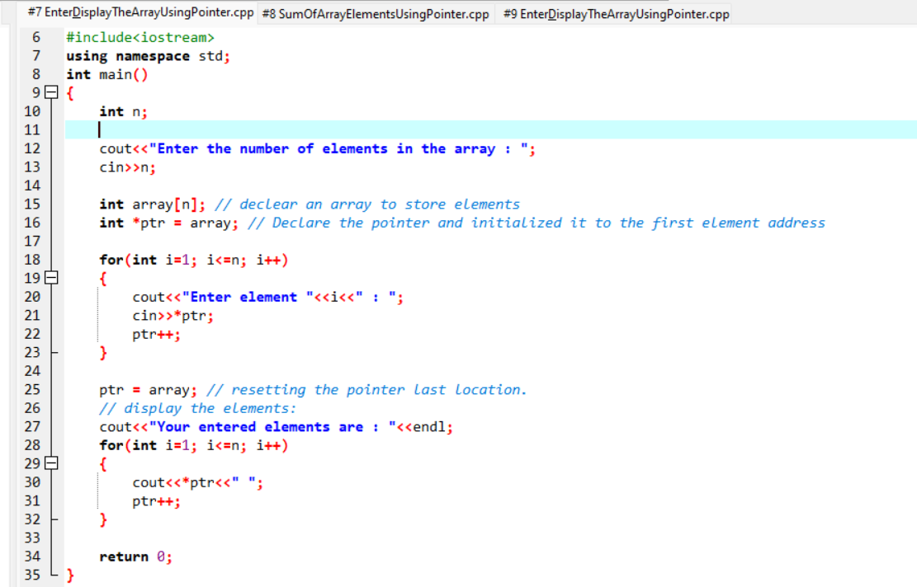  
Code:

|  |
| --- |
|  |
|  |  |

Output:

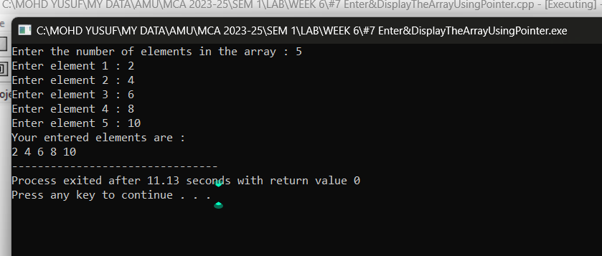8# Write a program for reading elements using a pointer into the array and display the values using an array.

|  |
| --- |
|  |
|  |  |

Code: 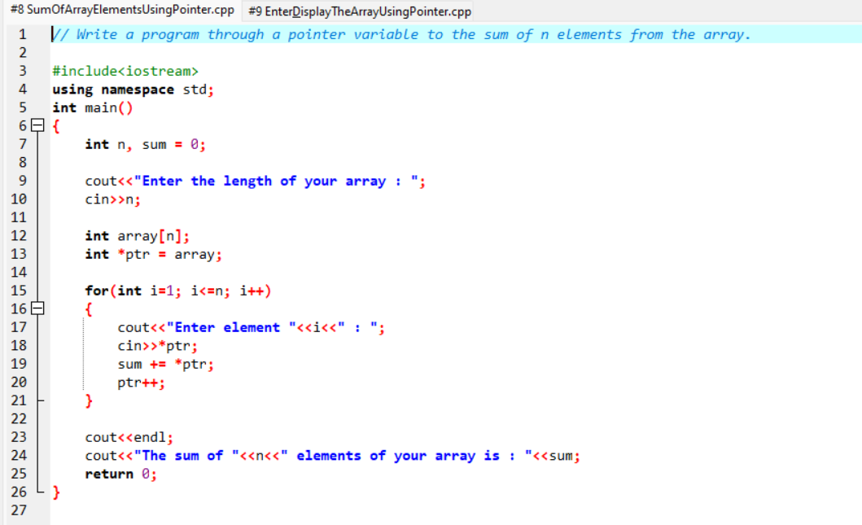

|  |
| --- |
|  |
|  |  |

Output:

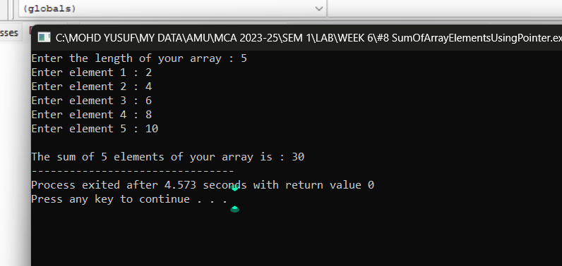9# Write a program for reading elements using a pointer into the array and display the values using an array.

|  |
| --- |
|  |
|  |  |

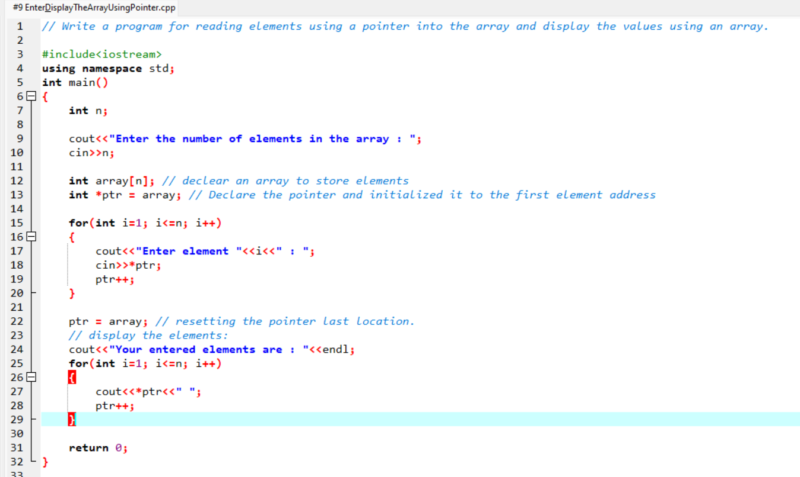  
Code:

|  |
| --- |
|  |
|  |  |

Output:

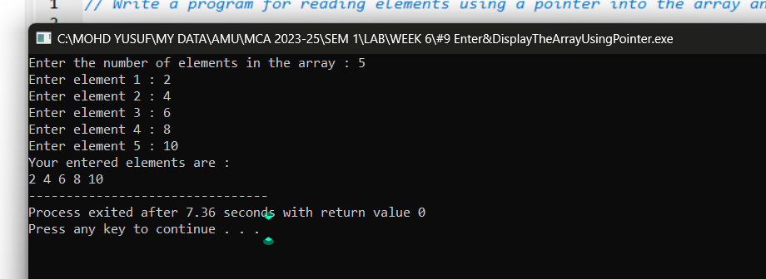

10# Write a C++ program to reverse a string using pointers.

Code: 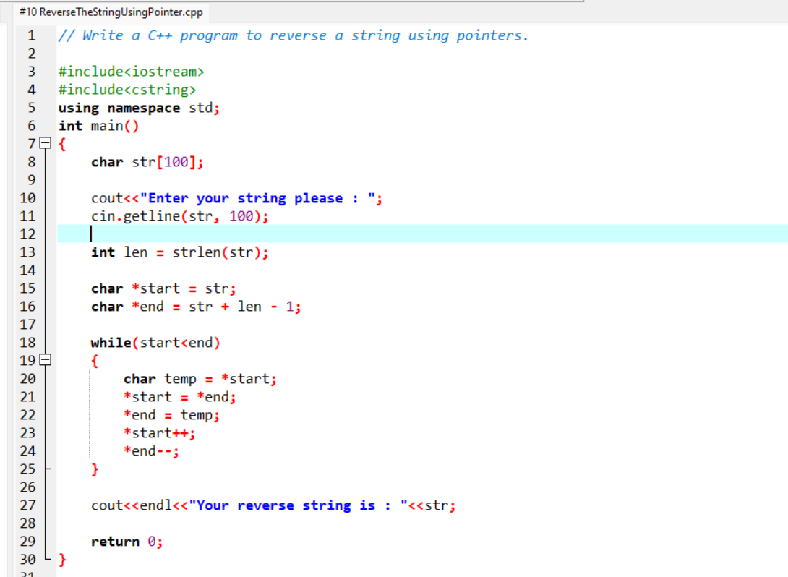

|  |
| --- |
|  |
|  |  |

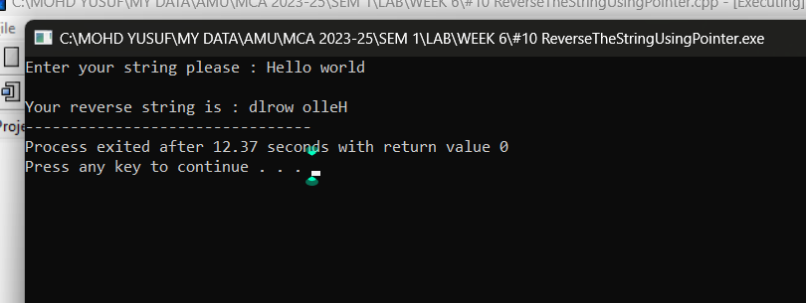  
Output:

**WEEK 7**

1# Write a C++ Program for Count vowels String Using Pointer.

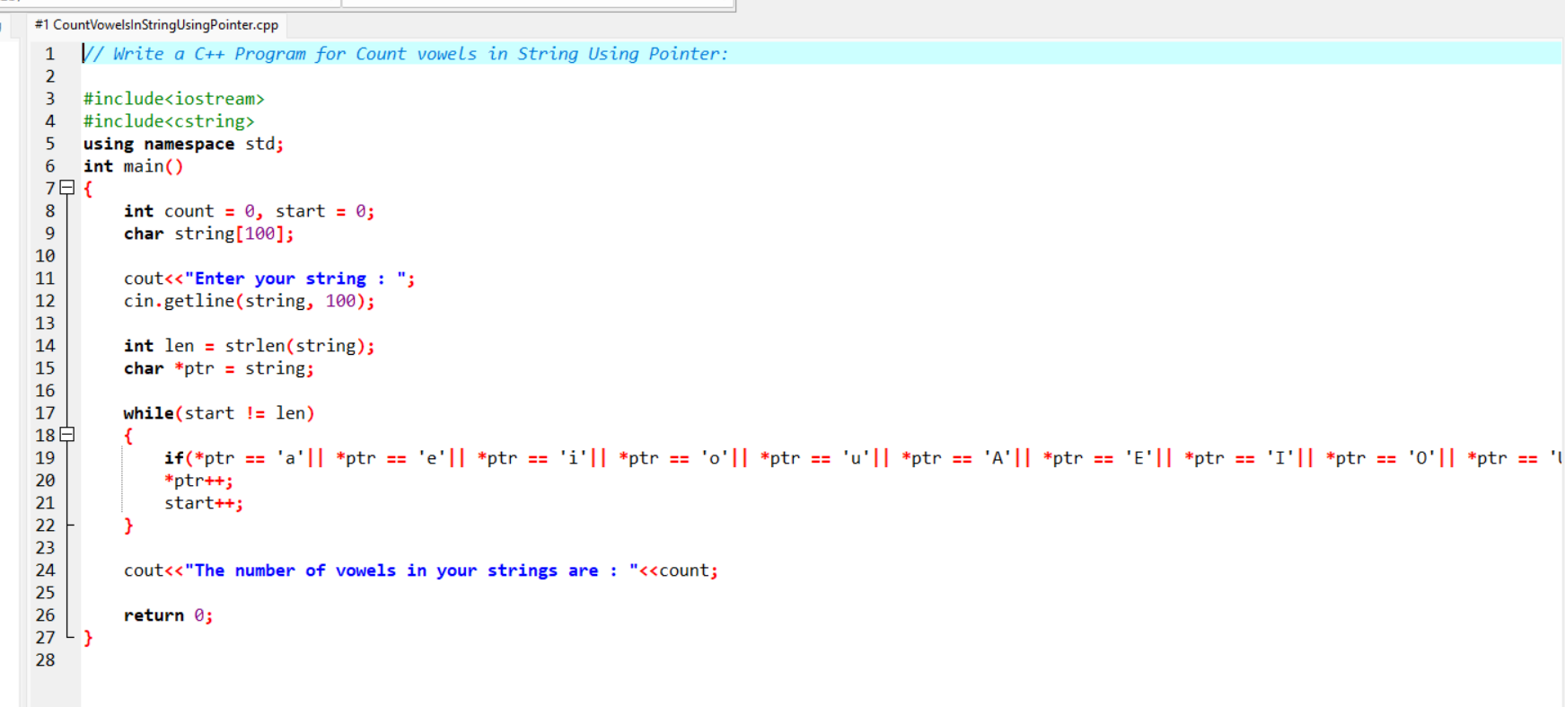Code:

Output:

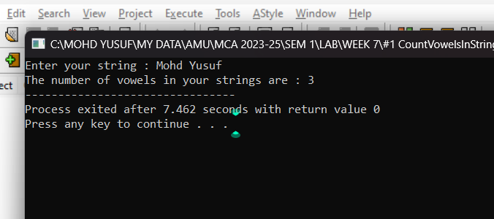

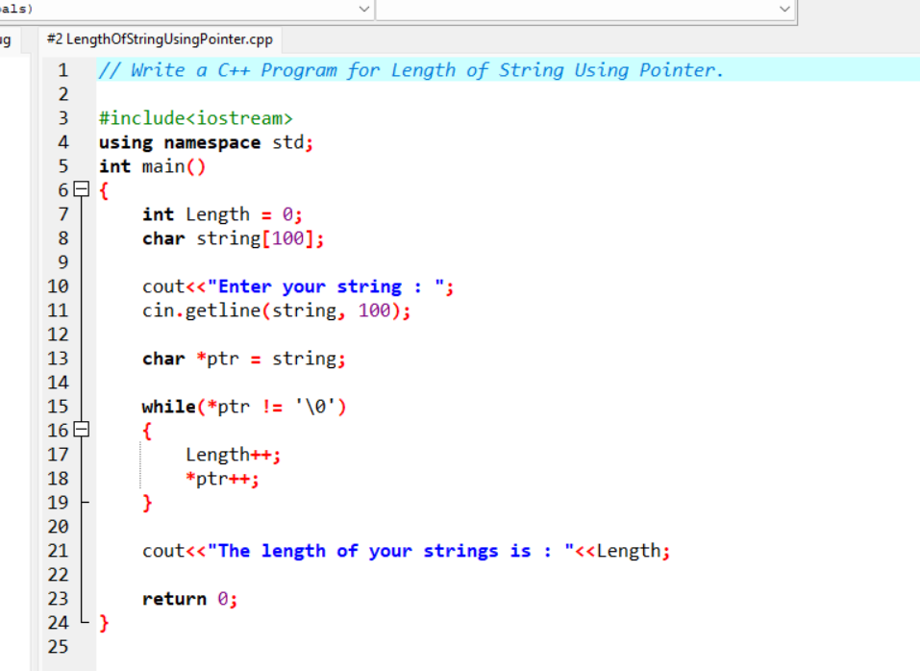2# Write a C++ Program for Length of String Using Pointer.

Code:

Output:

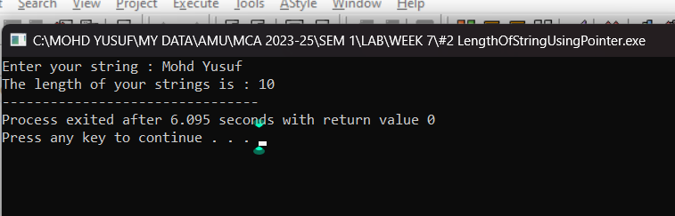

3# Write a C++ program using pointers to compute the sum, mean and standard deviation of all elements stored in an array of n real numbers.

|  |
| --- |
|  |
|  |  |

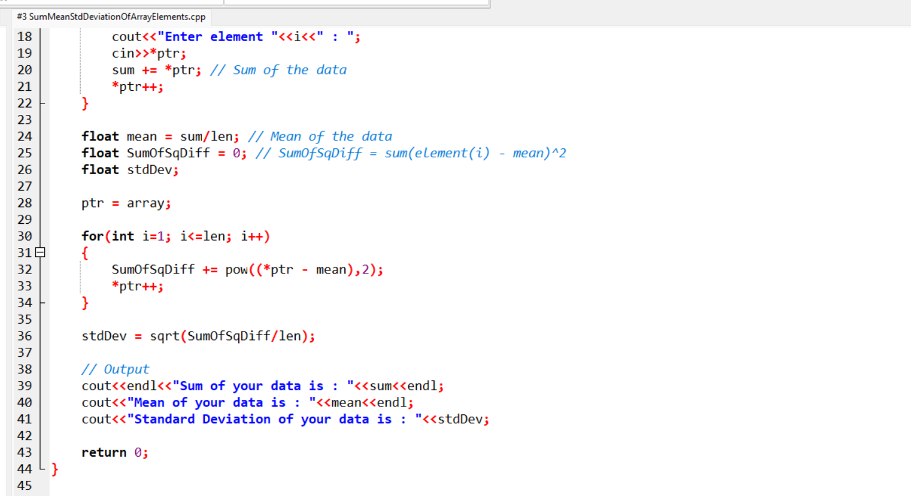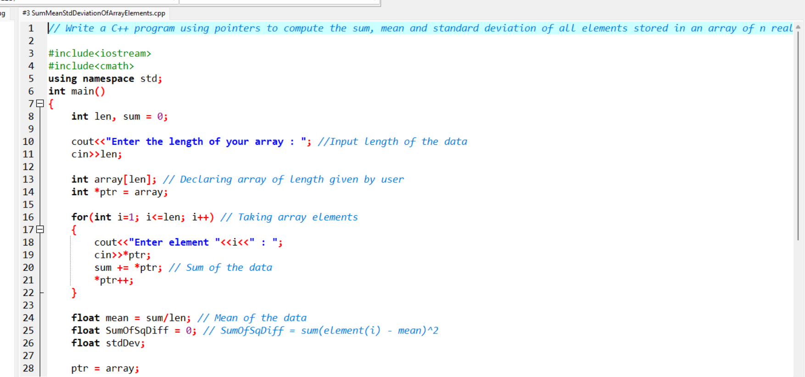  
Code:

Output:

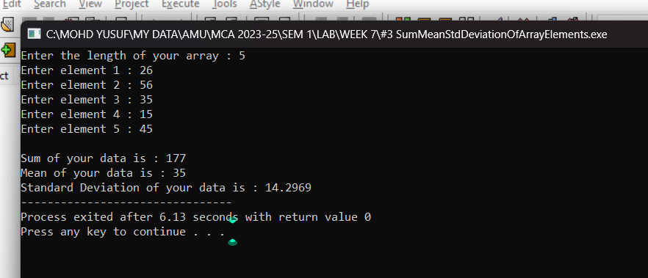

4# Write a C++ program to create three objects for a class named pntr_obj with data members such as roll_no & name. Create a member function set_data() for setting the data values and print() member function to print which object has invoked it using the ‘this’ pointer.

|  |
| --- |
|  |
|  |  |

Code: 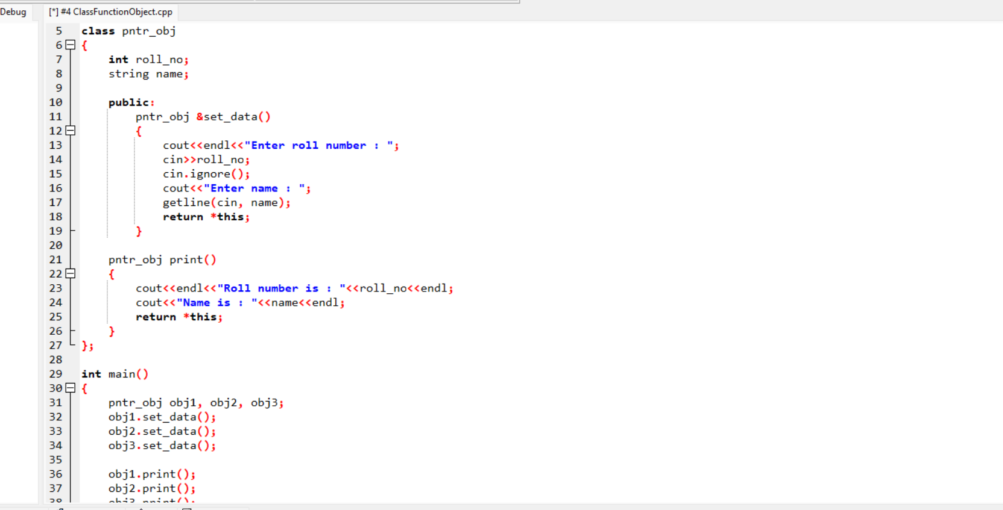

Output:

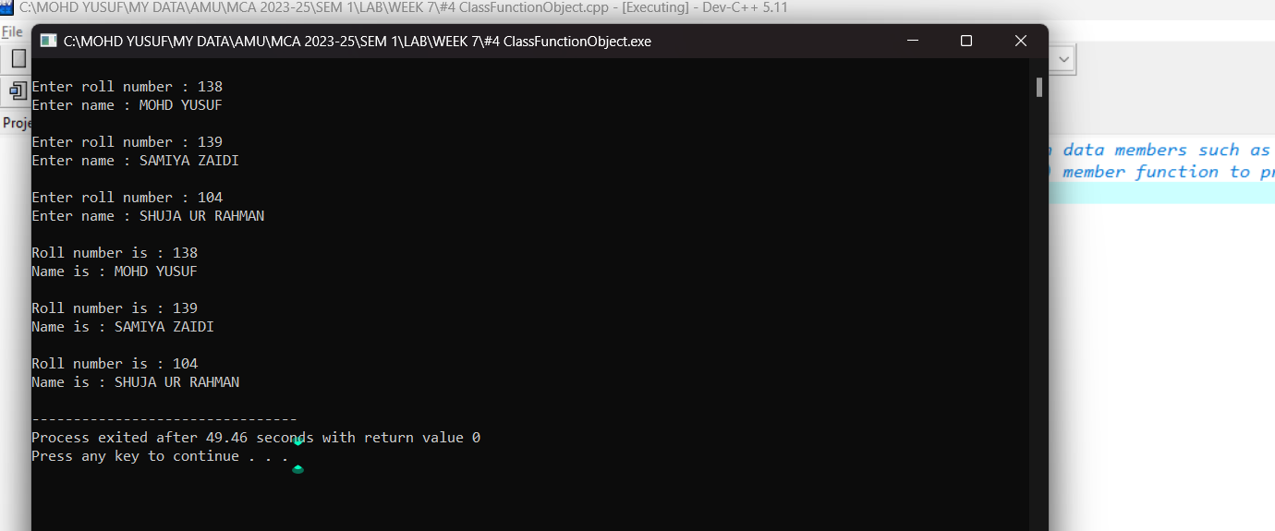

5# Develop a C++ program to find the greatest of two numbers using this pointer which returns the member variable.

|  |
| --- |
|  |
|  |  |

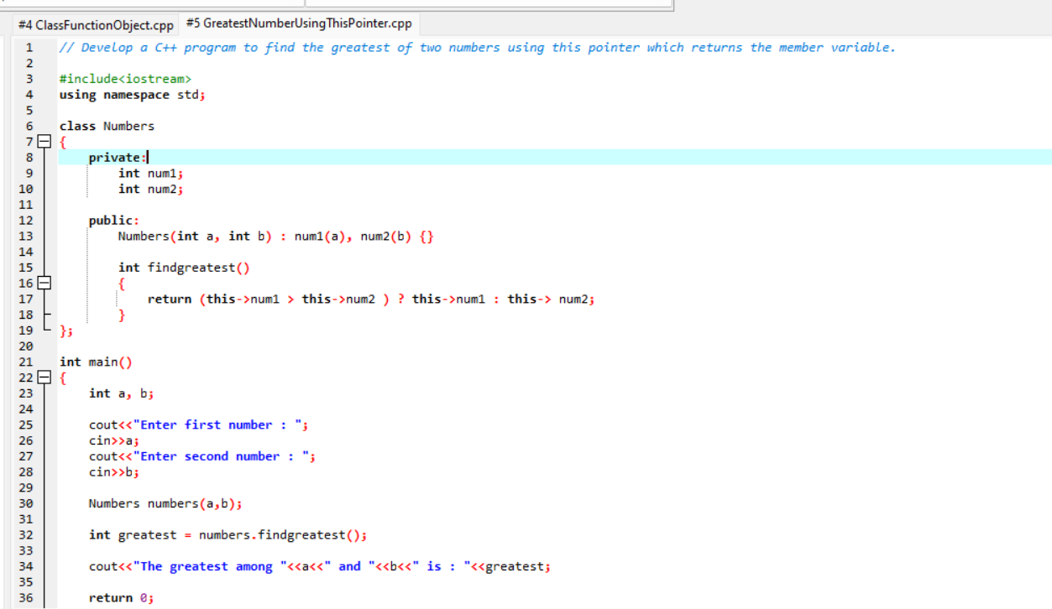  
Code:

Output:

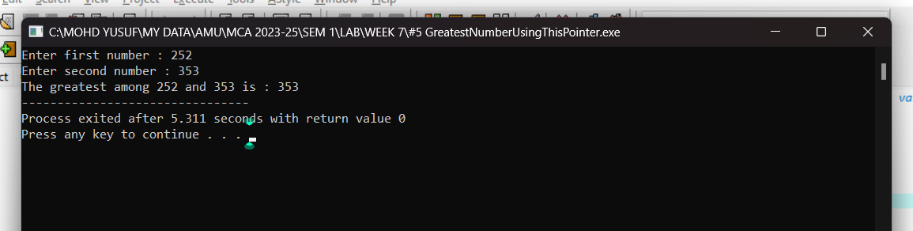

6# Write a C++ Program for Count vowels String Using Pointer.

|  |
| --- |
|  |
|  |  |

Code:

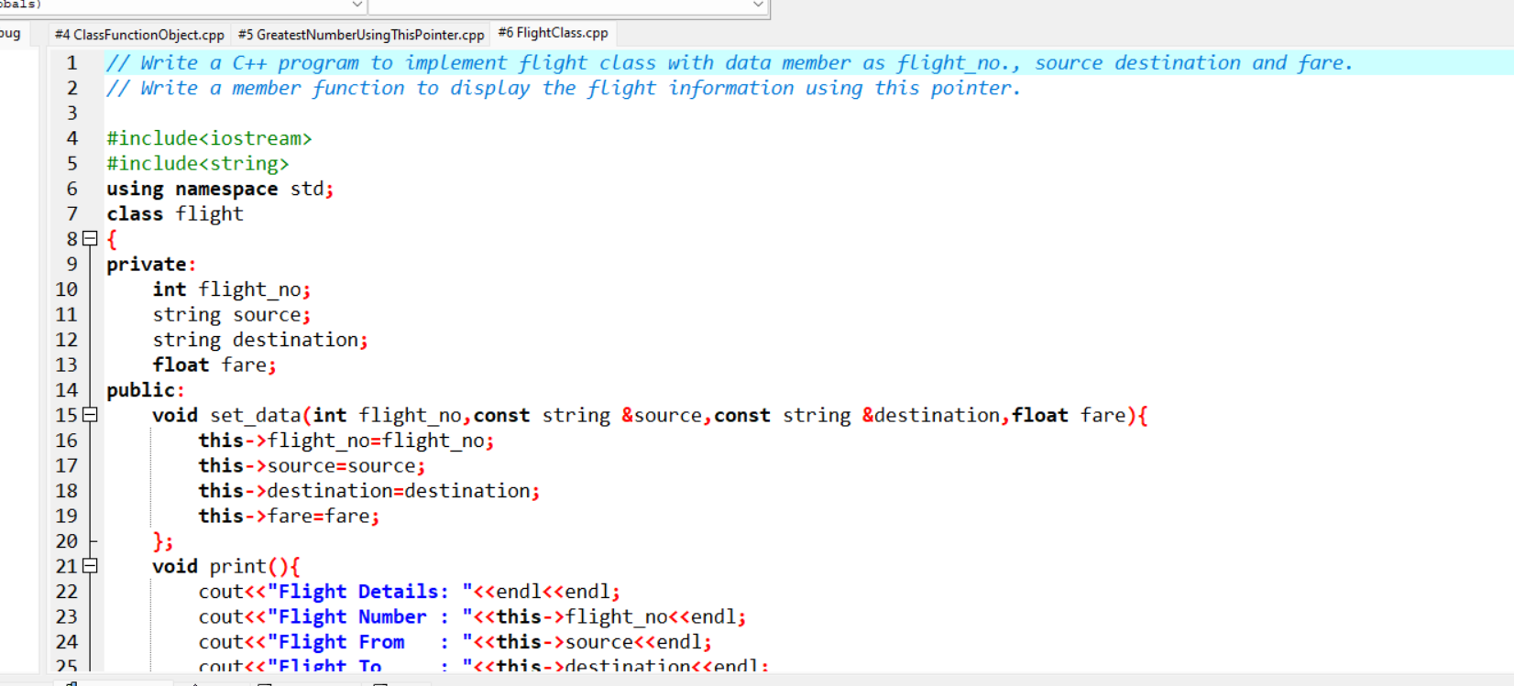

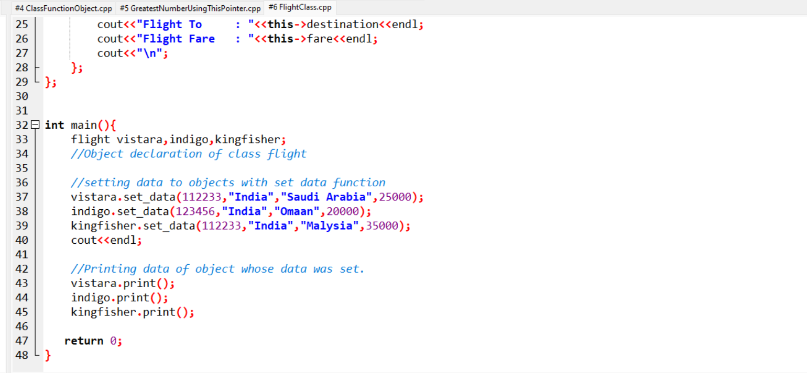

Output:

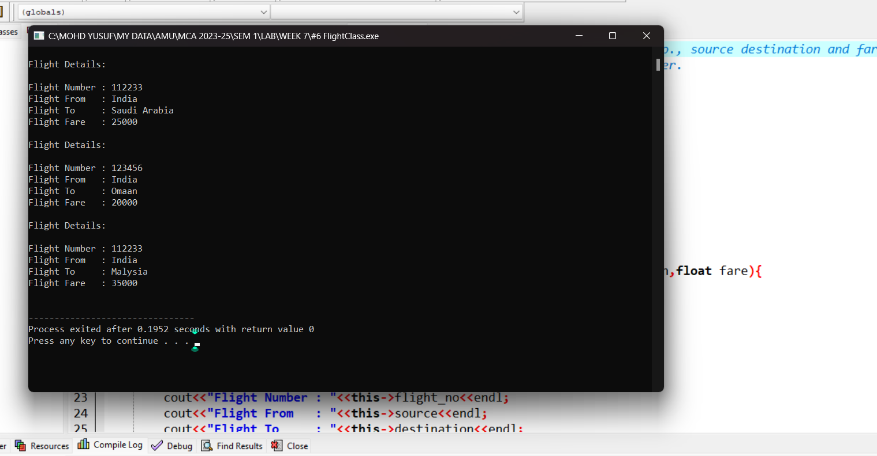

7# Write a C++ Program for Count vowels String Using Pointer.

|  |
| --- |
|  |
|  |  |

Code: 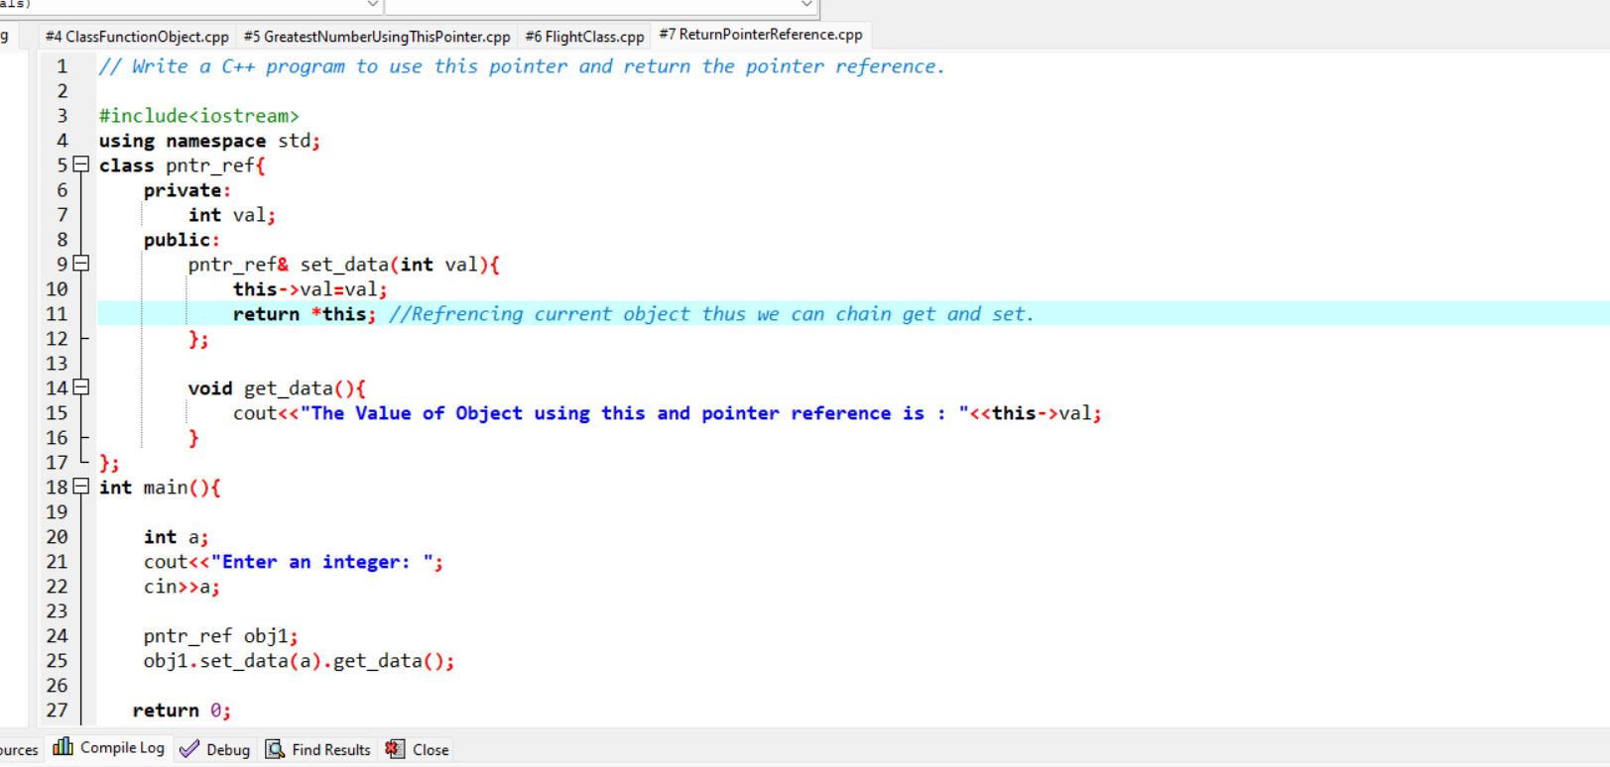

Output:

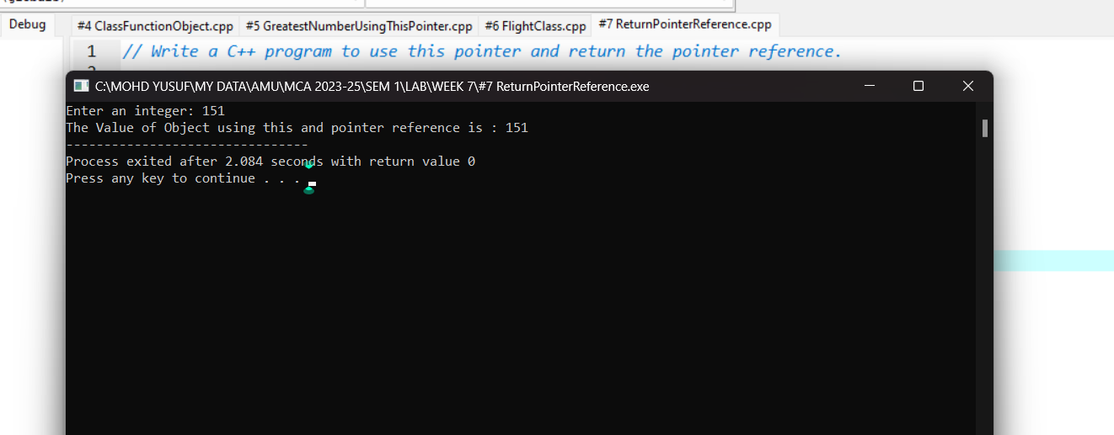

**WEEK 8**

1# Write a C++ program that uses functions to perform the following operations:

1. To insert a sub string into a given main string from a given position.
2. To delete n characters from a given position in a given string.

Code:

Output: